Eday Community School
Handbook
2025 - 2026

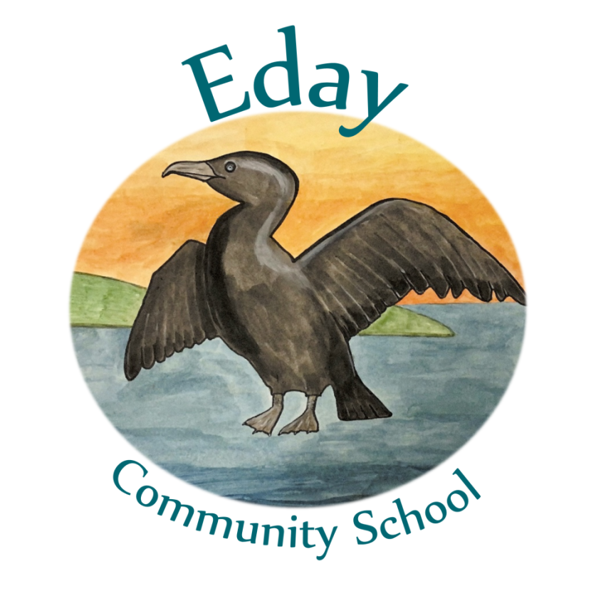

“Ready, Respectful, Safe”
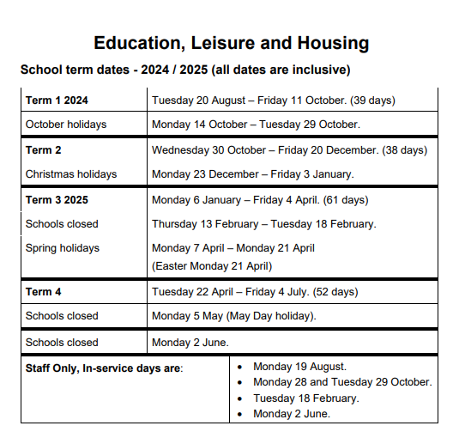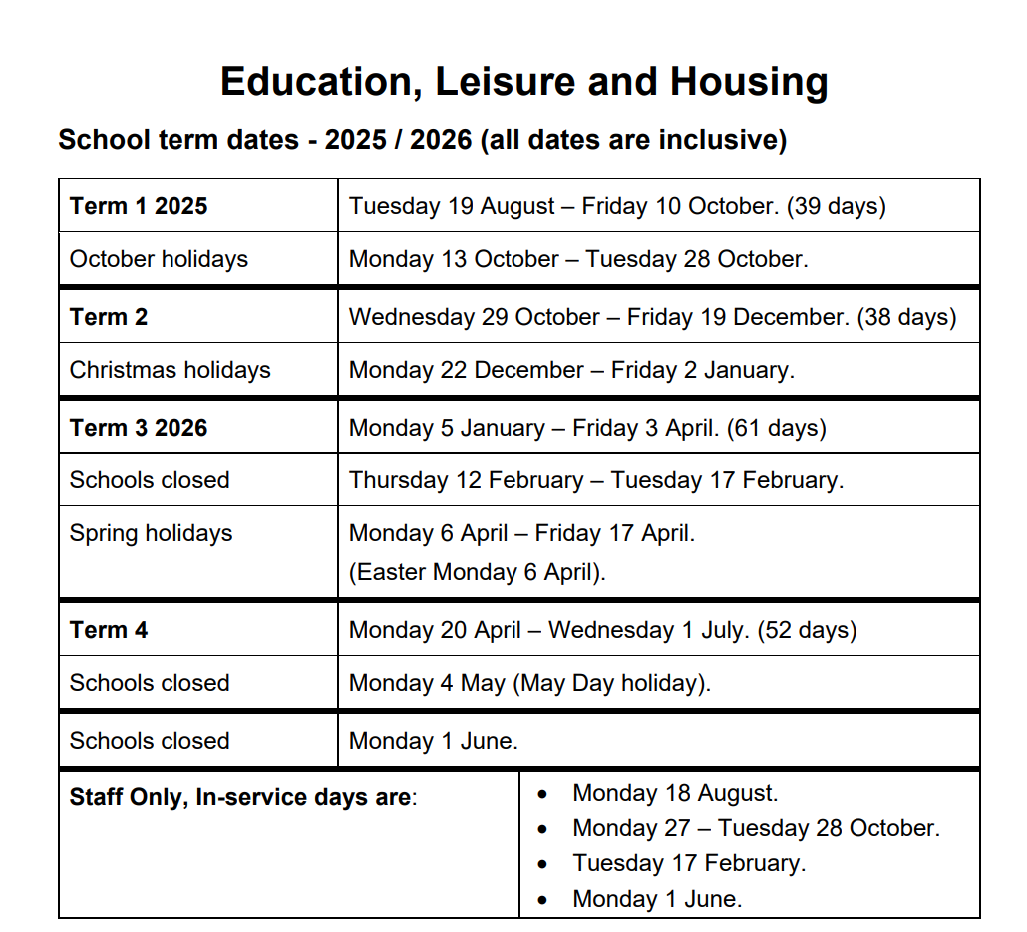

CONTENTS

General School Information 5
Contact Details 5
School Roll and Stages 5
School Staff 5
School Day 5
Early Learning and Childcare Provision for Children 3-4 years 6
Visits of Prospective Parents/Carers 6
School Uniform and PE Kit 6
School Clothing Grants 7
Parental Concerns 8
Pupil Absence Procedures 8
The Complaints Procedure 9

Parental Involvement 10
Learning at Home 10
Home /School partnerships 10
Becoming Involved in School 11
Opportunities for Parental Involvement 11
Parent Councils 12

School Ethos 13
School and Community Links 14
Behaviour 14
Discipline Procedures 15
Celebrating Achievement 15
Wider-Curricular Activities 16

Curriculum for Excellence (CfE) 17
Learning Opportunities 18
The Senior Phase 18
Skills for Learning, Life and Work 19
16+ Learning Choices 19
The Pupils’ and Parents’ Voice 19
The Curriculum at School, Local and National Level 20
Careers Information Advice and Guidance 20
Financial Guidance 21
Sexual Health and Relationships Education 21
Drugs Education 21
Religious and Moral Education 22

Assessment 23

Reporting 24

Transitions 25
Starting Early Learning 25
Starting Primary One 25
Transfer to Secondary School 25
Moving from Stage to Stage 25
Moving Between Schools 26
Leaving School 26

Support for Pupils 27
Support Arrangements for All Pupils 27
Identifying and Addressing Additional Support Needs 27
Staged Intervention 28
Further Information about Additional Support Needs 29

School Policies and Practical Information 32
School Meals 32
Free School Meals 32
Special Dietary Requirements 33
Health Care 33
Administration of Medicines 33
Transport 34
Insurance 34
Child Protection 35
Acceptable Use of Personal Internet Enabled Devices 35
Transferring Educational Data about Pupils 35
Emergency Closures 36

Useful Links / Contact Details 37

Breastfeeding Friendly Early Learning Scheme
Scotland is breastfeeding friendly, and so are we. We are members of the Breastfeeding Friendly Scotland Early Learning Scheme which promotes, supports and protects breastfeeding. We want parents to feel comfortable in our school, and that includes supporting breastfeeding families. If you are in the school, you can breastfeed in our reception area or any other space where parents have access. If, however, you would prefer a private space to breastfeed, please ask and we will do our very best to help.

GENERAL SCHOOL INFORMATION

Contact Details: Mrs Rona Humphreys
Teaching Head
Eday Community School
Eday
Orkney
KW17 2AA
01857 622227
Mobile: 07903 410 974

admin.eday@glow.orkneyschool.org.uk for general enquiries, or
rona.humphreys@orkney.gov.uk for anything of a more sensitive nature.

School Staff
Mrs Rona Humphreys Teaching Head
Kirsty Glen Class Teacher
Mrs Roksana Allen Clerical Assistant
Mr Aaron Garson Janitor/ Cleaner
Ms Cathryn Townsend Early Years Lead Practitioner
Mrs Lorna Garson Early Years Practitioner
Mr Aaron Garson Auxiliary
Miss Meriel Cant Catering
Mrs Roksana Skrobisz Chair of the Parent Council

About the school
We provide education for children from the age of 3-12 (Nursery-P7), along with eligible 2-year-olds.
The present roll: 2 children in Nursery, 11 children in Primary.
The school is of non-denominational status

Eday Community School and Nursery weekly timetable
Monday 10am to 3.15pm
Tuesday 9am to 3.15pm
Wednesday 9am to 3.15pm
Thursday 9am to 3.15pm
Friday 9am to 3pm

Organisation of the school day
Break 10.30am to 10.45am (no break on Mondays)
Fruit and story 10.45am to 11.00am
Lunch 12.30 - 13.15 (lunch break to 13.30 on Mondays)
Physical Education (P.E.), takes place on a Tuesday and Wednesday, so please ensure your children wear comfortable clothes and have trainers or soft shoes suitable for this.
Art is on a Friday, so please ensure your child is wearing appropriate clothes that you do not mind get damaged or dirty.

Details of school holidays for current year can be found on the inside cover. Further holiday dates are available on the Orkney Islands Council website.

Early Learning and Childcare Provision for Pupils aged 2-5 years

3- 5-year-olds:
Each child is entitled up to 1,140 hours of funded Early Learning and Childcare a year (around 30 hours per week term time) if your child is 3 or 4 years old. If your child turns 3 years old between 1st March 2022 and 28th February 2023 they are entitled to Early Learning and Child Care place the term after their third birthday.

Eligible two-year-olds:
Children aged 2 years old are eligible for a funded two-year-old place from the term after their second birthday if their parents or carers are receipt of certain benefits.

Visits of Prospective Parents/Carers
If you would like to send your child to Eday Community School or nursery, contact the school by phone, letter or email and we will arrange a visit, show you round, help you with the necessary forms, and answer any questions you might have. A child’s primary care giver must accompany their child on the first day of starting nursery and are welcome to play and stay on Thursdays or by prior arrangement.

School Uniform
In Eday Community School, we encourage the wearing of our school polo shirt and jumper. The logo on it is the Scarfie, Eday’s emblem.

P.E. Kit:

Please ensure your child wears comfortable clothing and soft shoes or trainers on a Tuesday and a Wednesday, when P.E. is taught.

Waterproofs
We keep a set of waterproofs and wellies for pupils at the school, so they can enjoy outside play during the winter months. However, please send the children with gloves, scarves, and hats when the weather turns colder as the waterproofs are not warm.

Please remember that the children are here to have fun with their learning. Do not send your child to school with clothing items that:

- you will be upset about if it gets lost or damaged,
- could cause offence,
- could cause health and safety difficulties (such as dangling earrings, hanging laces or high heels),
- the child cannot fasten themselves i.e. laces, if they cannot tie them, and
- carries advertising.

All clothing worn or brought to school should be clearly labelled with your child’s name.

School Clothing Grants

Parents or carers who have a child under 16 attending an Orkney Islands school and receive certain benefits may be eligible for a School Clothing Grant and/or free school meals. Please visit the link below for more information.

School meal and Clothing grant applications.

School Meals

Did you know?

By applying for free school meals not only will your child be receiving nutritional benefits, but you will also be supporting their school. For every pupil that registers for free school meals, the school may receive funding through the Pupil Equity Fund (PEF). This funding can be used to support a wide range of initiatives and can help those who experience barriers to learning. We strongly encourage all parents who are eligible for free school meals to apply for them.

At Eday Community School we encourage healthy eating. A snack of fresh fruit is provided at break time. There is no need for children to bring any snacks from home.

All P1 to P5 pupils are entitled to free school lunches. School lunches are planned so that children have a well-balanced meal, and copies of the menus are available from the school. A good selection of salad, vegetables, fresh fruit, milk, and water are available daily.
The school aims to encourage children to enjoy food, which, is attractive to them and nutritionally sound.

P6 and P7 pupils pay £3.70 per school meal, unless they are entitled to free school meals.

Please contact the school if your child has special dietary requirements. Our meals are planned and cooked onsite in the school kitchen and the school cook, Meriel, caters to all dietary requirements. Due to the size of the school, Meriel produces a two-course meal which all the children eat except for those who have different requirements.

Parents can find information and apply for school transport provision at the following website: https://www.orkney.gov.uk/Service-Directory/S/School-Transport.htm

Parental Concerns

If you are concerned about anything regarding your child’s education or health and wellbeing, please contact Rona at the school. The school is open after 3.15pm every Tuesday for parents and carers to come in and have a chat or appointments can be made for other times.

School Attendance

Parents/carers are responsible for ensuring that their children attend school regularly and arrive on time. The expected level of attendance should be 95% or above. Parents are also responsible for ensuring the safety of their children on their journeys to and from school. Because regular and punctual attendance is linked closely to achievement, we must make a record of all attendance and lateness. Please get in touch with the school if you are having difficulties with this as we are happy to help and may be able to put some support in place.

Planned Absence

Parents/carers are encouraged not to arrange family holidays during term time, but it is realised that, in exceptional circumstances, this is unavoidable. In such cases, parents/carers are asked to seek permission from the Head Teacher and provide information of the dates when the child is to be absent from the school in good time.

Contact Details

Parents/carers are asked to ensure that telephone contact numbers – home, work and emergency contact(s) are kept up-to-date and are numbers at which a response can be obtained in all normal circumstances.

The Complaints Procedure

A complaint is ‘an expression of dissatisfaction about the Council’s action or lack of action, or about the standard of service provided by or on behalf of the Council’. Complaints can be notified in person, by phone, by email or in writing to the Head Teacher. If parents/carers have cause for complaint, they should contact the school in the first instance to make an appointment to meet with the Head Teacher.

The Orkney Island Council policy for complaints is available on the OIC website.

Pupil Absence Procedures

If your child is too ill for school:
Contact the school as soon as possible and before 9.00am on 01857 622227 with details of your child’s illness.
Inform school transport if appropriate.
Keep us informed if the illness continues.
Warn us if the sickness is contagious.

If Your child has an appointment that must be held in school time:
Contact the school as soon as you know the appointment date.
Send a note with details of the appointment, or phone the school office, in advance.
Send a copy of the clinic or hospital appointment letter for your child’s records
Keep us informed of any follow-up appointments.

If you need to take you child out of school.
Contact the school as soon as possible and definitely by 9.00am.
Give the explanation for the absence via the phone, email or by letter.

Health Care

Orkney Health and Care provides an Orkney wide school health service to all school age children and young people to promote their health and wellbeing and to provide information to make more informed decisions on lifestyle choices. They undertake routine screening of P1 and P7 pupils and the school nurse visits the school to deliver health related talks and lessons. More information on the school health programme is available in a leaflet from school, or direct from the School Health Service on 01856 888 262.

PARENTAL INVOLVEMENT

The school values the important part that parents play in their children’s education and sees partnership with parents as an effective way of enhancing children’s achievements and promoting better school ethos and communication.
There are three areas in which parents are involved in their children’s education
- Learning at home
- Home-school partnership
- Parent council

Learning At Home
Parents are the first and on-going educators of their own children and, as such, should receive information and support to help develop their child's learning at home, in the community and at school.
In Eday Community School we do this by:
  - Having an open-door policy that invites parents to come into school regularly to view work and discuss progress.
  - Discussing current work and upcoming projects with parents, face to face and in Newsletters sent home.
  - Holding, hosting or joining with other schools to offer parental information evenings that include information about ways of using the home and community environment as a stimulus for learning or providing information on relevant topics e.g. drug awareness.
  - Occasionally, making some of our resources available for home use. E.g. pupils have taken times-table rainbows and practice sets home to support learning.
  - Providing resources like Numicon, and online access to websites such as Sumdog.
  - Indicating ways to practise or rehearse learning. E.g. we encourage the children to discuss with parents, the strategies we have discussed in class for spelling or for tackling a problem.
  - Providing appropriate homework.
  - Inviting any parent to discuss concerns, questions or request for information with us at a suitable time
  - Encouraging pupils to discuss their learning with parents and engaging them with such aspects as technology and healthy living.

Home – School Partnership
Learning works best when schools are open to the involvement of parents in the work they do, and it is important to consider ways of providing information that helps parents engage with school and their children's education.
In Eday Community School we do this by:
- Providing clear information at the start of the school year in the school handbook.
- Having regular parent council meetings.
- Regularly updating our website.
- Providing parents of new and prospective pupils with relevant and clear information through the handbook and advice.
- Involving parents in special events at Christmas, End of Terms or topic Celebrations.
- Inviting parents and the community to help resource, with suggestions, ideas, contacts and skills, various aspects of the curriculum. E.g. inviting parents and the community to help us plan, deliver and celebrate a topic or inter-disciplinary study. (subject to PVG checks)
- Using Reading books to communicate

Becoming Involved in School
The school values the important part that parents/carers play in their children’s education and sees partnership with parents/carers as an effective way of enhancing children’s achievements and promoting a better school ethos and communication. Please contact the school office in the first instance, if you would like to become involved in the school.

Opportunities for Parental Involvement

During the school day:
- Supporting Art/Craft activities
- Sharing knowledge and expertise in some aspect of the curriculum (e.g. topic talk), history, science, health
- Reading stories to groups of children, playing reading/phonics games
- Running or assisting to run a Club
- Supporting educational visits/trips
- School events- working with the children to prepare
- School concerts – making costumes, props, supervision of children
- Helping assess and celebrate work

Out with the school day:
- Fundraising events
- Trips, e.g. sporting events, concerts, transition visits and residential visits.
- Wider-curricular activities, e.g. coaching, sports/art clubs/country dancing/school grounds – maintenance of garden areas

If you wish to be a regular parent helper, PVG (Protecting Vulnerable Groups) checks must be completed. This is something we offer to all parents when they join the school, as a matter of course.

Parent Councils

Parent Councils are now established in all Orkney Island primary and secondary schools. The Scottish Schools (Parental Involvement) Act 2006 recognises the vital role that parents/carers play in supporting their children’s learning.

The basic principle underpinning the Act is the desire to have children become more ‘confident learners’ through closer working between each family and school. It is anticipated that this can be done in three ways. These are: -

- Learning at Home: direct parental involvement in the child’s learning at home and in the community.
- Home/School Partnership: closer working partnerships between parents/carers and the school – such partnerships being essential to ensure that the child gets maximum benefit from their school experiences.
- Parental Representation: Parent Councils will be parent/carer led, and school supported, with all parents/carers being automatic members of the ‘Parent Forum’ and the Parent Council representing their views.

You can find out more about your Parent Council by contacting Rona Humphreys or Roksana Allen, the Chair of Parent Council.

SCHOOL ETHOS

‘Ready, Respectful, and Safe.’

We want every pupil to be engaged, enthused and achieving in their personal development, using creative investigation, disciplined work and focused learning. Every pupil is different, their challenges varied, and their learning journey very personal, but there are three key values that underpin this hard work and reflect the ethos of Eday Community School: being Ready, Respectful and Safe.

School Aims

Community
Our unique island identity enables active participation in a small community. We have a strong sense of community, both from our own school community, and the local community of which we are a part. We celebrate our successes and achievements, inside and outside of school and make the most of the opportunities that our small size gives to work closely together in small groups and mixed age teams.

Relationships
We work hard to learn how to have good, strong and healthy relationships, while living on a small island. We recognize the importance, in the world of work, of the ability to work cooperatively in teams and such learning is central to our approach.
We believe in respecting each other, in an inclusive approach and in all aspects of equality. All the staff actively seek to model the behaviours and attitudes we expect from students and can demonstrate the benefits of working as a close team.

Care
One of the many benefits of being a small school is that we know our pupils well. The pastoral care of pupils and staff is also an important feature of our school. We strive to provide an inclusive and caring environment for our staff and pupils.

Citizenship
We value positive citizenship. We encourage pupils to accept responsibilities through the pupil council, outdoor education sessions and through participating in daily routines. Here they learn to lead, discuss, share and cooperate all to a positive outcome. Pupils have opportunities to interact with their communities and local groups through projects, community events, fundraising, or enterprise activities.

Participation
Pupil involvement, parent involvement, community involvement and staff involvement are very important to us.
We work hard to help pupils find and use their voice in their education and their school. They make many important decisions about learning, experiences and school design in a variety of ways. We are committed to providing appropriate opportunities for the development of pupils’ spiritual, moral, social and cultural values through both the school ethos and the curriculum. This will be undertaken in partnership with parents and will take account of the individual needs of pupils and the views of parents.

Our school welcomes and encourages diversity and individuality, while emphasizing our common commitment to moral values such as honesty, respect for others, compassion and justice. Fundamental principles of our school are that all who are involved in the life of our school have the right to be respected as individuals and carry the responsibility to act in a considerate and respectful manner towards others. We are firmly committed to the elimination of any form of discrimination on the grounds of race, religion, gender or disability.

School and Community Links

In the past we have worked with local organizations and venues: Community Council, The Heritage Centre, The local Kirk, Eday Surgery, Eday’s London Airport and Fire Service and the Eday Partnership.

Behaviour

Good behaviour is essential to good learning. The general aim of the school is to provide an atmosphere of mutual respect and collective responsibility. Pupils, parents and staff have an important part to play in producing and sustaining this positive ethos. The rules of the school are Ready, Respectful, and Safe.

We show that we are READY for learning by:
- Being quiet and attentive to the learning leader,
- Having a rubber, sharp pencil and other materials needed to learn, and
- Wearing appropriate clothing for the task, i.e. waterproofs, painting clothes or PE clothing.

We show we are RESPECTFUL by:
- Taking care of ourselves and others,
- Taking care of the school and everything in it, and
- Taking care when we communicate.

  - T = Is it true?
  - H = Is it helpful?
  - I = Is it inspiring?
  - N = Is it necessary?
  - K = Is it Kind?

We keep ourselves SAFE by:
- Giving people personal space,
- Walking around the school,
- Using equipment in the way it is intended to be used, and
- Listening for instructions.
.
Discipline procedures
We have a low arousal behaviour management system in the school, based on the ethos of ‘First Attention to Positive Behaviour.’ This means that we congratulate the excellent behaviour we see and quietly discourage poor choices, often without the need to speak. If further action is needed, this is done in private, through discussion and collaboration with the pupil initially and possibly the pupil’s guardian if this is deemed necessary.

However, where there is conflict with the children, we use a formula to help the children express their feelings and perceptions in turn and then encourage them to try to resolve the issue through talking. If the situation is more serious an adult will go through this process with those involved and parents may be informed or asked to come in to discuss the situation.

Wider-Curricular Activities
There is currently an after-school gardening club one day a week until 4.00 pm, led by Roksana (Roxy) Skrobisz. Focus of the after-school clubs and the day they are held may alter over time.

CURRICULUM FOR EXCELLENCE (CfE)

The curriculum aims for all children to become:
- Successful Learners
- Confident Individuals
- Responsible Citizens
- Effective Contributors
“CfE represents a different approach to learning in schools intended to help learners develop skills, knowledge and understanding in more depth.”

We provide opportunities such as:

Using technologies in learning – to find material, communicate, create and present
Active learning – being actively engaged, whether mentally or physically, using real life and imaginary situations
Cooperative learning – encouraging, thinking and talking together to discuss ideas and solve problems by working as a team
Interdisciplinary learning – using links between different areas of learning to develop, reinforce and deepen understanding
Outdoor learning – making use of the outdoor environment for co-operative learning
Personalisation and choice – pupils are given choices and are involved in planning how and what they learn, avoiding the ‘one size fits all’ approach. This, in addition to core learning

Curriculum for Excellence (CfE) is the curriculum in Scotland which applies to all children and young people aged 3-18, wherever they are learning. It aims to raise achievement for all, enabling children and young people to develop the capacities, skills, knowledge and understanding they need to succeed in learning, life and work.

The Eight Curriculum areas are:

- Expressive Arts – including art and design, dance, drama and music
- Health and Wellbeing – mental, emotional, social and physical wellbeing; PE; food and health; substance misuse; and relationships, sexual health and parenthood
- Languages – listening and talking, reading and writing in English and modern languages, plus classical languages and literacy, and Gaidhlig/Gaelic learners (where available)
- Mathematics – including analysing information, solving problems and assessing risk
- Religious and Moral Education (denominational and non-denominational) – learning about Christianity, other world religions, and developing values and beliefs
- Sciences – understanding important scientific concepts across planet Earth, forces, electricity and waves, biological systems, materials and topical science
- Social Studies – understanding people, place and society in the past and present including history, geography, modern studies and business education
- Technologies – including computing science, food, textiles, craft, design, engineering, graphics and applied technologies

Additional important themes across the curriculum are creativity, enterprise and global citizenship, which include sustainable development, international education and citizenship.

Learning Opportunities

In Eday School, your child will be in a multi-composite class of different age groups. Your child will learn in a variety of different contexts and groups including ability, co-operative and social events and multi-composite teams.

There are national levels to describe different stages of learning and progress. For most children the expectation is:

- Early Level – pre-school to the end of P1
- First Level – to the end of P4
- Second Level – to the end of P7

Through Curriculum for Excellence children and young people are entitled to a continuous focus on literacy, numeracy and health and wellbeing. These skills are essential if children and young people are to gain access to continuous learning, to succeed in life and to pursue a healthy and active lifestyle. The use of ICT underpins these overlapping and mutually supportive skills sets; ICT skills will continue to be developed in a variety of contexts and settings throughout the learner’s journey.

All children and young people are entitled to opportunities for developing skills for learning, life and work. These skills are relevant from the early years right through to the senior phase of learning and beyond.

The Pupils’ and Parents’ Voice

Pupils are consulted frequently about their learning; it’s content, pace and delivery, sometimes at the start of a section of work, and during formal and informal discussions both at individual and group level.

Individualized learning means that time is made for quality discussion with pupils over their learning and development, and a key feature of these formal and informal interviews is in listening to determine pupils’ learning preferences and styles so our teaching can be adapted to their needs. Sometimes these discussions take place in class conferences, wherein preparation for a topic or new theme, we discuss together how we want to approach and celebrate our learning, what our success criteria might be, and how we might learn and what we would like to know.

Personalisation and choice are one of the seven principles of curriculum design and children and young people throughout their education will have the opportunity to discuss with their teacher the context in which they learn and how they will approach the learning. Staff will discuss new learning with the children at the beginning of a new topic and plan together the areas of specific focus.

Parents will be invited to share comment regarding the planned work for their child at various points throughout the year and are encouraged to feedback comment at any time to the school.

Useful Websites:

Parentzone
This is the official parent portal for education in Scotland. It is full of useful and helpful information and advice about all aspects including the Curriculum for Excellence.
www.educationscotland.gov.uk/parentzone/

Education Scotland
The official portal for education in Scotland including access to Her Majesty’s Inspectorate of Education (HMIe)
www.educationscotland.gov.uk/

National Parent Forum
The National Parent Forum of Scotland has been set up to give Parent Councils and Parents an opportunity to discuss and raise educational issues of mutual interest or concerns at a national level.
https://blogs.glowscotland.org.uk/glowblogs/NPF/

Scottish Qualifications Authority
Explains the development and structure of the new exams in secondary schools.
www.sqa.org.uk/sqa/57363.html

ASSESSMENT

Assessment is crucial to tracking progress, planning next steps, reporting, and involving parents and learners in learning. Evidence of progress can be gathered by learners themselves and by fellow pupils (peers), parents, teachers and other professionals.

A number of approaches are employed including the following:

- Self-assessment – learners will be encouraged and supported to look at and revisit their own work to develop a better understanding of what they have learned and what they need to work on
- Peer assessment – learners will be encouraged and supported to work together to help others assess what is good about their work and what needs to be worked on
- Personal learning planning – children, teachers and parents will work together to develop planning for next steps in learning
- Digital learning programs
- Profiles – a statement of achievements both within and out with school, to be introduced at P7 and S3.
- Teacher Assessment- a task is set based on prior learning success and it is shared with pupils
- Standardised and National Assessments: The school uses SNSA for P1, P4, P7 pupils and SOFA for the other years to track progress and achievement in Literacy and Maths. These tests give comparative data with other schools and national data.

Your child’s progress is not only based on ‘tests’ but on the learning that takes place within the classroom and in different settings out with the classroom.

Evidence of children and young people’s progress and achievements will come from day-to-day learning and through the things they may write, say, make or do. For example, evidence may emerge as a result of children and young people taking part in a presentation, discussion, performance, or practical investigation. Evidence may be captured as a photograph, video or audio clip as part of a particular learning experience.

Assessment takes place as part of on-going learning and teaching, periodically and at key transitions. Children participate in the assessment process at school, council and national levels.

The school has a timetable for the use of standardized assessments in reading, writing and maths progress against a benchmark. This is to identify pupils who may need extra support. For those pupils that might need that extra support, we provide a range of support and assessments that can be carried out by ourselves or, with the agreement of the parents, the educational psychologist, Imogen Kerr.

REPORTING

We report to parents throughout the year.
Parents are invited into school to discuss their child’s progress at the end of term, when they can also view work.

In June, a formal written report is issued which is a summary of discussions held throughout the year. The end of year written report will describe your child’s strengths and areas for

development, their progress in achievement across the curriculum areas, their progress in achievement within the curriculum levels (early, first, second, third in terms of developing, consolidating and secure as described above), their achievement in different contexts and settings, their next steps in learning and how parents can help.

We keep parents informed throughout the year, on their child’s learning journey through:
- Home-school diaries, email and telephone conversations, and the school’s private parent and staff only Facebook page, which can be used for messages and comments,
- WhatsApp
- See-Saw
- Praise notes and awards given to pupils,
- Informal and formal discussions which can take place at any time throughout the year,
- Curriculum Topic Guides and newsletters which outline what the pupil is learning that term.

TRANSITIONS

Transitions are the moves children and young people make from home to nursery, from nursery to primary, from primary to secondary, from secondary to further education and beyond.

Starting Early Learning

We host a stay and play session for parents/carers with preschool age children on Thursdays. Our Early Learning Centre caters for five children aged 3 years and over and eligible children aged over 2 years.

Starting Primary One

Children in Scotland who reach the age of five years between 1st March 2022 and 28th February 2023 should start school in August 2022. This generally means that children start school when they are aged between four-and-a-half and five-and-a-half.

To help your child prepare for a good start you can:

- Listen and talk to your child about this change in their lives
- Involve your child in getting ready for school by helping choose the things they will need, e.g. their uniform, lunchbox, school bag
- Keep in touch with the school about anything which may affect your child’s learning
- Attend induction events or introductory sessions
Transfer to Secondary School

Primary school pupils normally transfer to their catchment area secondary school in August following completion of their P7 year, which for Eday is Kirkwall Grammar School. P7 pupils are escorted to KGS on several occasions during the Summer Session to the experience High School environment and overnight stays in the school’s hostel.
Secondary schools have their own arrangements for meetings with prospective parents/carers, and you will be given details of these meetings.

Should you prefer your child to attend a school other than the designated catchment area school then a Placing Request must be made.

SUPPORT FOR PUPILS

Support Arrangements for All Pupils

Providing personal support for learners 3-18 is the responsibility of all staff. In the pre-school and primary setting the Early Years Practitioner or Class Teacher is the key adult who knows every child or young person in their care well, taking an avid interest in their welfare and progress.

Identifying and Addressing Additional Support Needs

In the Orkney Islands, the Getting It Right ‘Multi-Agency Staged Intervention' process is used to identify and meet pupils' needs and to manage and review provision. Getting it right for every child (GIRFEC) and young person is a national policy to help all children and young people grow, develop and reach their full potential. Its focus is to improve outcomes for children and their families based on a shared understanding of their wellbeing.

In ELC this is the health worker who will visit families. In Eday the head teacher will usually be the first point of contact for parents if they have any concerns about their child at school. The Named Person will work with parents to provide support to meet a child’s needs or resolve concerns. If there is a need to involve more than one agency to work together to provide support, then a Lead Professional will be appointed to coordinate that support.

Where support is being provided by a single agency then a Planning meeting may be held, and a Child’s Plan opened. Where two or more agencies are involved in supporting a child’s needs, then a Universal Child’s Plan will be opened. The Plan will include an assessment of the child’s needs using the My World Triangle assessment tool and a note of the agreed outcomes based on that assessment. Parents are an integral part of this meeting, and the Plan includes an opportunity to have their views recorded within it. Plans will be reviewed at appropriate intervals, again with parents as full partners in these meetings.

PRACTICAL INFORMATION

Eday School also liaises with the Eday Island Nurse Practitioners, who take a special interest in the health, wellbeing and health education of all children attending the school.
Our Nurse Practitioners can be phoned on 01857 622243
Infectious Illnesses
Colds, flu and gastroenteritis are the most common infections affecting children of school age. Please keep your children away from school for 48hours after the last episode of vomiting or diarrhoea.

Administration of Medicines

Wherever possible, parents/carers are requested to ask for GP prescriptions, which can be administered outside the school day, i.e., in the morning and evening.

When a pupil needs medication to be administered within the school day, parents/carers should discuss the matter with school staff and agree the arrangements which will be made to provide support for the pupil. A written request form and administration of medicines form must be completed in advance when any medication is to be administered or taken in school.

Insurance

The Authority insures against its legal liability for: -

- accidental personal injury and,
- accidental damage to property not belonging to the school or Council.

This means that if an injury is sustained or personal property is damaged/broken/lost due to negligence or omission on the part of the school or its staff, claim costs will be met by the Council’s public liability policy. There is no automatic right to compensation. It is the responsibility of the person making the claim to prove that the Council has been negligent in their actions leading to the loss.

Parents/carers may wish to consider their own insurance arrangements in terms of appropriate extensions to their household insurance or arranging their own separate covers.

Child Protection

Given on-going public concern on the subject of child abuse, and recent changes in the law, schools are now required to report if they think any child may have come to harm as a consequence of possible abuse.

Rona Humphreys has been appointed to be responsible for Child Protection matters and special training has been given to these people. Should you wish further advice about Child Protection and the safety of children, please feel free to contact the school.

The school has good liaison contact with the School Medical Officers, Social Workers, and the Police, any or all of whom may become involved if abuse is suspected.

Please see Concerned About a Child for more information on child protection.

Transferring Education Data about Pupils

When a pupil moves to another school within Orkney Islands Council or to another Local Authority which uses the SEEMiS Management Information System, their record will be transferred electronically via SEEMiS. Not all data will be transferred electronically and as such the Pupil Profile Record should be forwarded to the new school for their information. Further details on the data transferred can be obtained from Orkney Islands Council. Pupils can be marked as leavers in advance of their leaving date to enable the transfer school to provisionally enrol and plan for these pupils. All pupil transfers are monitored and tracked by Scottish Government School to School department to ensure pupils are not missing in education. It is crucial that the correct leaving details are entered for pupils, i.e. date, reason for leaving and destination. The SEEMiS system allows for the enrolment of pupils transferring from non-SEEMiS schools. Parents can request to see information the school holds about their child.

Emergency Closures

In the event of the school having to close due to an emergency, e.g. adverse weather conditions putting pupils at risk, heating failure, etc., the school will endeavour to call you.

In the event of an emergency closure out with school hours updated postings will be made on www.orkney.gov.uk/service-disruptions. You can also keep up to date with the latest information by calling 01546 604060.

In case of an emergency, if effective arrangements are to be made, it is essential that the school has up-to-date information from parents/carers regarding such things as changes in employer, telephone number, new emergency contact, etc. Where possible a text messaging system alerting parents/carers to arrangements will be used if mobile phone numbers have been submitted.

In whole school emergency situations, we will contact parents on the emergency numbers they provide the school and keep children in a safe place until they can be transported home or collected by a parent.

Useful Links and Contact Details

Eday Community School Website
Eday Community School (glowscotland.org.uk)

Education Scotland’s Communication Toolkit for engaging with parents/carers –
http://www.educationscotland.gov.uk/learningandteaching/partnerships/engagingparents/index.asp

The Scottish Government Guide Principles of Inclusive Communications provides information on communications and a self-assessment tool for public authorities –
http://www.scotland.gov.uk/Publications/2011/09/14082209/0

Choosing a School: A Guide for Parents - information on choosing a school and the placing request system – http://www.scotland.gov.uk/Publications/2010/11/10093528/0

A guide for parents/carers about school attendance explains parental responsibilities with regard to children’s attendance at school –http://www.scotland.gov.uk/Publications/2009/12/04134640/0

Parental Involvement

Guidance on the Scottish Schools (Parental Involvement) Act 2006 provides guidance on the act for education authorities, Parent Councils and others –http://www.scotland.gov.uk/Publications/2006/09/08094112/0

Parentzone provide information and resource for parents/carers and Parent Councils –http://www.educationscotland.gov.uk/parentzone/index.asp

School Ethos

Supporting Learners - guidance on the identification, planning and provision of support –http://www.educationscotland.gov.uk/supportinglearners/

Journey to Excellence - provides guidance and advice about culture and ethos –http://www.journeytoexcellence.org.uk/cultureandethos/index.asp

Health and wellbeing guidance on healthy living for local authorities and schools –http://www.scotland.gov.uk/Topics/Education/Schools/HLivi

Building Curriculum for Excellence through Positive Behaviour and Relationships outlines the Scottish Government’s priority actions around positive behaviour in schools and is also a source of support – http://www.scotland.gov.uk/Publications/2010/06/25112828/0

School Policies and Practical Information

National policies, information and guidance can be accessed through the following sites:
http://www.scotland.gov.uk/Topics/Education
http://www.scotland.gov.uk/Topics/Health
http://www.scotland.gov.uk/Topics/People/Young-People
Children (Scotland) Act 1995 – http://www.legislation.gov.uk/ukpga/1995/36/contents
Standards in Scotland's Schools (Scotland) Act 2000 –http://www.legislation.gov.uk/asp/2000/6/contents

Protecting Vulnerable Groups: www.disclosurescotland.co.uk/about/vunerable-groups/

