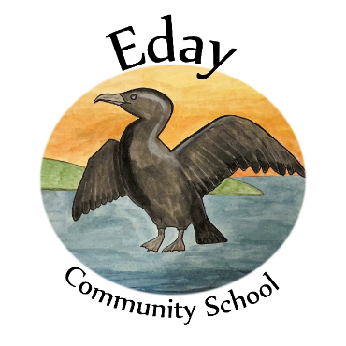
Positive Relationship Policy
Our Values:
Respect Responsibility Resilience
Our Vision:

A welcoming, safe environment for our children to learn and feel happy in. Nurtured by well supported and respected staff who build positive, trusting relationships with families.

Everyone is valued and encouraged to get involved with, feel informed about, and be empowered in engaging with learning.

This document has been written with reference to the recommendations of Promoting Positive Relationships and Behaviour in Educational Settings.

Eday Community School ethos is based on the principles of positive attention to positive behaviour first, as developed by Dix.
What this means in practice is that we publicly praise those children who are doing a good job and following the rules and instructions quickly. Giving that attention encourages all the children to gain that positive attention, rather than getting it through poor choices.

School Rules
Eday School rules are Ready, Respectful, and Safe. These three rules cover the essential areas of expected behaviour for everyone to get the best out of school.
Rules | Teacher responsibilities: |  | Pupil responsibilities:
Ready | - continually assess pupil understanding & adapt teaching to fill each child’s need for challenge and support,  - be prepared for lessons, and  - be ready to adapt lessons according to pupil interests. |  | - come to school with necessary equipment (school, bag, reflective vest, homework, reading book)  - get equipment ready for each lesson, and  - listen for instructions.
Respectful | - communicate calmly,  - celebrate achievements,  - keep behaviour issues private, and  - maintain dignity for all children. |  | - communicate calmly,  - look after each other & our things, and,  - build self-respect through effort and personal achievement.
Safe | - follow all child protection guidelines, and  - ensure risk assessments are in place and followed. |  | - follow safety rules for equipment,  - listen and follow instructions, and  - always look after ourselves & each other.
We will: |  | Because we want to:
- be kind to each other |  | - feel cared for, safe & respected
- be kind to ourselves |  | - feel healthy, happy, & able to learn
- take care of our things |  | - feel responsible & show gratitude
- take care of our school |  | - create a place where we can learn

What matters is: | We know:
- Our Relationships | - we might say or do something hurtful,  - we might talk badly about ourselves,
- Our Rights | - we might be disrespectful,  - we might disrupt learning,
- Our Behaviour | - we might be unsafe, or  - we might cause damage.

However, when this happens, we will:
- focus on repairing our relationships,
- remind ourselves of all the good things we bring to the school,
- take responsibility for ourselves, our actions & making things right,
- use the ‘Solve it Together’ technique,
- accept that we may need help to do this from a peer, adult, or parent, and
- accept that there may be consequences for poor choices beyond a restorative conversation

Because we are and will continue to be:
Responsible Citizens | Effective Contributors
Confident Individuals | Successful Learners

Pupils, parents, staff, and partners were consulted on this policy, which applies to all learners in our community.

