Name: ___________________________________ Date Due: ________________

National 5 Biology (Model 1/2, Qu 1 & Int 2 2004 Qu 7 & Model 3 Qu 3)

S4 Revision Homework 5

Question 1

The diagram below show two unicellular organisms.
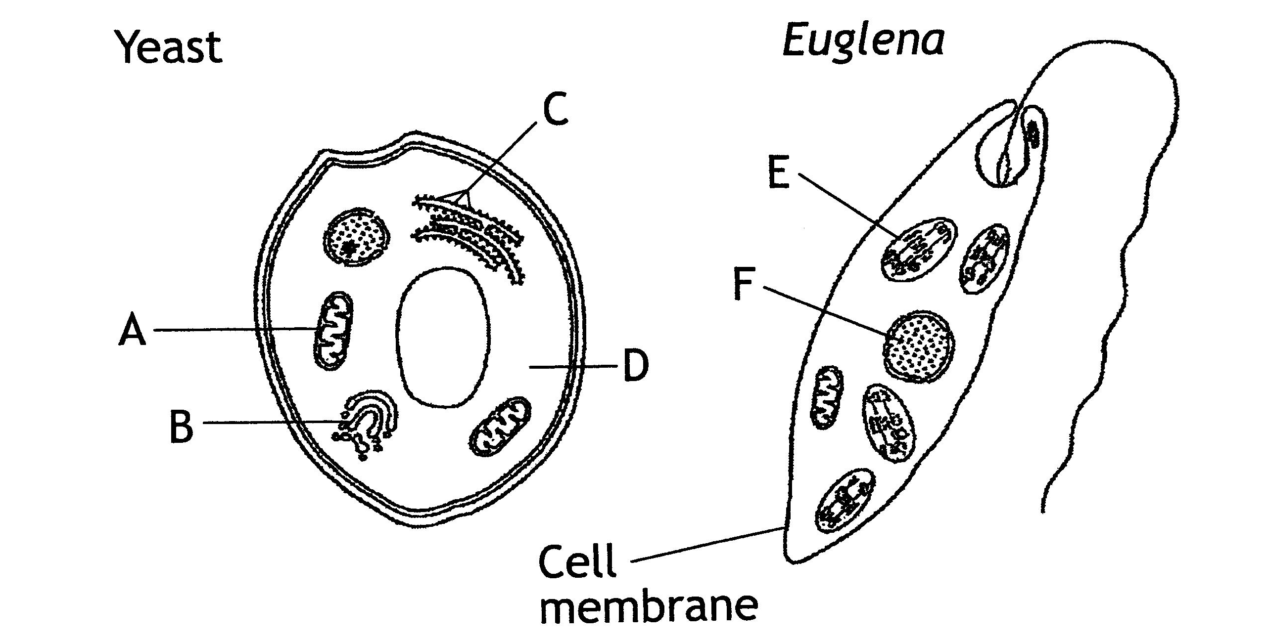

(a) Name the two chemical components of the cell membrane.

________________________________________________________________ (1)

(b) Name a molecule found in structure F which is composed of a sequence of bases.

___________________________ (1)

(c) Choose letters from the diagram to show where each cell process takes place.

Process | Letter
Aerobic respiration
mRNA synthesis
Protein synthesis
Photosynthesis

(4)

Question 2

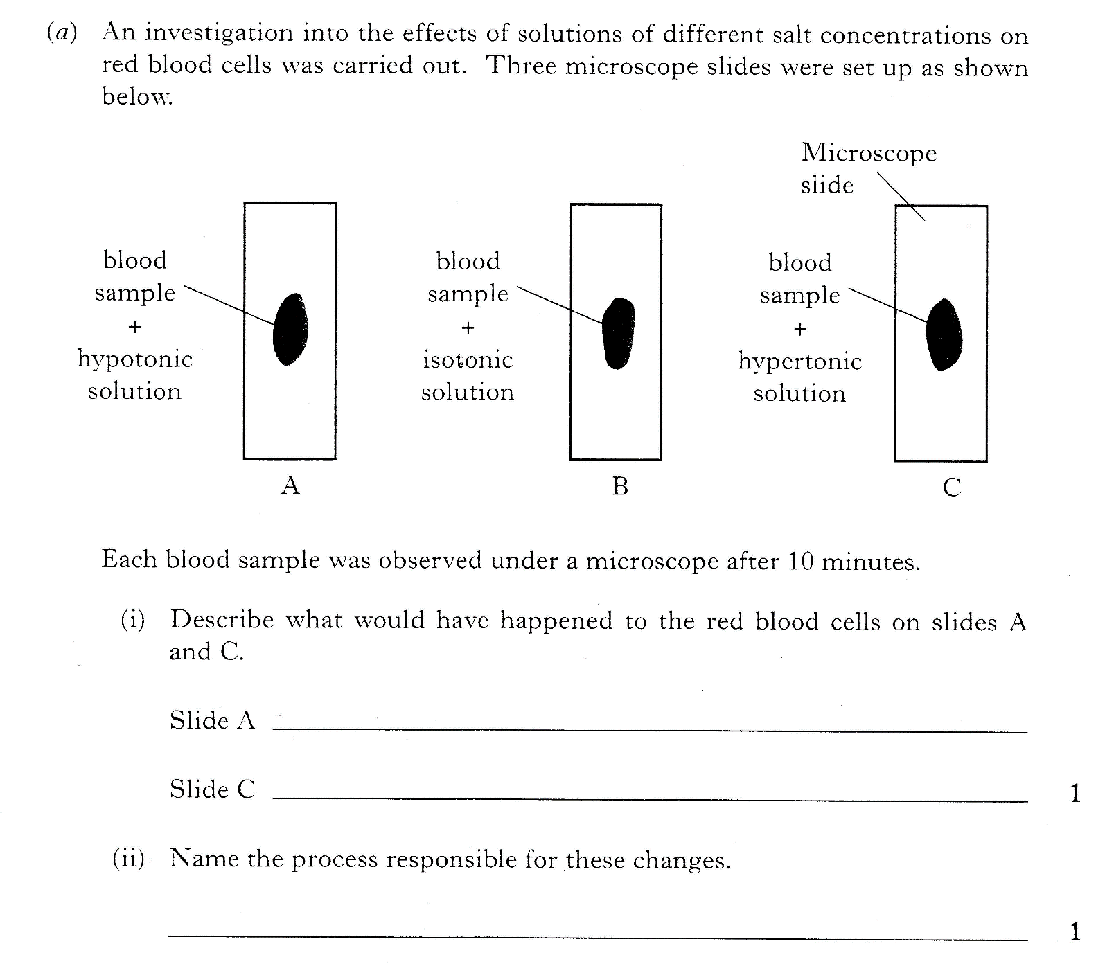
Water
Concentrated salt solution
Dilute salt solution

Question 3

(a) State why enzymes can be described as biological catalysts

________________________________________________________________ (1)

(b) Give one condition which could cause an enzyme to become denatured.

________________________________________________________________ (1)

Question 4

(a) The diagram below represents a bacterial cell.
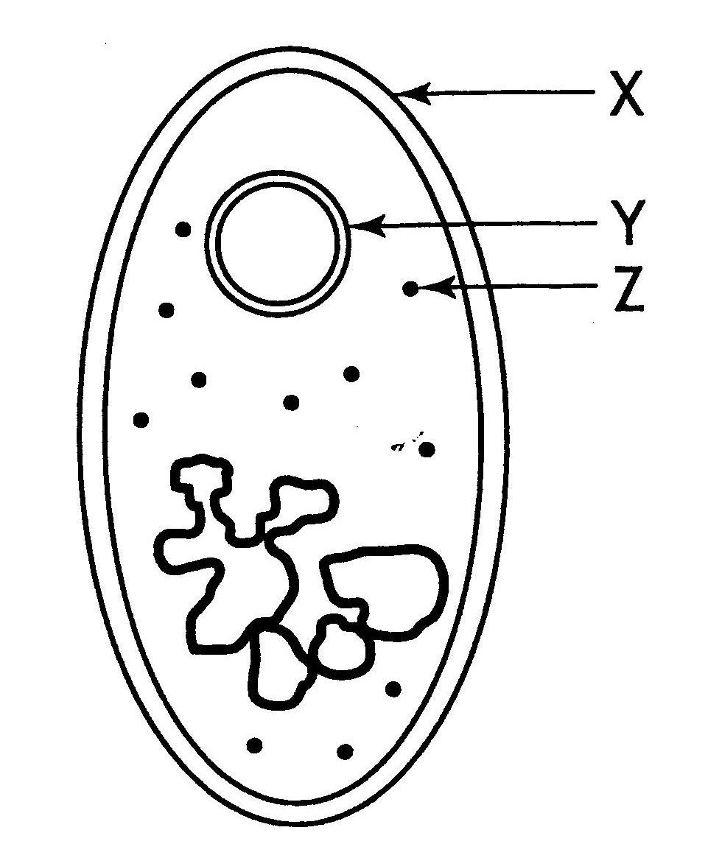

(i) Name the parts labelled X and Y.

X = __________________ Y = _________________ (1)

(ii) Give the function of structure Z.
________________________________________________________________ (1)

(b) Give one difference and one similarity between the structure of a fungal and a bacterial cell.

Difference

________________________________________________________________ (1)

Similarity

________________________________________________________________ (1)

(c) Give one reason why cell production by cell culture requires aseptic techniques.

________________________________________________________________ (1)

15 marks

