Name: ___________________________________ Date Due: ________________

National 5 Biology (Dart 2014, Qus 5 & 2014 Qu 7, 5 & Spec Qu4)

S4 Revision Homework 4

Question 1

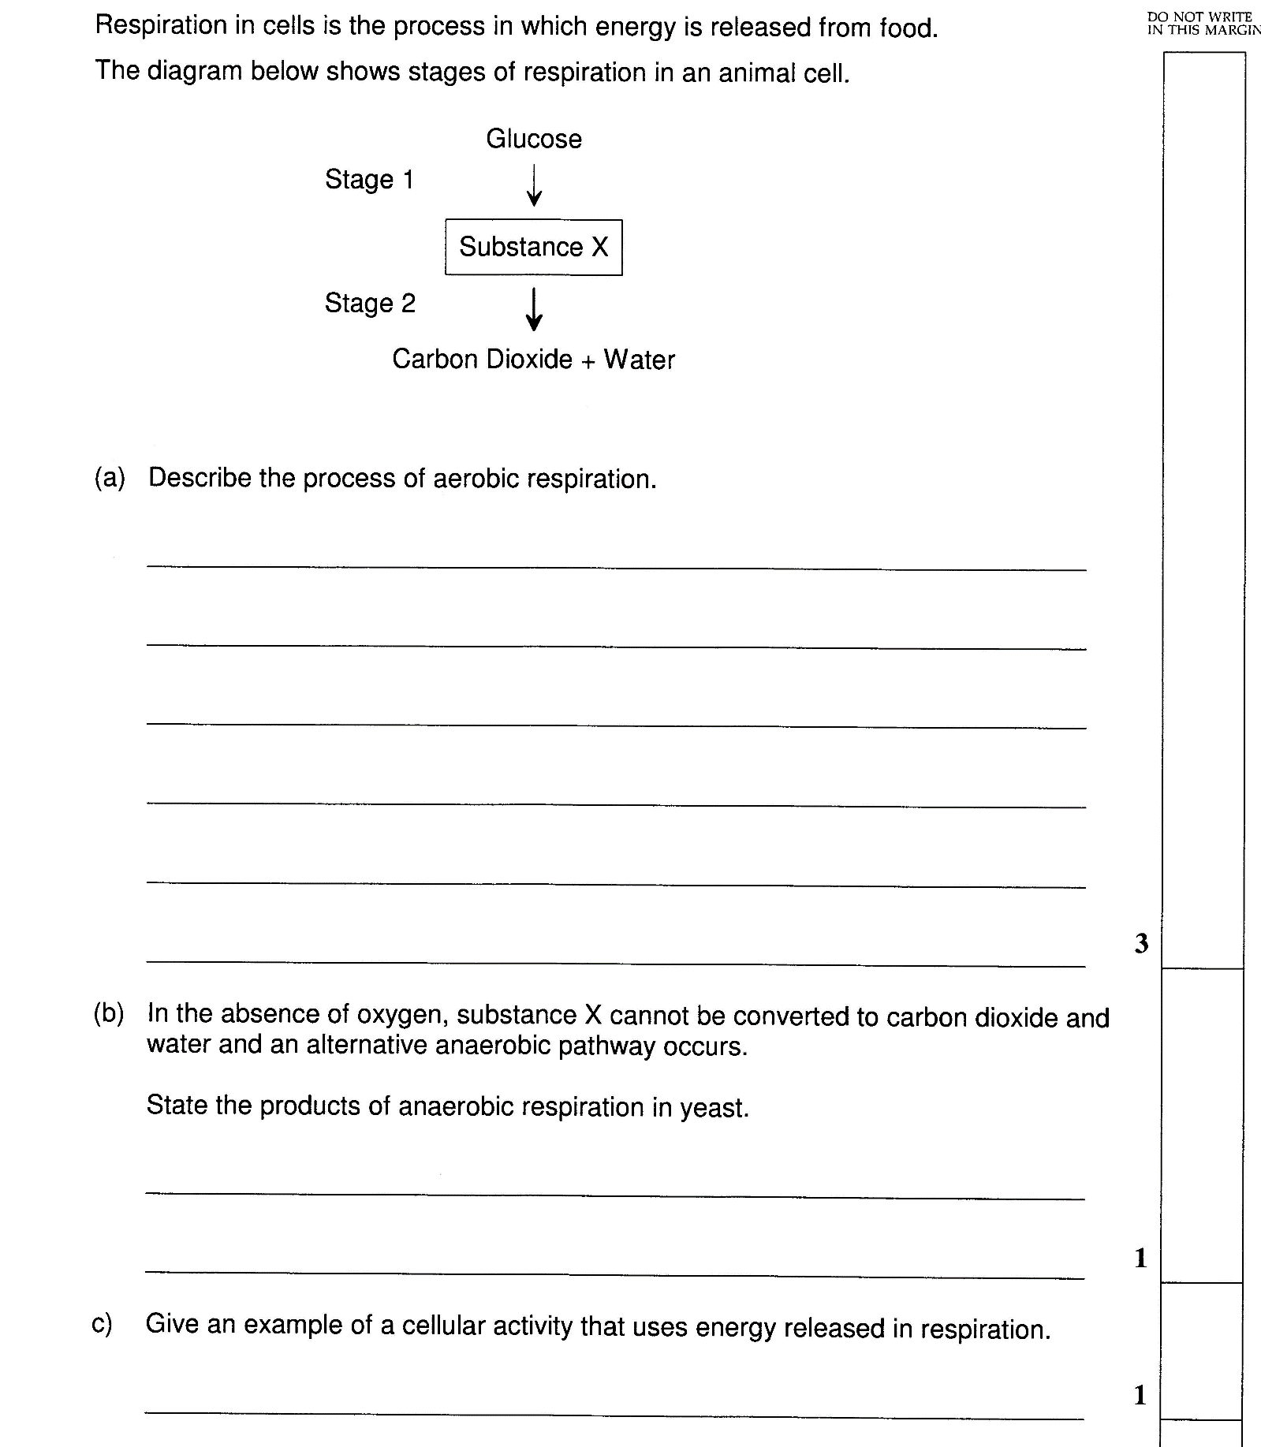
In the absence of oxygen, substance X cannot be converted to carbon dioxide and water and an alternative fermentation pathway occurs
State the products of fermentation in yeast cells.

Question 2
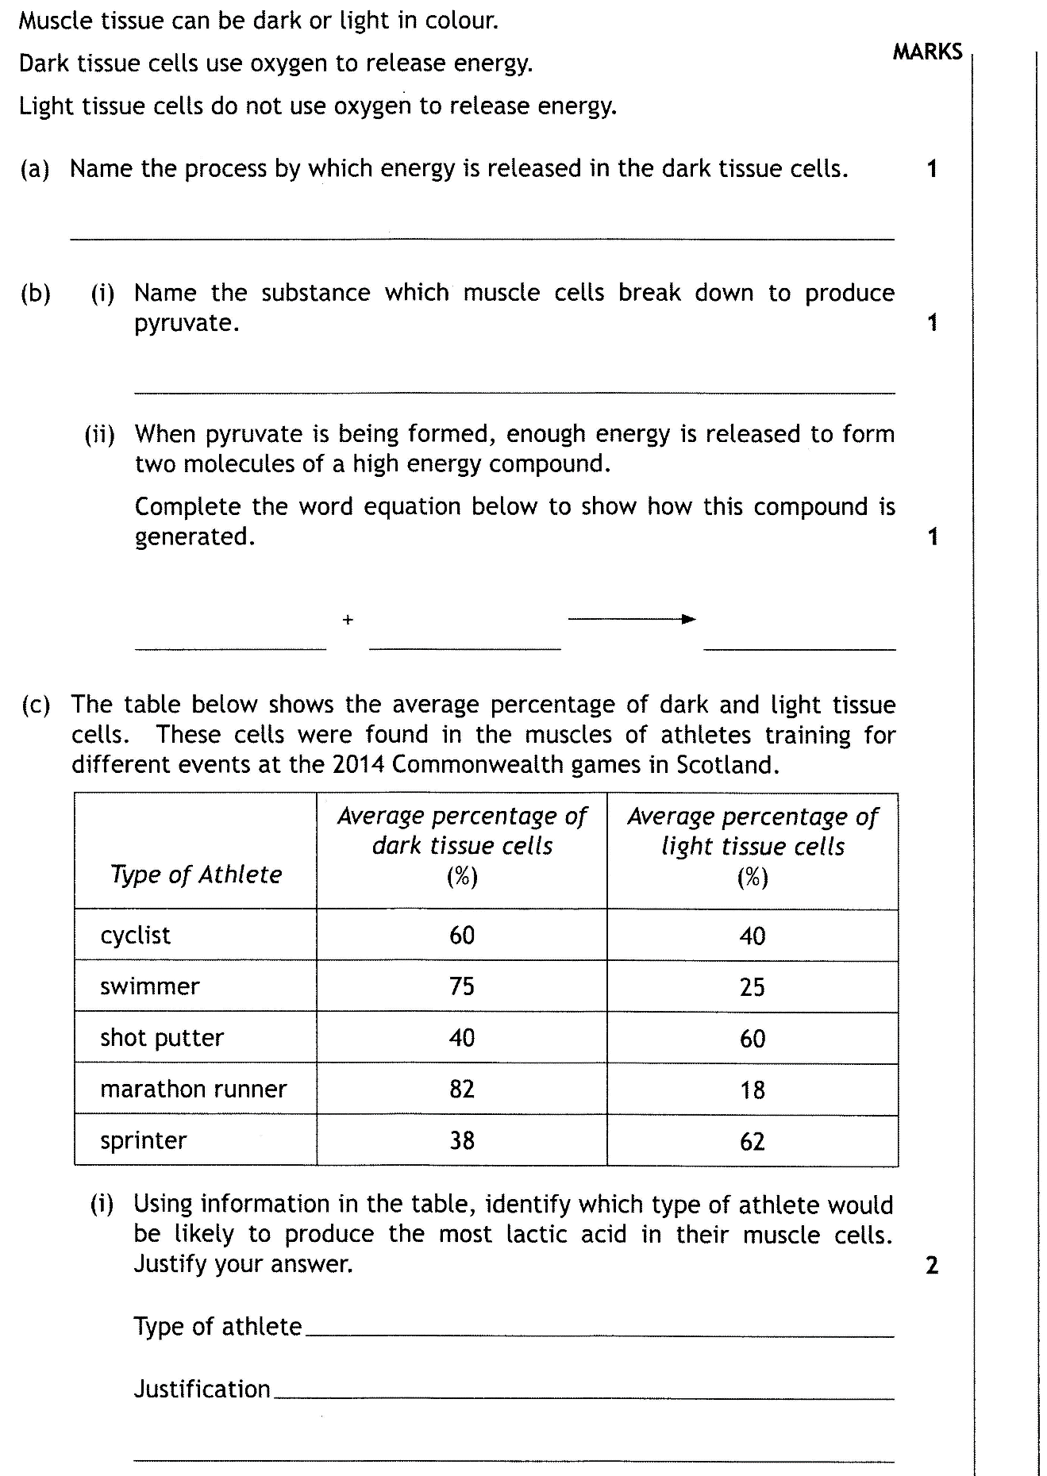
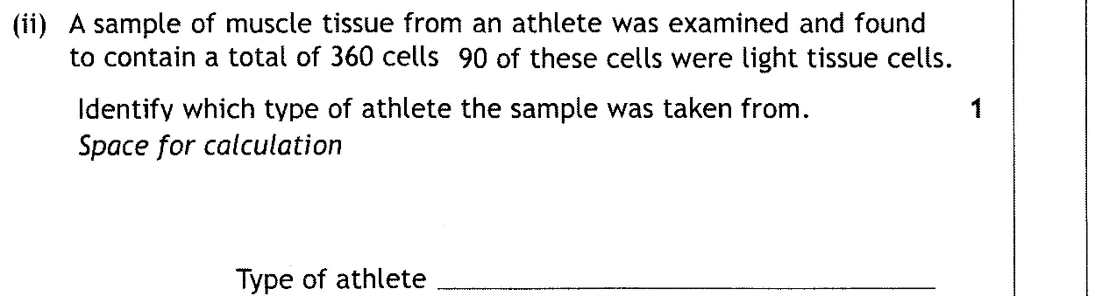

Question 3
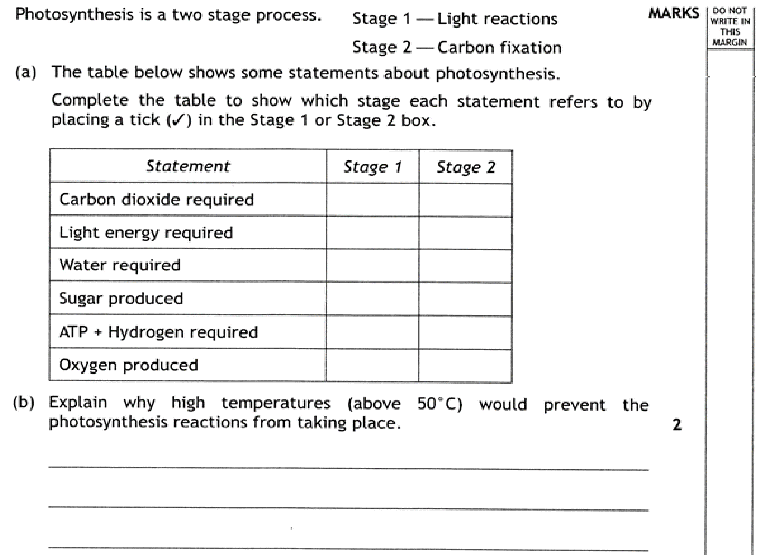

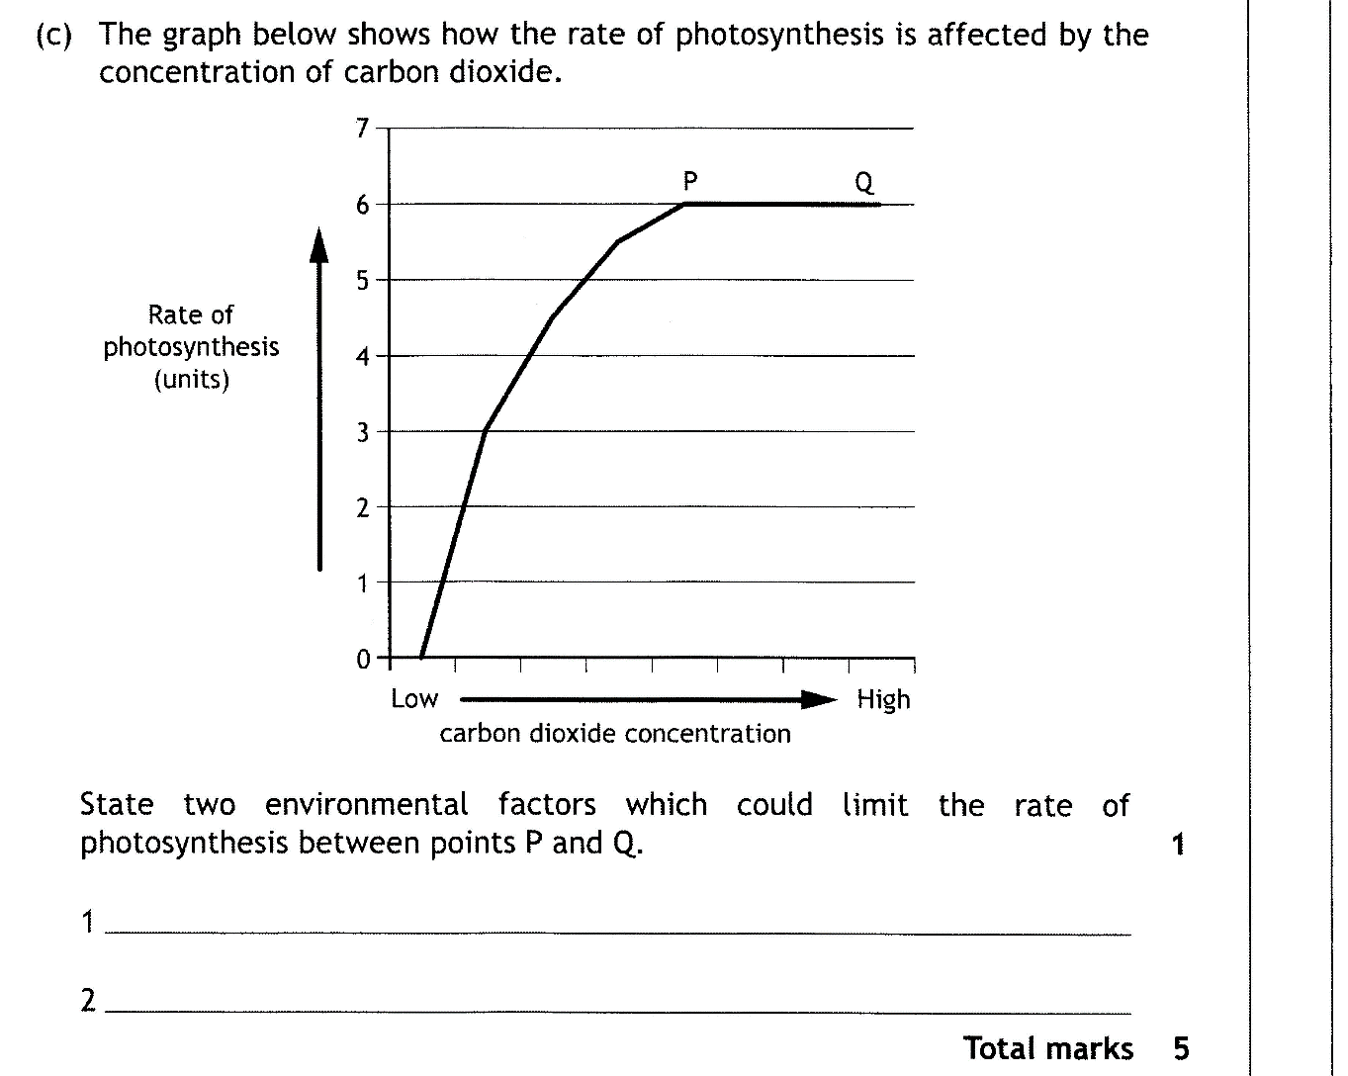
2

Question 4

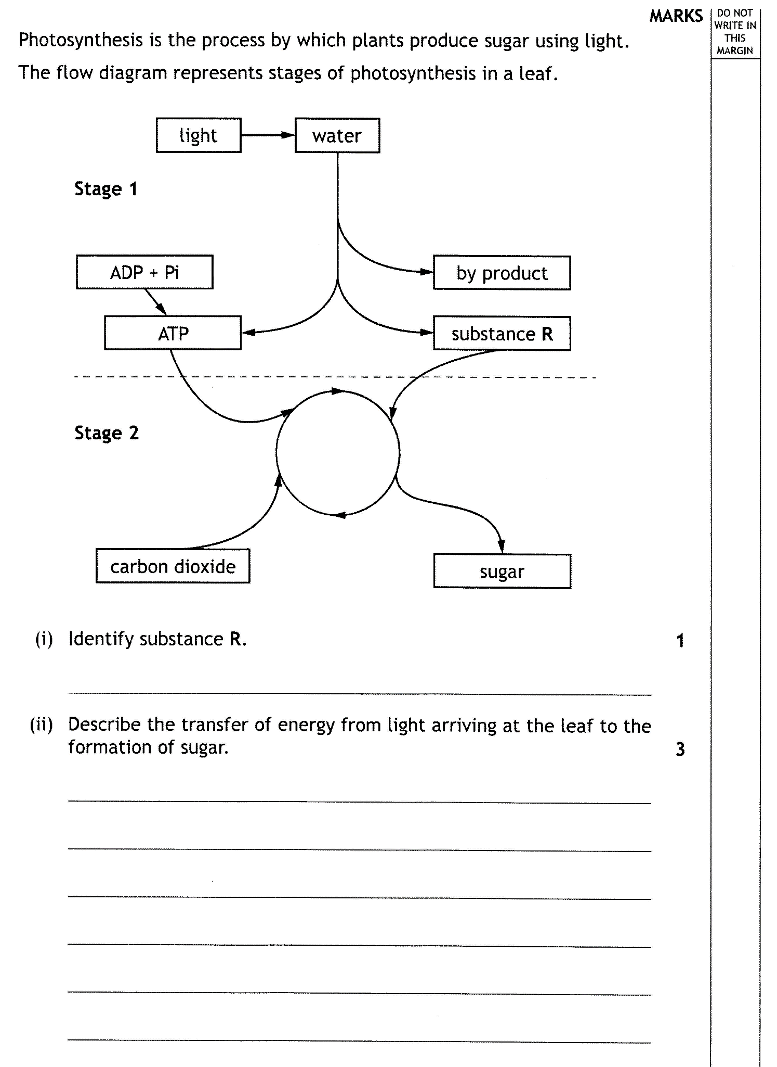

20 marks

