Name: ___________________________________ Date Due: ________________

National 5 Biology (2014, Qus 3 & Spec Qu 3)

S4 Revision Homework 3

Question 1

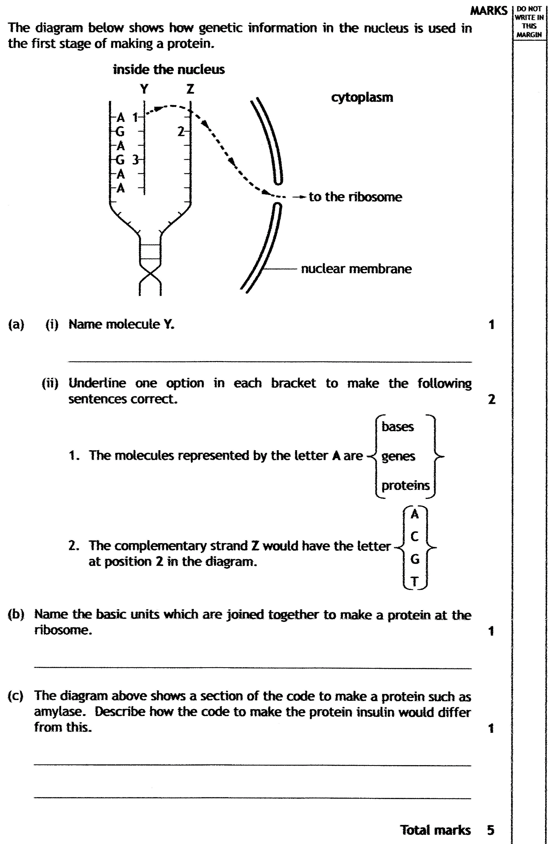
Question 2

