Name: ___________________________________ Date Due: ________________

National 5 Biology (Model Paper 3, Qus 1 & 5)
S4 Revision Homework 2

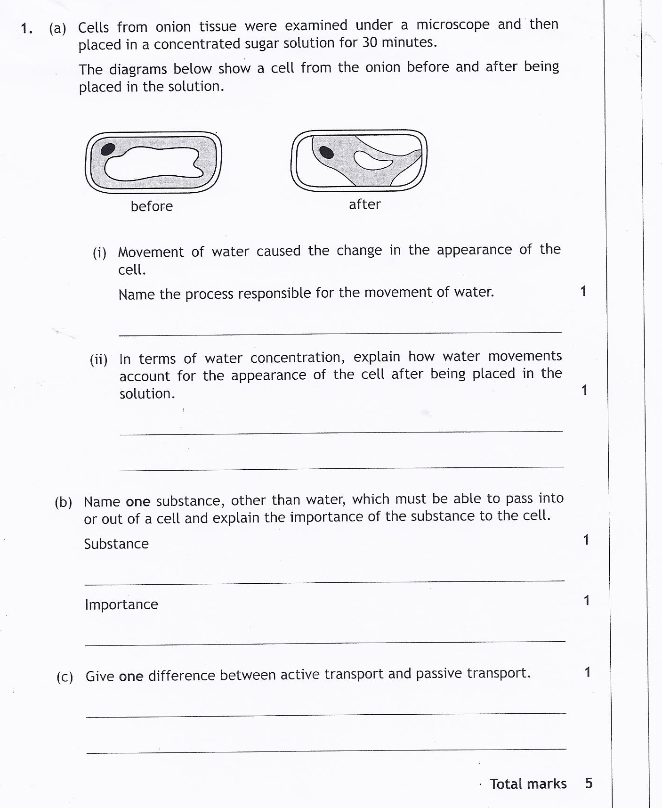
Marks

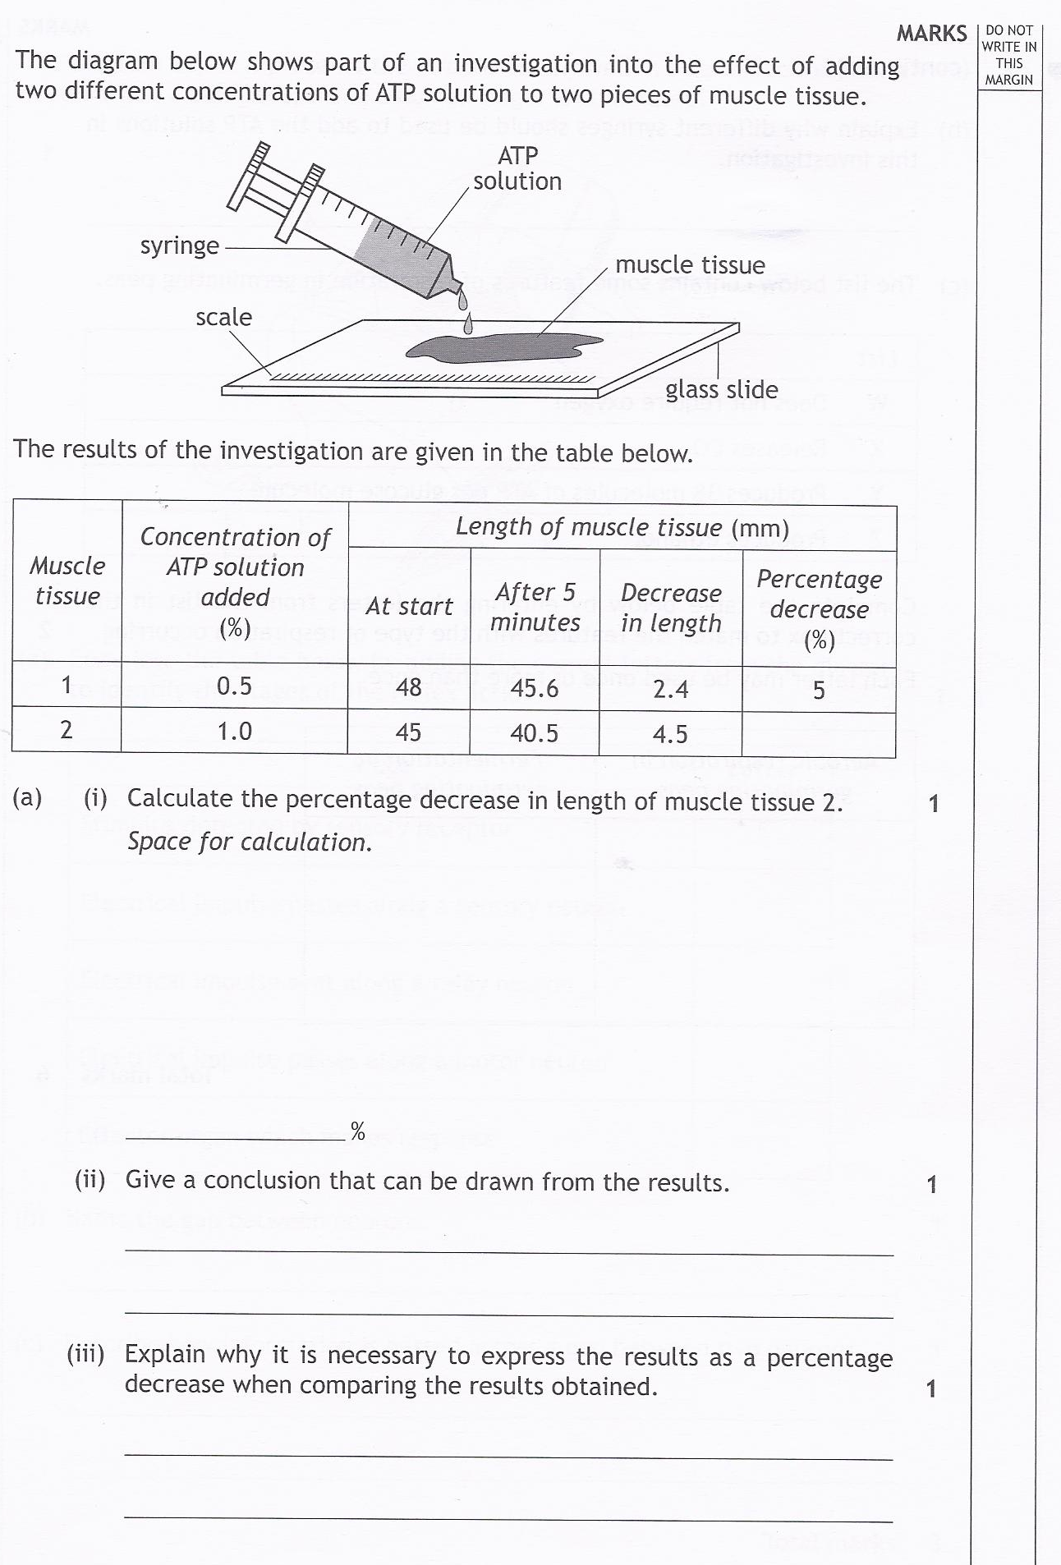
2.

2. (continued)

