Name: ___________________________________ Date Due: ________________

National 5 Biology (Model Paper 2, Qus 3 & 4)
S4 Revision Homework 1

Question 1
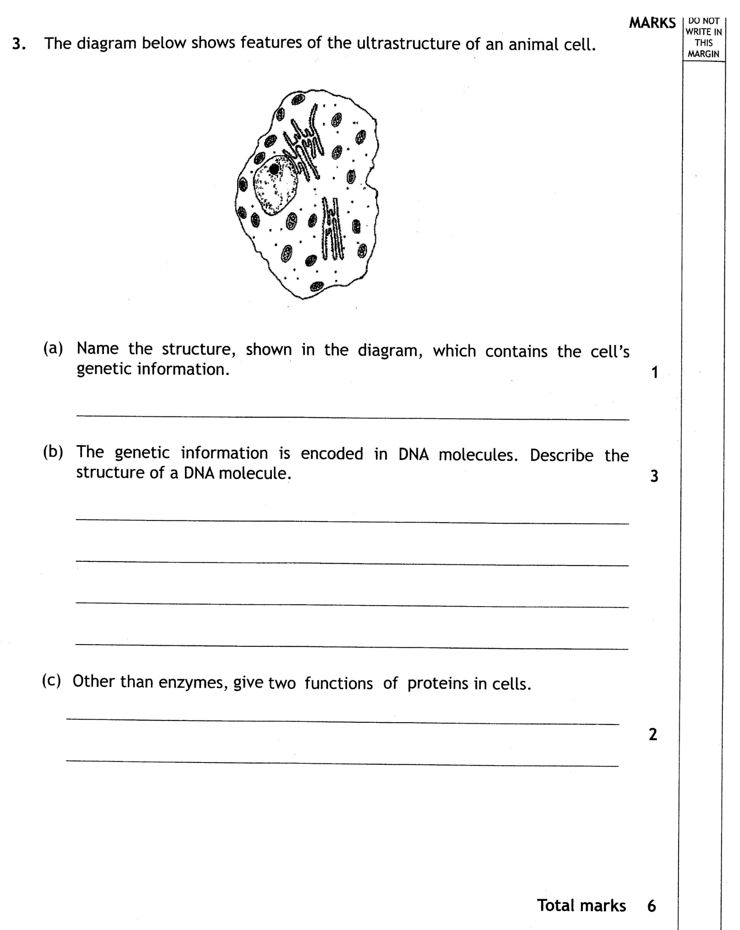

Question 2
