THINKING SKILLS ACROSS LEARNING

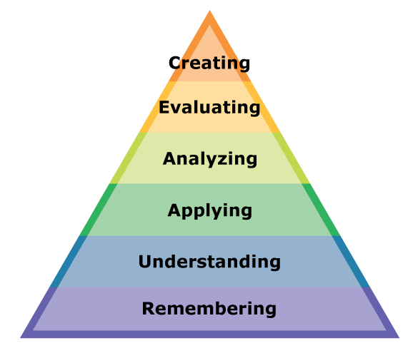

ACTIVE LITERACY ACROSS LEARNING

Prior Knowledge
Metalinguistics
Visualisation
Inference
Main Ideas
Summarising and Paraphrasing

Introduction

The aim of this booklet is to help to develop your skills in reading for meaning. These skills are very important and are a key part of English from S1 – S6.

What will I be asked to do?

Reading for meaning tests how well you can read a passage.

It tests that you can: UNDERSTAND the main ideas, ANALYSE how the writer portrays them and EVALUATE how successful the writer has been in doing so.
It does this by asking you different types of questions about the passage.

- You will be asked to read the passage and answer questions on it.
- You should attempt all questions and not leave any out.
- If you are unsure about any questions make sure you ask your teacher.
- Do not leave the homework until the night before to complete.
- You should answer in full sentences.

Different Types of Questions

You will be asked different types of questions. For example:

- To put something from the passage into your own words.
- To pick out an expression or a phrase from the passage.
- To pick out one word from the passage.
- To comment on the structure of a sentence.
- To comment on the writer’s attitude or tone.
- To identify techniques/figures of speech the writer has used.

Checklist of Questions
In order to answer these questions you must first understand what the question requires you to do. You should refer back to this checklist to remind yourself what different questions require you to do.

- Answer in your own words
In order to answer this type of question you need to go back to the passage and find the correct sentence that you have been asked to put into your own words. Identify key words from the sentence, then try to change these into your own words.

- Pick out an expression or a phrase
This type of question is testing you on two things. Firstly, it is testing your understanding of what an expression is. Secondly, it is testing whether you can pick out the correct expression. An expression or a phrase is a few words taken directly from the passage.

- Pick out one word from the passage
This type of question is again testing you on two things. The first thing is how carefully you have read the question and realise that it is only one word that you have to pick out. The second thing is can you pick out the correct word.

- Comment on the sentence structure
This type of question is asking you to look at how a sentence has been written, not what the sentence means.
The length of the sentences:
Is there one big long sentence? If so, think about why it might be used. It could be used to show the size or length of something or it could show that a lot of things are happening quickly.
Are there lots of short sentences? If so, why have they been used? Sometimes short sentences can be used to create tension or suspense. Or they can be used to show that something is very short and does not take a lot of time.
Punctuation:
Another thing that you have to think about is the punctuation that is used.
The full stop. This is used to show that it is the end of a sentence
This is used to divide words on a list.

The comma, This is used to divide words in a list.

The exclamation mark! This is used to show that someone is speaking
loudly because they are angry, excited,
shocked or happy.
The question mark? This is used to show that a question has been
asked.
Brackets ( )
These are used to give extra information.

Direct speech marks
or quotation marks “ “
These are used to show that someone is speaking or because there is a quotation from someone.

(5) Identify techniques the writer uses
Sometimes you might be asked to pick out or comment on techniques that the writer has used. This type of question is testing how well you can pick out any figures of speech that the writer has used. It might also be looking for you to comment on length of sentences or punctuation.
Figures of Speech
Alliteration: This is when words in a sentence start with the same sound, for example Tetley teabags tingle taste buds. The repetition of the t sound is called alliteration. Often alliteration is used in newspaper headlines to create an eye-catching headline.
Simile: This is when the writer compares two things using like or as, for example ‘The night sky was as black as ink.’
Metaphor: This is when the writer compares two things without using like or as. Instead they just say that the first thing is the second thing. ‘The man was a mountain.’
Onomatopoeia: This is when words imitate the sound they describe, for example: crash, smash, bang, whimper, …
Personification: This is a type of metaphor that makes objects sound as if they are alive. ‘The angry sea swept the boat towards the rocks.’
Repetition: This is simply when the writer repeats a word or phrase. This is usually done to draw attention to something.
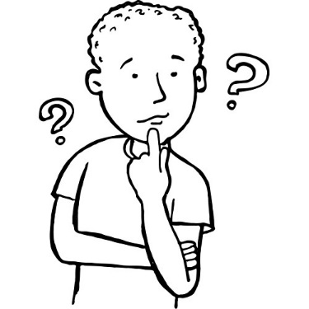
Tone: Sometimes you might be asked to pick out the tone of a passage or of something that someone says. When you are asked about tone, try to imagine someone speaking the lines and the tone of voice they might use: Common tones are: happy, sad, sympathetic, hurtful, doubtful, fearful, sarcastic, humorous, angry, ironic, …

Contents Page

Exercise One: Skellig
Exercise Two: Roll of Thunder Hear my Cry
Exercise Three: Montmorency
Exercise Four: The House on the Hill
Exercise Five: Going Solo
Exercise Six:
The Wonderful World of Henry Sugar
Exercise Seven: Call of the Wild
Exercise Eight:
Mrs Frisby and the Rats of Nimh
Exercise Nine: Flour Babies
Exercise Ten: Whispers in the Graveyard
Exercise Eleven: Holes

Exercise One
Below is an extract from the novel ‘Skellig’. It describes how a boy named Michael and his family move into a new house. Michael goes out to the garage to explore and finds a strange man who seems to have been there for a long time.
I nearly got into the garage that Sunday morning. I took my own torch and shone it in. The outside doors to the back lane must have fallen off years ago and there were dozens of massive planks nailed across the entrance. The timbers holding the roof were rotten and the roof was sagging in. The bits of the floor you could see between the rubbish were full of cracks and holes. The people that took the rubbish out of the house were supposed to take it out of the garage as well, but they took one look at the place and said they wouldn’t go in it even for danger money. There were old chests of drawers and broken wash-basins and bags of cement, ancient doors leaning against the walls, deck chairs with the cloth seats rotted away. Great rolls of rope and cable hung from nails. Heaps of water pipes and great boxes of rusty nails were scattered on the floor. Everything was covered in dust and spiders’ webs. There was mortar that had fallen from the walls. There was a little window in one of the walls but it was filthy and there were rolls of cracked lino standing in front of it. The place stank of rot and dust. Even the bricks were crumbling like they couldn’t bear the weight any more. It was like the whole thing was sick of itself and would collapse in a heap and have to get bulldozed away.

Questions
1. Where does Michael go on Sunday morning? [1]
2. In your own words, describe what the entrance to the garage and the roof looks like. [2]
3. Explain why the garage had not been cleared out. [1]
4. Look at the sentence that begins “There were old chests…” what do you notice about the length of the sentence? Why do you think it has been written like this? [2]
5. Pick out an expression that describes what the garage smelled like. [1]
6a. Write down the expression the writer uses which makes the garage sound as if it has feelings. [1]
6b. Name the figure of speech the writer uses. [1]
7. In your own words, describe what Michael thinks will happen to the garage. [1]
8. Find out the meanings of the following words and write their definitions: timbers, sagging and bulldozed. [3]
9. Use each word in an interesting sentence. [3]

Exercise Two
Below is an extract from the novel ‘Roll of Thunder Hear my Cry’. It describes what life is like for Cassie who is a young black girl living in Mississippi in the 1930s which could be a very dangerous place for Black people because of some racist attitudes.

I started to climb back up into the porch but froze as a caravan of headlights appeared suddenly in the east, coming fast along the rain-soaked road like cats eyes in the night. Jason whined loudly, growing skittish as the lights approached, and when they slowed and braked before the house he slunk beneath the porch. I wanted to follow, but I couldn’t. My legs would not move.
The lead car swung into the muddy driveway and a shadowy figure outlined by the headlight of the car behind him stepped out. The man walked slowly up the drive.
I stopped breathing.
The driver of the next car got out, waiting. The first man stopped and stared at the house for several long moments as if uncertain whether it was the correct destination. The he shook his head, and without a word returned to his car. With a wave of his hand he sent the other driver back inside, and in less that a minute the lead car had backed into the road, its headlights facing the other cars. Each of the cars used the driveway to turn around, then the caravan sped away as swiftly as it had come, its seven pairs of rear lights glowing like distant red embers until they were swallowed from view by the Granger forest.

Questions
1. In the opening sentence the speaker describes seeing ‘…a caravan of headlights…’ In your own words explain what she means by this. [1]
2. Pick out the figure of speech the writer uses in sentence one. [1]
2b. Why is it effective? [2]
3. In your own words, explain how Jason feels when he sees the light approaching . [1]
4. What does Jason do when the cars stop? [1]
5. Look at the last two sentences in Paragraph One. What do you notice about the length of the sentences? Why do you think they have been written like this? [2]
6. The writer describes the man who gets out of the car as being “… a shadowy figure…” Give two reasons why she might describe him like this. [2]
7. Explain why you think the writer has made Paragraph Three so short “I stopped breathing.” [1]
8a. When the cars leave the house the writer describes their lights as “glowing like distant red embers…” Name the figure of speech used. [1]
8b. Why is it effective? [2]
9. Find out the meanings of the following words and write their definitions: skittish, slunk and embers. [3]
10. Use each word in an interesting sentence. [3]

Exercise Three
Below is an extract from the novel ‘Montmorency’. It is set in Victorian London and tells the story of a man who leads a double life; he is a gentleman by day and a thief by night.
From his room, on days when the smoke from London’s chimneys had not curdled the fog into smog, he had a clear view of the enormous green space that was one of the town’s lungs. If he went on to the balcony, he could look down on the chaotic traffic: an undisciplined sprawl of horses, carriages and pedestrians, and then across the road to the calm of the park. In the early morning, shop workers, and even some of the Marimion’s own staff could be seen hurrying along the paths, anxious to get to work, and hardly noticing their surroundings at all. Later, children would play with balls or hoops, and wealthier adults walked at a more leisurely pace. He observed how the men conducted themselves: how they wore their clothes, held their gloves and used their canes. He saw them stop, bow forward slightly and mechanically life their hats when they met an acquaintance coming the other way.

Questions
1a. Why do you notice about the length of the opening sentence? [1]
1b. Why do you think the sentence has been written like this? [1]
2a. Pick out the figure of speech the writer uses in the opening sentence. [1]
2b. Why is it effective? [2]
3. In your own words, describe what he can see if he looks from his balcony. [1]
4. Explain the contrast (differences) in what he sees. [2]
5. Pick out one word that describes how the staff of the Marimion walked to work and one word that describes how the wealthier adults walked? [2]
6. Pick out three things that he notices about how the men behave. [3]
7. Pick out one word which shows that these men are used to behaving a particular way. [1]
8. Find out the meanings of the following words and write their definitions: curdled, smog, sprawl, conducted, mechanically and acquaintance. [6]
9. Use each word in an interesting sentence. [6]

Exercise Four
Below is an extract from ‘The House on the Hill’. It tells the story of two cousins who go to stay with their aunt in her old spooky mansion. They discover a secret room which hides a secret.
Now it was November. Fireworks had their season, wet yellow leaves lay like skin on the pavements of Knightshill, and glistening black trees were everywhere adrip. Each afternoon, fawnish fog slipped up the river, blanketing the low-lying parts of the city, and coiling lazily upwards into Wisteria Avenue. The old Gothic mansions took on the appearance of castles in a ghost story, with their pointed roofs and ornamental turrets wrapped in gauzy scarves of mist. In the garden of The Mount, every tree wept sadly, and Jane took to filling hot-water bottles for the children before she went off to bed.
For Philip and Susan it was a waiting time. Although the light under the door continued to shine, they had no inclination to investigate further. The information in Ewan MacNeil’s letter to Hamish Gilmore, interesting though it was, did not immediately seem to lead to any further discovery. So, as Susan said, there was nothing for it but to wait and see what happened next. But what did happen next was so unexpected, and so upsetting, that it drove all thoughts of eerie rooms and past events from their minds, for a considerable time to come.

Questions
1a. What figure of speech is used in the second sentence? [1]
1b. Why is it effective? [2]
2a. In your own words, describe how the fog moves once the afternoon arrives. [2]
2b. Pick out any two words that describe the movement of the fog. [2]
3a. Explain what each word tells you about how the fog moved. [2]
3b. Describe the overall tone of the first paragraph. [1]
4a. Name the figure of speech used in the sentence that begins “In the garden of The Mount...” [1]
4b. Explain why it is effective. [2]
5a. What do you notice about the length of the sentence at the beginning of the second paragraph? [1]
5b. Why is it effective? [2]
6a. How would you describe the tone that is created by the final sentence? [1]
6b. Pick out two words that help to create the tone. [2]
7. Find out the meanings of the following words and write their definitions: adrip, fawnish, ornamental, gauzy and inclination. [5]
8. Use each word in an interesting sentence. [5]

Exercise Five
Below is an extract from ‘Going Solo’. It is the second part of Roald Dahl’s life story. It tells of his adventures in Africa when he was a young man.
Only once did I see any elephant. I saw a big tusker and his cow and their one baby moving slowly forward in line astern about fifty yards from the road on the edge of the forest. I stopped the car to watch them but I did not get out. The elephants never saw me and I was able to stay gazing at them for quite a while. A great sense of peace and serenity seemed to surround these massive, slow-moving, gentle beasts. Their skin hung loose over their bodies like suits they had inherited from larger ancestors, with the trousers ridiculously baggy. Like the giraffes they were vegetarians and did not have to hunt or kill in order to survive in the jungle, and no other wild beast would ever dare to threaten them. Only the foul humans in the shape of an occasional big-game hunter or an ivory poacher were to be feared, but this small elephant family did not look as though they had yet met any of these horrors. They seemed to be leading a life of absolute contentment

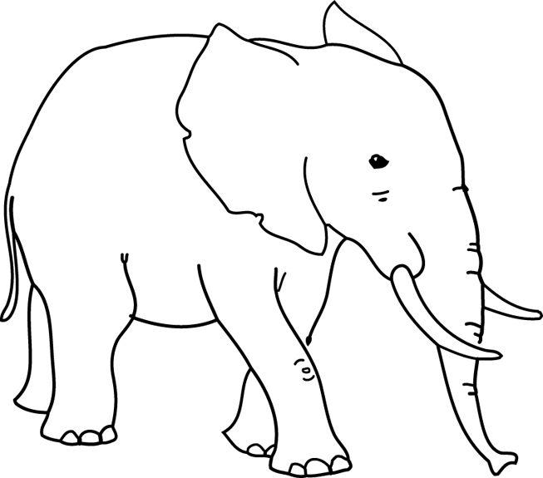

Questions
1. What do you notice about the length of the opening sentence? [1]

2. Why do you think it has been written like this? [1]

3. Why do you think the writer does not get out of the car to watch the elephants? [1]

4. In your own words, describe the feeling that the writer says these animals give off. [1]

5a. Name the figure of speech used to describe their skin. [1]

5b. Explain why it is effective. [2]

6. What do elephants have in common with giraffes? [1]

7. Who is the elephants’ only enemy? [1]

8. What is the writer’s attitude towards the enemy? [1]

9. Pick out one word that conveys his attitude. [1]

10. Find out the meanings of the following words and write their definitions: tusker, astern, serenity and ancestors. [4]

12. Use each word in an interesting sentence. [4]

Exercise Six
Below is an extract from ‘The Wonderful World of Henry Sugar’. It tells the story of a successful businessman who is very self-centred and vain.
Henry Sugar was forty-one years old and unmarried. He was also wealthy. He was wealthy because he had had a rich father who was now dead. He was unmarried because he was too selfish to share any of his money with a wife.
He was six feet two inches tall, but he wasn’t really as good-looking as he thought he was.
He paid a great deal of attention to his clothes. He went to an expensive tailor for his suits, to a shirtmaker for his shirts, and to a bootmaker for his shoes.
He used a costly aftershave lotion on his face, and he kept his hands soft with a cream that contained turtle oil.
His hairdresser trimmed his hair once every ten days, and he always took a manicure at the same time.
His upper front teeth had been capped at incredible expense because the originals had had a rather nasty yellowish tinge. A small mole had been removed from his left cheek by a plastic surgeon.
He drove a Ferrari car which must have cost him about the same as a country cottage.

Questions
1. In your own words, explain why Henry Sugar has so much money and why he has never married. [2]

2. What does he look like? [4]

3. What special ingredient does his hand cream contain? [1]

4. Pick out an expression which emphasises how much money he spends on his teeth. [1]

5. In your own words, explain why he spends so much on his teeth. [1]

6. What is the overall impression you get of Henry Sugar? [2]

7. Find out the meanings of the following words and write the definitions: manicure, capped and tinge. [4]

8. Use each word in an interesting sentence. [4]

Exercise Seven
Below is an extract from ‘Call of the Wild’ which tells the story of a dog called Buck who lives in California and is stolen from his owners by gold diggers to help them find gold and become rich.

And through it all Buck staggered along at the head of the team as in a nightmare. He pulled when he could; when he could no longer pull, he fell down and remained down till blows from whip or club drove him to his feet again. All the stiffness and gloss had gone out of his beautiful furry coat. The hair hung down, limp and draggled, or matted with dried blood where Hal’s club had bruised him. His muscles had wasted away to knotty strings, and the flesh pads had disappeared, so that each rib and every bone in his frame were outlined cleanly through the loose hide that was wrinkled in folds of emptiness. It was heartbreaking, only Buck’s heart was unbreakable. The man in the red sweater had proved that.
As it was with Buck. So it was with his mates. They were perambulating skeletons. There were seven all together, including him. In their very great misery they had become insensible to the bite of the lash or the bruise of the club. The pain of the beating was dull and distant, just as the things their eyes saw and their ears heard seemed dull and distant. They were not half living, or quarter living. They were simply so many bags of bones in which sparks of life fluttered down in the traces like dead dogs, and the spark dimmed and paled and seemed to go out.

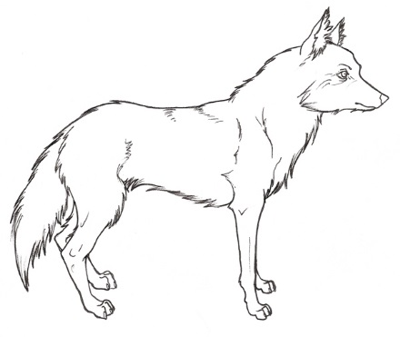

Questions

1. Why do you think the writer says that Buck ‘staggered’ along the
Road? [2]

2. Pick out an expression that reveals how exhausted he was. [1]

3. In your own words, explain what it was that made him get back up again. [2]

4. In what ways had Buck’s appearance changed? Answer in your own words. [2]

5. Look at the sentence that begins “His muscles had wasted away…” What do you notice about the length of the sentence? Why do you think is has been written like this? [2]

6. Look at the sentences “As it was with Buck. So it was with his mates.” How do these sentences link the first and second paragraphs together? [2]

7. Pick out one expression which emphasises how thin the dogs were. [1]

8a. Look at the sentence that begins “The pain of the beating…” What figure of speech does the writer use? [1]

8b. Why is it effective? [2]

9. What is the overall tone of the passage? [1]

10. Find out the meanings of the following words: draggled, knotty perambulating and insensible. [4]

11. Use each word in an interesting sentence. [4]

Exercise Eight
Below is an extract from ‘Mrs Frisby and the Rats of Nimh’ which tells the story of Mrs Frisby and her family. Their nest is about to be ploughed over by the farmer so she seeks advice from an owl who tells her to ask the rats of Nimh for help.
She might, she thought, go back to Mr Ages and see if he had any ideas that would help. Was there some medicine that would make Timothy get strong sooner? She doubted it; surely if he had such medicine he would have given it to her the first time. She was thinking about this when she climbed out through the knot hole and slithered to the ground below – not ten feet from the cat.
Dragon lay stretched out in the sunlight, but he was not asleep. His head was up and his yellow eyes were open, staring in her direction. She gasped in terror and whirled around the fence post to put it between her and him. Then, without pausing, she set out on a dash across the garden as fast as she could run, expecting at any instant to hear the cat’s scream and feel his great claws on her back. She reached the shrew’s hole and considered for a fraction of a second diving into it, but it was too small.
Then she glanced back over her shoulder and saw an amazing sight. The cat had not moved at all! He was lying exactly as before, except that now one of his eyes was closed. The other, however, was still looking straight at her, so she did not pause, but raced on.
Finally when she was a safe distance away – two-thirds across the garden and nearly home – she stopped and looked again more carefully. The cat still lay there and seemed to have gone to sleep. That was so odd – so unheard of – she could hardly believe it. Feeling quite safe, but puzzled, she looked for a vantage point from which she could see better. By rights, she should be dead, and though she had escaped by what seemed almost a miracle, she scolded herself for having been so careless. If the cat had killed her, who would take care of her children?

Questions

1. What is the main thing on Mrs Frisby’s mind when she leaves her home? [1]
2. The writer says that she ‘slithered’ to the ground. Why is this a good word to use to describe her movements? [1]

3. Pick out an expression which shows Mrs Frisby’s surprise at seeing Dragon the cat. [1]

4. Pick out one word that writer uses to describe the speed of Mrs Frisby. [1]

5. Why does Mrs Frisby not jump into the shrew’s hole? [1]

6. Look at the third paragraph that beings “Finally when she was a safe distance away…” Name the punctuation used and explain why you think it is effective. [2]

7. It says that Mrs Frisby looked for a ‘vantage point’. In your own words explain what this means. How did the paragraph help you to arrive at the meaning? [2]

8. Find out the meanings of the following words and write their definitions: slithered, whirled and vantage point. [3]

9. Use each word in an interesting sentence. [3]

Exercise Nine
Below is an extract from a novel called ‘The Flour Babies’. It tells the story of a boy called Simon Martin who becomes involved in a project looking after imaginary babies made from bags of flour.
The place he chose was a bush a few yards behind the one goal still flooded in sunlight. He thrust the flour baby into the rather meagre greenery, desperately hoping she would appear to be no more than a bundle of towel to the circle of his team mates already booting the ball to one another in the warm-up. Mr Fuller was watching him dangerously, arms folded, from the side of the pitch. But still Simon took his time, wedging the flour baby firmly into the bush. Mr Fuller was the least of his problems. At least now the snoopers couldn’t pick on him. She was there, in sight, and she was clean and safe. Mr Fuller could punish him for being late by giving him fifty press-ups. But if Simon got thrown off the flour baby project, he might miss The Glorious Explosion.
And it was going to be brilliant. That much he knew. Once or twice since Mr Cartwright dealt out the flour babies, Simon had suffered moments of doubt. It struck him that he might somehow have misheard the conversation in the staffroom, or missed the point. And even if he hadn’t, one question still remained to be answered. Was the whole business worth it? After all, it wasn’t generally Simon’s way to stick at a project for the length of a lesson, let alone for a whole three weeks. Would any – Could any explosion Mr Cartwright had to offer be worth the grind of dragging this flour baby around, keeping her clean, for twenty-one days of his life?

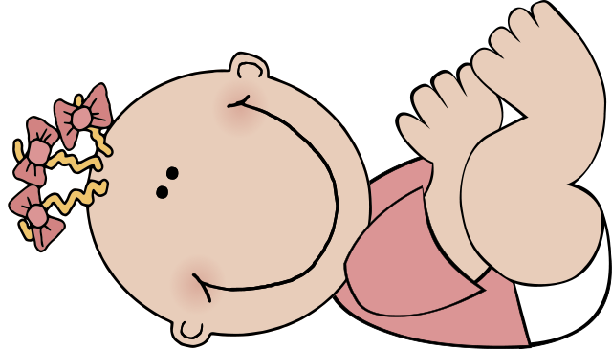

Questions

1. Why does Simon stand next to the bush at the beginning of the passage? [1]
2. The writer says that “He thrust the flour baby into ...greenery.” Why do you think the writer chooses to use the word “thrust”? [2]
3. In your own words, explain why Simon is not too concerned about the fact that his football coach is watching him do this? [2]

4. Why does Simon not want to be thrown off the project? [1]

5. Look at the opening sentence of Paragraph Two. Why does the writer put the word brilliant in italics? [1]

6. How does this sentence act as a link in the passage? [1]

7a. In your own words describe what the Flour Baby Project is. [1]

7b. What do you think the purpose of this experiment is? [1]

8. Find out the meanings of the following words and write the definitions: meagre, snoopers and misheard. [3]

9. Write each word in an interesting sentence of your own. [3]

Exercise Ten
Below is an extract from a novel called ‘Whispers in the Graveyard’. It tells the story of a boy called Solomon who discovers a sinister secret in his local graveyard.
It’s almost midnight when I get home. He’s flaked out on the couch, mouth open. The telly’s talking loudly to itself. I pause before drawing the curtains over.
The world news. Images of starving children and warring adults are reflected on my window panes. The lights in the street beyond and the houses opposite are ghostly shadows. Are the pictures which I see captured on the glass a distortion or for real? I shut the blinds and they disappear.
When I was younger I thought that the people on the telly were actually there. Then at night when the set was turned off, they got smaller and smaller, and slid down the cables all the way to London or wherever. In Primary Five the teacher explained to the class how television worked. I remember thinking that my idea was more sensible.
I try not to look at him lying there like a felled tree, jaw slack, face worn and stubbly. I throw a travelling rug over him and go through to the kitchen.
I just leave the mess. I don’t have the energy to clear up this war zone. I find some bread and make myself a sandwich and go upstairs.
As I take my jeans off I find the notice which I took from the graveyard earlier. I spread out the crumpled paper on the floor and peer at it closely. It’s too difficult for me to work out what it says. I’ve a problem with print for as long as I can remember. From the very first reading book I ever had.

Questions
1a. Look closely at the paragraph one. What do you notice about the length of the sentences? [1]
1b. Why do you think they have been written like this? [2]
2. In your own words, describe what Solomon’s father is doing when he returns home. [1]
3. Pick out an expression which shows that Solomon finds his street quite frightening. [1]
4. How did Solomon think television worked when he was younger? [1]
5. Pick out an example of informal language in paragraph three. [1]
6a. Look at paragraph three. “I try not to look at him...” Name the figure of speech Solomon uses to describe his father’s appearance. [2]
6b. Why is it a good description of his father? [2]
7. When Solomon goes upstairs he tries to read a notice but says he has difficulty doing so. What do you think his problem might be? [1]
8. Find out the meanings of the following words and write their definitions: captured, distortion, sensible and slack. [4]
9. Use each word in an interesting sentence. [4]

Exercise Eleven
Below is an extract from ‘Holes’. It tells the story of Stanley Velnats whose punishment is to dig hole after hole in the burning desert at a juvenile detention centre. As his story unfolds, so does that of his ancestors. Will Stanley be able to dig up the truth before he falls victim to the family curse?
The sun was almost directly overhead. He figured he could walk for no more than another hour, maybe two, before he had to turn back.
It seemed pointless. He could see there was nothing ahead of him. Nothing but emptiness. He was hot, tired, hungry, and, most of all, thirsty. Maybe he should just turn around now. Maybe he’d already gone halfway and didn’t know it.
Then, looking around, he saw a pool of water less than a hundred yards away from where he was standing. He closed his eyes and opened them to make sure he wasn’t imagining it. The pool was still there.
He hurried toward it. The pool hurried away from him, moving as he moved, stopping when he stopped.
There wasn’t any water. It was a mirage caused by the shimmering waves of heat rising off the dry ground.
He kept walking. He still carried the empty sack of sunflower seeds. He didn’t know if he might find something to put in it.
After a while he thought he could make out the shape of the mountains through the haze. At first he wasn’t sure if this was another kind of mirage, but the farther he walked, the clearer they came into a view. Almost straight ahead of him, he could see what looked like a fist, with its thumb sticking up.

Questions
1a. Look at the second paragraph “It seemed pointless…” What do you notice about the length of the sentences? [1]
1b. Why do you think they have been written like this? [1]
2a. Look at the last two sentences of paragraph two. Pick out one word that the writer repeats. [1]
2b. Why do you think it is repeated? [1]
3. Why does Stanley close his eyes in paragraph three? [1]
4. In your own words explain what a ‘mirage’ is. [1]
5a. Name the figure of speech used to describe the heat. [1]
5b. Why is it effective? [2]
6. Look at paragraph six “He kept walking…” Why do you think he chooses to start every sentence with the word “He”? [1]
7a. Look at the sentence in the last paragraph that begins “At first he wasn’t sure if this was another mirage…”. What do you notice about the length of the sentence? [1]
7b. Why do you think it has been written like this? [1]
8. Find out the meanings of the following words and write their definitions: mirage, shimmering and haze. [3]
9. Use each word in an interesting sentence. [3]

