St Ambrose High School



S1 English

Knowledge
About
Language

We can understand K.A.L .

Nouns

A noun is the name of any person, place, animal or thing.

1. Proper Nouns
A proper noun is the name of a particular person, animal, place or thing.
Proper nouns always have a capital letter.
For example: Lassie Coatbridge Celtic

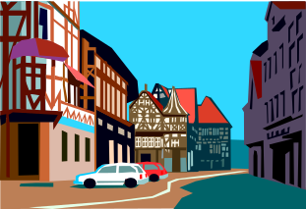
Task
There are 10 proper nouns in the box.
Write them correctly in the blank spaces
below.

kiera knightley ship box paris flu japan bicycle
dog glasgow edinburgh castle glass rover cage
rangers computers grass world cup madonna
sunshine coffee buttons queen elizabeth pizza

____________________ _____________________
____________________ _____________________
____________________ _____________________
____________________ _____________________
____________________ _____________________
2. Collective Nouns

A collective noun is a noun that groups things together.
For example: a herd of cows
a choir of angels

Task
Here is a list of collective nouns.
Write the correct noun from the box in the blank spaces.

flowers players books sailors bees soldiers

- an army of __________________

- a team of ___________________
- a crew of ___________________
- a library of __________________
- a swarm of __________________
- a bouquet of __________________

Choose a collective noun from the box to go with each of the groups in the list below.

class warehouse orchard pack hanger basket

- a ________________ of apple trees.
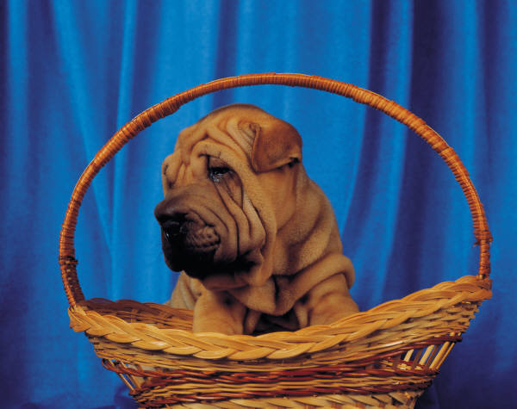
- a ________________ of puppies
- a ________________ of furniture
- a ________________ of wolves
- a ________________ of pupils
- a ________________ of aeroplanes

3. Abstract Nouns
Abstract nouns are the words for all feelings, thoughts and ideas. They are things that you cannot see, touch or hear.

For example: sadness anger friendliness

Task
You can make some abstract nouns by adding the letters ‘-ness’ to the end of a word.
For example; happy - happiness

Make the following into abstract nouns by adding ‘-ness’

1. kind - __________________
2. short - __________________
3. sad - __________________
4. smooth - __________________
5. cold - __________________
6. clever - __________________

Complete the sentences below by using one of the abstract nouns from the box.
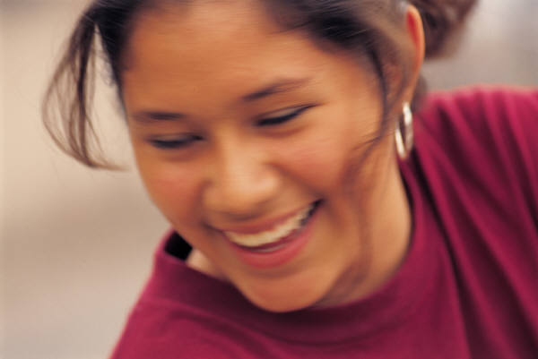
1. The thief was accused of _______________________
2. The hero was known for his ______________________
3. The diamond ring was well known for its _______________
4. The footballer was famous for his ______________
5. The teacher praised the pupil for his __________________
6. Foxes are famous for their _____________________

beauty cleverness skill cunning dishonesty courage
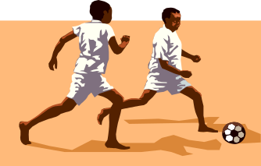

Adjectives

An adjective is a word that we use to describe a noun.
For example: a stormy sea a thin man an angry dog

Task
Underline the adjectives in the sentences below.
The first has been done as an example.

- The sky was blue and there were fluffy, white clouds.
- The dazzling sun shone in the bright sky.
- The sea was grey and enormous waves shook the tiny ship.
- The fields were green with the new grass in early spring.
- Tall trees and thick hedges surrounded the ruined castle.
- Heavy rain fell on the dark, shining streets in the old town.
- The elegant woman wore high heels and a smart designer suit.
- Billy was a dreadful child – wild, cunning and dangerous.
- The Queen’s necklace had dark red rubies and dazzling diamonds.
- The 1970s school was in a bad state with rotting window frames and dull, depressing corridors.

Write 3 short sentences about this picture.
Each sentence must have an adjective in it.
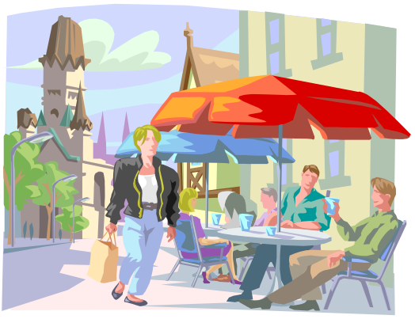
_________________________________________________________________________________
___________________________
___________________________
___________________________

Comparative Adjectives

We use these adjectives to compare two people or things.

For example: Jimmy is taller than John.

There are 2 ways of turning an adjective into a comparative:
- Add the letters ‘–er’ to the end.
For example: tall – taller.
- Put the word ‘more’ in front of the adjective.
For example: interesting – more interesting

Task
Write the comparative of the adjectives below. You will have to either add ‘–er’ to the end or put ‘more’ in front.

Hard _____________________
Small _____________________
Loud _____________________
Cool _____________________

Kind _____________________
Smooth _____________________
Few _____________________
Fast _____________________
New _____________________
Old _____________________
Modern _____________________
Different _____________________
Helpful _____________________
Important _____________________
Popular _____________________
Beautiful _____________________
Relaxed _____________________
Superlative of Adjectives

The superlative adjective is used to compare one thing with all other things.

For example: John is tall but James is the tallest in the class.
Mary is thin, but Margaret is the thinnest person.

There are 2 ways to make the superlative of an adjective.
1. Add the letters ‘-est’ to the adjective.
For example: small - smallest
2. Put the word ‘most’ in front of the adjective.
For example: beautiful - most beautiful

Task
Write the comparative of the adjectives below. You will have to either add ‘–est’ to the end or put ‘most’ in front.

Fast ______________________

Old ______________________
Big ______________________
Loud ______________________
New ______________________
Hard ______________________
Small ______________________
Kind ______________________
Cool ______________________
Few ______________________
Popular ______________________
Helpful ______________________
Modern ______________________
Different ______________________
Important ______________________
Relaxed ______________________
Double Comparatives and Double Superlatives

Double comparatives are, for example ‘more bigger’, ‘more better.’
Double superlatives are, for example ‘most cleverest’, ‘most nicest’.

If you use a double comparative or a double superlative it is like saying the same thing twice.
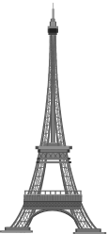
Task
Tick the correct sentence in each pair of sentences below.

- The Eiffel Tower is the most tallest building in Paris.
The Eiffel Tower is the tallest building in Paris.
- Mary is cleverer than John.
Mary is more cleverer than John.
- Coke is a tastier soft drink than Irn Bru.
Coke is a more tastier soft drink than Irn Bru.
- My teacher is the kindest person in the school.
My teacher is the most kindest person in the school.
- Windows 95 is a more older Windows programs.
Windows 95 is an older Windows programs.
- Mice are some of the smallest mammals in the world.
Mice are some of the most smallest mammals in the world.
- Butterflies are the most loveliest insects.
Butterflies are the loveliest insects.

- Wayne Rooney is the best footballer on the planet.
Wayne Rooney is the most best footballer on the planet.
The Auxiliary Verb
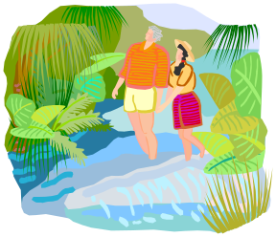
A verb is a word that tells you what someone did.
For example: Ted walked through the park.

Some verbs are made up of more than one word.
For example: Jane was walking with Ted.

The extra word is called an auxiliary (helping) verb because it helps us to know more clearly what happened.

Task
Choose the correct auxiliary verb from the box to complete the sentences below.

- We _________ all talking at once.
- You ________ able to work alone.
- The girls ________ come to see you.
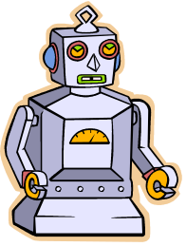
- I _____ not have to do the dishes.
- They ________ stay as long as they liked.
- I _________ not go to the club to-morrow.
- We ________ watch television tonight.
- I ______ not seen the film before.
- They __________ always be on time.
- We ________ not be late for school again.
- I _______ thinking about school.
- They _________ play chess if they knew how.

will could are would had do

should am might were have can

Changing the Tense of the Verb (1)
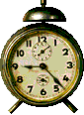
Tense means to do with time.

The tense of a verb tells you when the thing happened
– now, in the past or in the future.

Examples | When it happened | Tense of the Verb
I am going to  school. | This is happening now. | Present Tense
I went to school. | This happened in the  past. | Past Tense
I will go to school. | This will happen in the future. | Future Tense.

Task
The sentences below are all in the present tense.
Write them out again below, changing the verb to the past tense.

- My baby brother cries all night.
________________________________________________
- John swims for the school team.
________________________________________________
- I feel sick because I eat too much.
________________________________________________
- My parents tell me off when I come home late.
________________________________________________
- Jim plays for Stirling Albion.
________________________________________________

Changing the Tense of the Verb (2)

Task
The sentences below are all in the past tense.
Write them out again below, changing the verb to the present tense.

- My mates went to the disco.
_____________________________________________
- The train to Manchester left the platform on time.
_____________________________________________
- The Queen visited the town and waved to the people.
_____________________________________________
- The mechanic repaired the car and drove it outside.
______________________________________________

Task
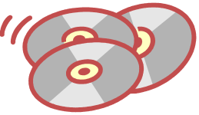
The sentences below are all in the future tense.
Write them out again below, changing the verb
to the present tense.

- I will go outside to get some fresh air.
______________________________________________
- We will buy the newest CDs when we have enough money.
______________________________________________
- The dog at Number 14 will bark when it hears us coming.
______________________________________________
- The library will stay open until eight o’clock tonight.
______________________________________________
Nouns that Change Places with Verbs
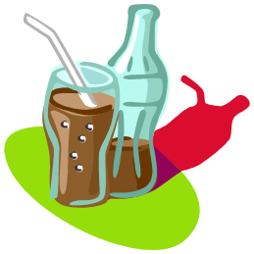
Some words can be used as a noun or as a verb.

For example: drink
Coke is a fizzy drink. (noun)
We don’t want to drink Coke any more. (verb)
To think of the word as a noun, put the in front of it.
To think of the word as a verb, put to in front if it.
Task
Write a short sentence using the words below as both a noun and a verb, as in the example.

1. ring
________________________________________________
________________________________________________

2. hammer
________________________________________________
________________________________________________

3. wave
________________________________________________
________________________________________________
4. suit
________________________________________________
________________________________________________

5. watch
________________________________________________
________________________________________________

Adverbs (1)

An adverb usually tells you more about a verb. Be careful. Adverbs generally, but not always, end in “ly”. Not all words that end in “ly” are adverbs. Write the following sentences into your jotter. Underline the adverb and the verb it tells you more about. Each sentence group contains two adverbs.

Exercise 1 Fire Escape

1. “Fire!” I shouted desperately. “Fire!” Already my room was densely filled with smoke.

2. I stumbled blindly to the door. Flames darted savagely at my face.

3. I slammed the door hard and rushed panic-stricken to the window.

4. I threw it open quickly. Outside the night sky was glowing brightly.

5. I vaguely heard screams and shouts mixed with the loudly wailing sirens.

6. Fire engines, police cars and ambulances were all driving madly about. I pulled myself clumsily onto the window sill, ready to jump.

7. I stared hopelessly down at the sickening drop. My vision blurred as my head spun giddily.

8. “Stay where you are!” I thought a voice shouted loudly. I paused, breathless.
9. Seconds later a ladder crashed heavily against the sill and a fireman pulled me to safety.

10. “Thanks for telling me not to jump,” I gasped hoarsely, trembling with shock and relief.

11. “What?” replied the man blankly. “No one called to you.”
I fainted.

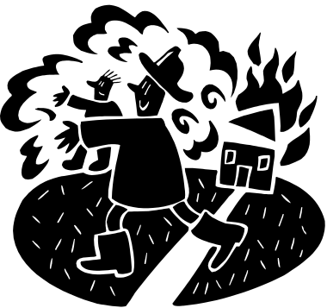

Adverbs (2)

Exercise 2 Victorian Days

This exercise describes the day of a thirteen year old scullery maid in the 1890s.

1. I rise wearily at 5.30, dressing hurriedly in the cold and dark.

2. Downstairs my first job is to light the kitchen fire. That quickly done, I have to heat the water so the squire can wash comfortably in warm water.

3. Other servants arrive. Everyone bustles about getting the family’s breakfast. Cook is generally bad tempered at this time of the morning and scolds us fiercely.

4. After the family have had their breakfast we go to chapel. I love the hymns. I also smile shyly at Matthews, the groom. I think he’s really wonderful.

5. When chapel is over, the kitchen maids begin their endless preparing of vegetables. I am forever hurrying to and fro fetching water from the pump in the yard.

6. Once the family have had lunch, I’ve got sewing to do. I have to make all of my own clothes. I think it’s incredibly unfair. The men servants get all their clothes freely provided.

7. The family eat about 8.00. Then I’m rushing madly about, collecting dirty dishes from the service tray. Sometimes if I listen carefully, I can hear sounds of music and laughter coming from the dining room. It’s like Heaven.

8. At 10.30 I am still washing dishes but I am hopelessly tired. I get one day’s holiday a month. I earn only a few shillings a month. Sometimes I could cry with misery.
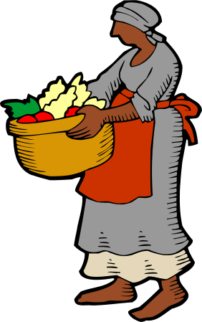

Adjectives and Adverbs

An adjective is a word that tells you more about a noun
(person, place, animal or thing).
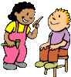

Examples of Adjectives
Mary is a bad girl. (Bad tells you more about Mary.)
John is a good boy. (Good tells you more about John.)

An adverb is a word that tells you more about how
something was done. Adverbs go with verbs (doing words).

Examples of Adverbs
Mary did her work badly. Badly tells how how Mary did her work.
John did his work well. Well tells you how John did his work.

Task

Write adjective or adverb in the space after each sentence.

1. Anne plays the piano badly. _________________
2. Jane is a tall girl. _________________
3. Robert is feeling angry. _________________
4. Gary is a brilliant footballer _________________
5. Amy does her maths properly. _________________
Choose an adjective or an adverb from the box to complete the sentences below.
loudly
new
beautifully
busy
noisily
clearly
modern

- The teacher sings ________________.
- The boys play ________ in the playground.
- The school is ________ and __________.
- We like people who speak ____________.
- Mum and Dad are very __________ today.
- John played the trumpet _________.
Personal Pronouns

Pro means instead of.
A pronoun means a word that is used instead of a noun.

Examples
You use the pronoun I instead of your own name.
You use the pronouns he or him instead of saying someone’s name.
You use the pronoun it instead of always saying, for example, the cat.

Some pronouns are: I we he she it they
you me him her them us

Task
Underline the pronouns in the sentences below.
There are 26 altogether.

- The cat likes cream so they gave it some more.
- Mary and Anne gave us some books and we gave them sweets.
- He went to the match with us but we didn’t think much of it.
- Do you like computer games? I’ve got some of them I could lend you.
- When they came back from a trip to the cinema they told us all about it.
- I’d like him to know that they don’t want me to come and visit them again.
- She looked them up in the phone book to see if she could find out where they lived.
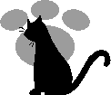
The Conjunction

A conjunction is a word that you use to join two sentences together.
Some conjunctions are:
- and
- because
- but
- so
- since
Examples:
Mary came home late last night. She went straight to bed.
Mary came home late last night and went straight to bed.
She went straight to bed. She was very tired.
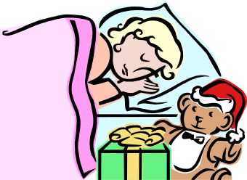
She went to bed because she was very tired.

Task
Join the sentences below together using one of the conjunctions on the list above.
- Gary was chosen for the team. He was a very good player.
_______________________________________________
- He was a striker. The manager put him in goals.
_______________________________________________
- Gary was not happy. He wanted to score goals.
_______________________________________________
- He spoke to the manager. He was allowed to play up front.
_______________________________________________
- Gary was much happier now. He scored lots of goals for the team.
_______________________________________________
Choosing the Conjunction

There are lots and lots of conjunctions.
Conjunctions are words that are used to join sentences together.

More Conjunctions

yet for until or nor although if because since where
unless so then when while
before after whether as and



Task
Use one of the conjunctions in the box in each of
the blank spaces below.

- Jamie asked the teacher for a pencil sharpener ___________
he had forgotten his own.
- Sam could not get any pudding __________ he had eaten all his vegetables.
- __________ Billy did his experiment he cleaned up.
- _____________ Katie usually likes P.E. she did not want to do any last week.
- _______ you see Sally, tell her I want to speak to her.
- I can’t tell ____________ Charles likes this book or not.
- You cannot go to see the film ____________ you pay for the ticket now.
- Harry was too late for the football match ________ he watched the tennis instead.
- __________ she didn’t want to speak to her awful cousins, Marian went out with her friends.
- ____________ George and his family were having breakfast, a fire engine arrived outside.
Conjunctions to do with Time

Conjunctions to do with Time

as when till
before since while
after until whenever

Task
Write a conjunction from the box in the blank spaces in the sentences below.

- She watched the car ______________ it turned the corner.
- The striker waited patiently ___________ he saw a chance to score a goal.
- _____________ he had to give up work because of an accident, my Dad has been out of a job.
- My teenage son sleeps and takes it easy _____________ I go out to work.
- I always think carefully _____________ I answer questions in a test.
- ______________ I moved suddenly the guard dog growled fiercely.
- I am ready ______________ you want to go home.
- I’ll come round to your house _______________ you say.
- ________________ she had finished her homework, Susan went out to see a film.
- ______________ the pupils stopped talking, the Head Teacher started to speak.

‘Special Meaning’ Conjunctions

‘Special Meaning’ Conjunctions
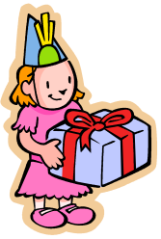

but although unless
as whether if
because where

Task
Write a conjunction from the box in the blank spaces in the sentences below.

- I didn’t want Emma at my party ___________ she promised to behave herself.
- _____________ it was a summer party, all the guests wore shorts and tee-shirts.
- _____________ there were lots of activities, we all decided played Rounders.
- We were all very excited ______________ of how close the game was.
- Mum said the game would have to end ________ people were sick with excitement.
- We asked if we could stay all evening _____________ we already knew that Mum would say no.
- We could not decide ______________ to go on playing or to stop when the ice cream arrived.
- I wanted to finish the ice cream ___________ Mum said no.

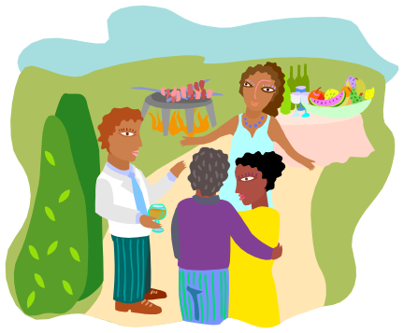

The Wrong Use of ‘then’ and ‘so’
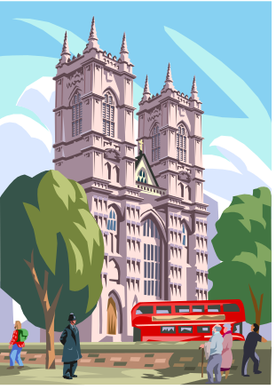
Then means the next thing that happened.
We went into the shop and then we bought a pen.

So means because of something that has happened.
I wanted a pen, so we went into the shop.

Task
Fill in either then or so in the sentences below.

- Uncle George took me on a visit to London last Saturday _________ we went on the Underground to Baker Street Station, __________ it was a short walk to Madame Tussaud’s Museum.
- I wanted to see the Chamber of Horrors _________ we went to see all the murderers, _________ we went next door to the Planetarium.
- __________ after lunch we went for a walk by the Thames ___________ that we could see the Houses of Parliament.
- ___________ we visited Westminster Abbey _________ that we could see the old tombs.
- ____________ we took a taxi _________ that we could go home by train.
- We told Mum and Dad what we had seen and ___________ we had supper. _________ it was a great day out.

Connectives and Compound Words

Look at this list of connectives. Connectives are used to link one sentence to another or to extend a sentence.

whoever whatever if meanwhile
nonetheless for while when
therefore however so and
although besides but since
furthermore henceforward until notwithstanding
whereas then because whenever
nevertheless yet alternatively after
moreover as with consequently

Task 1
Some of the connectives above are simple words, others are compound words. Compound words are words made up of more than one word. Put the words in the box into two categories:
Simple Words Compound Words
if moreover

Task 2
At the side of your list of compound words, write in brackets the number of words that are within the connective:
Compound Words
moreover (2)

Task 3
Look carefully at the compound words. They contain words you are familiar with. Write down each compound word and write down what it actually means. You should use a dictionary to help you.
E.g. furthermore suggests that there is more information to follow what has already been given.
Prepositions

A preposition tells you the relationship of one thing (usually a noun) to another.

For example: The ball was in the tree and I was on the ground.

Complete the story, using each of the words in the word bank only once.

Word Bank
above beside off across down past in through
after into around to before behind towards on after

Dangerous Games

1. I was playing football ____ the street. Suddenly the ball bounced ___the pavement.
2. It ran ___the road. Without thinking I chased ___ the ball.
3. Rajiv shouted to me to stop. It was too late. A car was coming ____ me. All kinds of thoughts went ____ my mind.
4. Then the car hit me and knocked me ___ the road. I could hear it as it went ___ me. Then I passed out.
5. I don’t remember anything else. Rajiv says they put me ___ the stretcher and then drove me ___ by ambulance.
6. I suppose they must have done because I woke up ___ the hospital. ___ I was coming round though, I had a strange experience.
7. It was like a dream. I was floating ___ my bed. Looking ___ I could see the doctors.
8. I wondered what they were doing ___ me. There were little drips and pipes going ___ my arms.
9. When I did wake, mum and dad were sitting ___ me.
Sentences, Phrases, and Clauses

Sentences are grammatically self-contained and make complete sense on their own. They have at least one verb with a subject. Sentences can be statements, questions, commands or exclamations. All sentences begin with a capital letter and end with either a full stop, a question mark or an exclamation mark.

Statement: I’ll climb down in a minute.
Question: What are you doing up there?
Command: Be careful!
Exclamation: What a dreadful child you are!

The verb in a command has a subject which is ‘understood’. That is, it is not actually said but everyone knows what it is:
E.g. (you) Be careful!

Phrases are groups of words without finite verbs which do not make sense outside the context of the sentence.
at the weekend
on the bus
singing in the bath

The present participle (for example, singing), the past participle (for example, sung), and the infinitive (for example, to sing) are non-finite parts of the verb when used on their own and not as part of tenses with subjects.

Subordinate clauses are groups of words with finite verbs, but which do not make complete sense without the rest of the sentence.
after I have done my homework
which has a sad ending
that she will come
Sentences, Phrases, and Clauses

Activities

Exercise 1

The exercise below contains only ten complete sentences. They have been written without capital letters or full stops. Copy the sentences into your jotter, using the correct punctuation.

a) feeling very sad and miserable
b) both children are doing very well at school
c) giggling and whispering in the corner
d) he has been promoted
e) we know her well
f) their house has been sold
g) because they want to go on holiday
h) the story seemed rather far-fetched
i) they are not here
j) they apologised
k) it cost me £2
l) as they rushed down the slope
m) with every intention of making me trip up
n) the headmaster will be late this morning
o) your car looks very clean 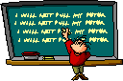

Exercise 2

Punctuate the sentences that follow with a full stop, a question mark or exclamation mark as necessary.  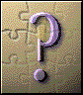

a) Would you like me to open a window
b) Leave my bag alone
c) He is a very kind man
d) I should like to ask you some questions
e) Oh no, I have lost my car keys
f) What’s the time
g) Do you know Michael well
h) Fiona is playing netball today
i) Have you decided what to do
j) It’s a pity that you didn’t tell me this before

Exercise 3

Incorporate these phrases and clauses into sentences.

a) sneezing and coughing
b) if I can
c) I think he is learning to play the flute
d) with a nasty smile
e) at Christmas

Question Marks

All questions need question marks. Questions often include the words what, where, why, when and how, but sometimes just depend on the way words are spoken. Simply raising the voice at the end of a sentence can turn the sentence into a question.

Add one question mark to each of the sentence groups below (except the last).

Exercise 1 Lost without Paul

Tracey: Excuse me, can you help. I’m lost.
Alan: On dear. Are you very lost.
Tracey: What do you mean. I’m just lost.
Alan: Yes. But are you a lot lost or only a little bit lost.
Tracey: How can I tell. I don’t know where I am.
Alan: Do you have a map. Maps can be useful when you are lost.
Tracey: If I had a map I wouldn’t be lost, would I. I had one, but Paul ate it.
Alan: That was a mistake. Who is Paul.
Tracey: He used to be my friend. Have you seen him wandering about.
Alan: No. When did you last see him.
Tracey: When did I last see him. About five hours ago.
Alan: He could be anywhere by now. Do you know what I would do.
Tracey: No. Can you tell me.
Alan: Well if I was you, I’d ask someone for help. Have you tried that.
Tracey: Yes. I asked you. Remember.
Alan: Oh, that’s no good. Want to know why.
Tracey: Why. There has to be a good reason.
Alan: There is. I’m lost too.
Question Marks

Add one question mark to each of the sentence groups below.

Exercise 2 Questions, Questions

Mr Side: Well done, Jade. Now then, where would I find the capital of Japan.
Darren: Please, Sir, can I answer, Sir.
Mr Side: Certainly, Darren. What is the answer.
Darren: Please, Sir, would you find the capital of Japan in Japan, Sir.
Mr Side: Are you playing the fool, Darren.
Darren: No, Sir. Of course not, Sir. I mean, you wouldn’t find the capital of Japan in America or Spain would you, Sir.
Mr Side: Are you all right, Darren. You’re normally quite a sensible boy.
Darren: I’m fine, Sir. Japan’s an interesting country, isn’t it, Sir.
Mr Side: It certainly is. Like Britain, Japan is a series of islands. It’s capital is Tokyo. Does anybody know where I would find Tokyo on the map.
Darren: Please, Sir, I know. Would it be on one of the islands, Sir.
Mr Side: Darren, I am becoming very, very cross. Are you sure you’re not playing the fool.
Darren: No, Sir. I mean, the capital of Japan wouldn’t be in the sea, would it.
Mr Side: That’s it! I’ve had enough! Any more nonsense and I will send you to the Head Teacher. Do you understand.
Darren: Yes, Sir. Please, Sir.
Mr Side: Enough! No more questions. Is that clear.
Darren: Yes, Sir. Sorry, Sir. Can I just ask…

Exclamation Marks

Exclamation marks are used to give extra emphasis to particular statements. They can indicate strong feelings such as surprise, joy, anger, pain etc. Add exclamation marks to this dialogue. Think carefully about whether the speaker is excited or calm.

Exercise 1 Space Travel

Captain Kirk: Look out, Commander, a giant asteroid is heading for the ship.
Commander Kate: Put the crew on full red alert, Captain. Reverse thrust the engines.
Captain Kirk: There’s no time, Commander. We’re going to be hit.
Commander Kate: Ooomph.
Captain Kirk: Aggghh.
Commander Kate: Are you all right, Captain.
Captain Kirk: My leg. I think it’s trapped. Are you hurt, Commander?
Commander Kate: Don’t worry about me. Look at the monitor.
Captain Kirk: It’s some kind of alien. It’s taken over the lower flight deck.
Commander Kate: It’s horrible. We’re the only ones left, Captain. We have to stop it. We have to.
Mrs Brown: Kate. Kirk. What are you doing? What is going on?
Kate: We’ve finished our topic work, Mrs Brown.
Kirk: And we’re just about to start on our maths.
Mrs Brown: Well, less noise, please. I can hardly hear myself think.
Kate: Yes, Mrs Brown.
Kirk: Sorry, Mrs Brown.

Exclamation Marks

Exclamation marks are used to give extra emphasis to particular statements. They can indicate strong feelings such as surprise, joy, anger, pain etc. Add exclamation marks to this dialogue. Think carefully about whether the speaker is excited or calm.

Exercise 2 Rock Bottom

Andrew: It’s wonderful. It’s amazing.
Sharon: Is it. If you say so.
Andrew: There can’t be any doubt. It’s fantastic.
Sharon; It just looks like a bit of old rock to me.
Andrew: But can’t you see? It’s art. It’s a very, very early stone carving. It could be 50,000 years old.
Sharon: It just looks like a bit of old rock.
Andrew: Stop saying that. Where did you get it?
Sharon: Off the rockery.
Andrew: Your rockery?
Sharon: Yes. There are lots of them on my rockery.
Andrew: Lots of them?
Sharon: Yes, and stop repeating everything I say. You sound like a parrot.
Andrew: But this is incredible. They could be worth millions of pounds.
Sharon: I don’t think so.
Andrew: Why not?
Sharon: Because if you look at the bottom it says “A Present Fron Iraklion”. My aunt brings them back from holiday every year.
Andrew: Oh. Nice rockery you’ve got there.

Commas (Pauses within Sentences)

Commas mark a pause within a sentence and are sometimes used with conjunctions. Each sentence needs two commas.

Exercise 1 Amazing Me

1. I am at least three metres tall which I suppose is quite tall though I can easily make myself taller.

2. My brain is as big as a ten story block of flats though I don’t use it much. I keep it in my pocket in a matchbox.

3. If I need to fly anywhere I simply grow wings. My wings are long and silvery but difficult to dry when wet.

4. When it rains my head turns into an umbrella covering my whole body. If you want my opinion I think it looks great.

5. You might think I should use my umbrella head to keep my wings dry but it’s not that simple because when my head turns into an umbrella I can’t see where I am going.

6. I have ten fingers on each hand which is brilliant for playing the piano but difficult when it comes to buying gloves.

7. I live in a cave but because I am afraid of the dark I sleep with the light on. I sleep upside down like a cricket bat.

8. You might catch sight of me riding my penny farthing bicycle. If you do take care there’s only one of me left.

Commas (Pauses within Sentences)

Commas show where to pause in a sentence. Each sentence group needs the number of commas marked in brackets.

Exercise 2 Hammy

1. Have you read about the famous Hammy? Hammy is of course a hamster but you probably guessed that. (3)
2. Now you might think that a hamster is a funny subject for a story but Hammy is an escape artist. Worse still not only does she escape but she is also a one-hamster demolition team. (3)
3. My brother is a carpenter and he built Hammy’s cage complete with house and exercise area from wire and old boxes. (2)
4. From her very first day in the new house Hammy could escape without leaving a trace of how she did it. One day lying quietly on my bed so that she could not see me I watched her for twelve hours. As soon as I fell asleep Hammy was gone. (4)
5. It would not matter but whenever she gets out she always seems to cause damage. One time she gnawed all the curtains and another she ate a hole in the carpet. One Christmas she even bit through the cable of the Christmas tree lights luckily for her the lights weren’t on at the time. (4)
6. Her most famous escape was last weekend just after Dad had finished gardening. He was tired so he lay on the couch to watch the football. Within a few minutes he was sound asleep his moustache twitching as he snored. (2)
7. Unfortunately Hammy had just woken up and decided to go exploring. (1)
8. When Dad opened his eyes there was Hammy not two centimetres away peering at him. He must have thought that a giant rat was attacking him because he let out a huge bellow. (3)
9. Anyway my brother now has strict orders to build as quickly as possible an escape-proof cage. I bet he can’t keep Hammy locked up. (3)
Commas (Lists)


In this exercise you are going
to use commas to separate the items in
a list.

Exercise 1

- I want a bag of potatoes a bag of apples a tin of beans a jar of jam and a loaf of bread.
- In the High Street there is a grocer’s shop a fishmongers a chemists a supermarket a garage and a shoe shop.
- I’m taking Maths English German Chemistry Art Home Economics and Biology next year.
- There are trains to Edinburgh at nine o’clock at ten thirty at midday and at five o’clock.
- First Gary went to the Library then to the Games Hall then to the Football Pitch then to the Science Lab and lastly to the Canteen to find his friends.
- Brown Owl called the names of the children in the Brownie pack: Lucy Mary Lorraine Jennifer Claire Amy Kathleen and Carol.

Commas (Lists)

Commas can be used to separate items in a list. Each group of sentences needs three commas.

Exercise 2 On the Move

1. Dad gave me a shopping list. It read: 1 pineapple 4kg bananas 1 pkt spaghetti 1kg tea and 1kg coffee.
2. You might think that’s nothing. You don’t know my dad. My dad is the richest oddest most extravagant most demanding chef in the world.
3. Fresh means fresh. He doesn’t just mean fresh from the shop. He means fresh from the stream bush tree field or whatever.
4. With the shopping list dad gave me tickets passport money travel sickness pills and a map of the world.
5. Pinned to the map was a note. The note read: “Please also get me pineapples from Kenya bananas from Jamaica spaghetti from Italy tea from China and coffee from Brazil.”
6. Packing a toilet bag sleeping bag clothing bag and a book to read on the journey I set off.
7. Italy was hot Kenya was hot China was hot Brazil was hot and Jamaica was hot too.
8. I arrived home feeling hot tired happy hungry and generally pleased that I had succeeded. On the table was another note.
9. It read: “Forgot to ask you for: beef – Texas caviar – Russia snails – France butter – New Zealand. Sorry about this.” I felt like laughing. Most of my friends hate shopping but I can’t wait for my next shopping trip.
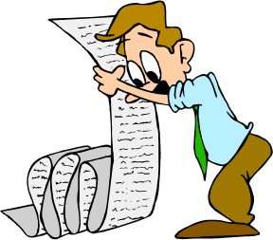
Speech Marks

Speech marks look like this “…………”
When you write a story, you need speech marks to tell the reader what words a person actually said.
The words that the person said go in between
the marks.


Example
“Go to bed right now!” said Dad angrily.

Task
  - Underline the exact words that someone said in the sentences in the story below.
  - Put in the speech marks. “ …..”

- I want to stay out late tonight said Tom.
- Dad answered No way.
- Mum said I want you back here for nine thirty.
- Could you not make it ten thirty? asked Tom.
- Certainly not said Mum.
- How about ten o’clock, please Mum said Tom pleadingly.
- Mum thought for a moment and then said Oh, all right then.
- But not a minute later or there will be trouble added Dad.
- Thanks, Dad. Thanks Mum. said Tom.
Speech Marks Exercises

Remember:
When you write a story, you need speech marks to tell the reader what words a person actually said.
The words that the person said go in between the marks.
Speech marks look like this “…………”
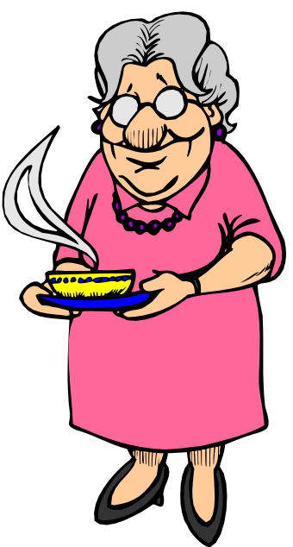

Task
a) Underline the exact words that someone said
in the sentences in the story below.
b) Put in the speech marks. “ …..”
c) Write 3 more sentences with speech in them
to complete the story.
- What would you like for your dinner tonight? asked Gran.
- I don’t want any dinner tonight. I’m going to the cinema and I’ll buy some chips answered Julia.
- Gran was annoyed. That’s not good for you she said.
- But I haven’t got time for soup or meat and two veg, Gran. I’m meeting Kenny at six o’clock said Julia.
- That’s another thing. That Kenny is bad news. Gran was really worried about the way Julia was behaving since she met Kenny.
- He’s all right said Julia. Really he is, Gran.
- _____________________________________________________________________________________________________________________________________________
- _____________________________________________________________________________________________________________________________________________
- _____________________________________________________________________________________________________________________________________________

Commas (Mixed)

Commas are used to separate words in a list, to mark where pauses are needed in sentences, and with direct speech. Each sentence group needs at least two commas.

Exercise 1 Inuit and Masai 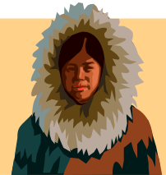

1. Many things such as climate natural resources and landscape
influence the way people live.
2. Incredibly human beings have found ways to live in every part of the world no matter how difficult the environment.
3. One of the toughest places of all to live is Greenland. Despite its name Green land is a country of ice snow and bitter cold winds.
4. To make life tougher still Greenland is dark for three long hard winter months.
5. The Inuit people have survived in Greenland Alaska and Canada for thousands of years hunting caribou seal and fish.
6. Ane is an Inuit. She says “My people are still hunters but life is changing for example we no longer live in igloos. I live in a house with a TV.”
7. Juma lives in a very different part of the world in the Rift Valley in Kenya. Juma is a Masai. His people are farmers herding cattle sheep and goats.
8. “I began herding my father’s cattle when only four years old” Juma says bursting with pride. “Cattle are the most important thing in the world to my people.”
9. The Rift Valley is also home to many wild animals such as lions elephants rhinos and zebras.
10. These days traditional ways of life are under threat. “Two of my brothers have already gone to live in Nairobi” Juma told me “but I will stay with my cattle.”



Commas (Mixed)

Commas are used to separate words in a list, to mark where pauses are needed in sentences, and with direct speech. Each sentence group needs four commas.

Exercise 2 The Storm

1. Thunder rolled and cracked as rain lashed a rocky jagged mountainside. Its dirt road was like a river running with mud twigs dead leaves and stones.

2. Two travellers staggered on hardly able to drag one foot after the other. Tired cold hungry and soaked to the skin they felt more dead than alive.

3. Lightening flashed. Briefly the travellers saw the roofs chimneys turrets and battlements of an enormous crumbling castle outlined on the mountain top.
4. “There is hope” one traveller gasped “because I can see lights in the castle.” His friend too tired to reply merely nodded.

5. Blinded by rain slipping sliding at times clinging together for support the travellers staggered onwards.

6. At last they neared the castle. It was a huge grim building. Most windows were empty of glass whilst broken roof tiles lay everywhere. Caught by the wind strands of ivy scratched and whipped like the claws of a mad beast.

7. “We are safe” the first traveller cried sinking to his knees. Approaching the gatehouse his friend took hold of the heavy rusting knocker.

8. The hollow empty thuds of the knocker seemed to echo through the castle mixing with the angry crashes of thunder. There was silence then at last they heard the faint distant sounds of footsteps.

9. First one then a second bolt was drawn back. Whinging and whining the door inched open. Wrapped in a cloak his face hidden in shadow a man stood before them.

10. He held a lamp. By its dim light they could see he was tall thin and pale. “Welcome welcome!” he said showing two odd sharp- pointed teeth. “My name is Count Dracula.”

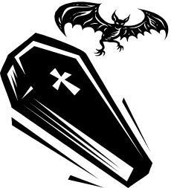

Prefixes (1)

Prefixes are syllables added at the beginning of words or word roots. e.g pre + fix = prefix
under + ground = underground
super + sonic = supersonic

Negative Prefixes

You can make a lot of words negative by using the right prefix.
e.g. visible invisible
tidy untidy
appear disappear
understand misunderstand

Take care when adding in- and un- to words beginning with n:
e.g. in + numerable = innumerable
un + necessary = unnecessary

Take care when adding dis- and mis- to words beginning with s:
e.g. dis = satisfied = dissatisfied
mis + spell = misspell
You do not have to double the s otherwise.
e.g. dis + appear = disappear
mis + behave = misbehave

The prefix in- changes when it is added to words beginning with n, l, m, p, r.
e.g. noble (in + noble) ignoble
legal (in + legal) illegal
mature (in + mature) immature
patient (in + patient) impatient
responsible (in + responsible) irresponsible

Number Prefixes

Recognising the prefix at the beginning of a word gives you a valuable clue to its meaning and also helps with the spelling. Here are some prefixes that indicate numbers. They have all come into the language from Greek or Latin.

uni- unicorn ( a mythical creature with one horn)
mono- monocle (a single eye-glass)

bi- bicycle (a cycle with two wheels)

tri- tricycle (a cycle with three wheels)

quad- quadruplets (four children born at one birth)

penta- pentagon (a five-sided figure)

hexa- hexagram ( a six-pointed star)

oct- octet ( a group of eight musicians)

dec- decade (a period of ten years)

cent- century (a period of a hundred years)
mill- millennium ( a period of a thousand years)

hemi- hemisphere (half the world above or below the equator)
semi- semi-conscious (half- conscious)

multi- multicoloured (with many colours)
poly- polysyllabic ( a word with many syllables)

omni- omnivore ( an animal that eats all sorts of food.

Prefixes (2)

Supply the missing letters. A dictionary will be useful here.

a) dis----- persuade someone not to do something
b) in--------- unwilling or unable to believe
c) dis--------- to break into small pieces
d) im------- fair to both sides
e) ir-------- having nothing to do with the subject
f) im------ perfectly still
g) in------- not able to be heard
h) dis-------- (of clothes or hair) untidy, unkempt
i) ir--------- not able to be proved false
j) dis------ to take something to pieces
k) in--------- more than can be counted
l) un----- rude and rough
m) mis------- unacceptable or wrong behaviour
n) un-------- not expected or seen in advance
o) ig------ knowing little about a subject

Supply the missing prefixes.

a) ----tonous lacking in variety
b) -----tude a huge crowd
c) -----thlon a sporting competition with five events
d) ----logue a long speech by one person
e) ----scient knowing everything
f) ----ruple to multiply by four
g) ---te to join together to make one
h) --ennial happening every two years
i) ---que only one of its kind
j) ----rille an old-fashioned dance for four couples

Suffixes
Suffixes are added to the end of words

-ful When full is used as a suffix, it is always spelt –ful
e.g care = full = careful

-ly Just add –ly to the base word. If the base word ends in l you will have double l
e.g. part + ly = partly, real + ly = really

-cal for adjectives
e.g. nautical, practical
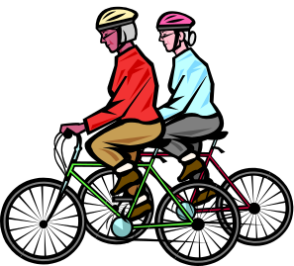
-cle for nouns
e.g. icicle, bicycle, vehicle

-able and –ible are very tricky.
-able is more common than –ible
Use –able with whole words e.g. washable
Use –ible with incomplete words e.g credible
Use your knowledge of other words in the same family
e.g. adapt, adaptation, adaptable
e.g. comprehend, comprehension, comprehensible

-ant/-ent and –ance/-ence are also very tricky. 
People are usually –ant.
e.g. sergeant, attendant

Nouns from verbs are usually –ance
e.g. appearance, reliance, attendance

Use –ant/-ance after hard c and g
e.g. significant, significance, elegant, elegance

Use –ent/-ence after soft c and g
e.g innocent, innocence, intelligent, intelligence

Use –ent/-ence after words ending in –i
e.g. audience, obedient, obedience.

Exercise 1

waste + full = spiteful + ly =
hope + full = practical + ly =
sorrow + full = sincere + ly =

Exercise 2

Add –ant, -ent, -ance, or –ence

- differ_________recipies
- suffice________information
- innoc__________victims
- ignore_________ behaviour
- a radi__________smile
- neat appear_________
- Garden of Remembr________
- frequ_________interruptions
- adolesc___________readers
- intellig____________comments
- signific_____________looks
- mysterious disappear_________
- insur_____________policy
- arrog_________behaviour
- leni_____________sentence
- extravag_____________gift
- an import_____________point
- persist________efforts 

Exercise 3

Add -able or –ible

- We are not respons___________for our children’s debts.
- Is the Severn a navig__________river?
- Her whisper was clearly aud________.
- The two friends were insepar________.
- The cabbage is a versatile veget_________.
- Charles is a sens______child.
- Your writing is almost illeg_______.
- All the equipment is easily port______.
- It was an unforgett_____occasion.
10.The doctor says an operation is not advis_______.



Plurals

Rules

Most nouns simply add -s or -es to form the plural.
e.g table tables
cat cats
fow foxes

But some groups of nouns require extra care.

Nouns ending in –y
Nouns ending in a vowel +y ( -ay, -ey, -oy, -uy) are straightforward. Add –s.
e.g. monkey monkeys

Nouns ending in a consonant +y (-by, -py, -ty etc) are more complicated. Change –y to –ies.
e.g baby babies

Nouns ending in –f
Add –s to nouns ending in –f.
e.g. cliff cliffs
However, if you hear a ‘v’ sound when you say the plural word, spell the plural –ves.
e.g. loaf loaves

Nouns ending in –o
Add –s to most nouns ending in –o.
e.g. photo photos
Be aware that there are some everyday exceptions.
e.g tomato tomatoes

There are a number of irregular plurals. It is worth making a list of the ones you often need.
man men louse lice
woman women mouse mice
goose geese child children
tooth teeth ox oxen
foot feet sheep sheep (no change)

Exercise

Write the plurals of these singular nouns.
a) thief
b) city
c) woman
d) memory
e) witch
f) hero
g) bicycle
h) inch
i) potato
j) donkey
k) calf

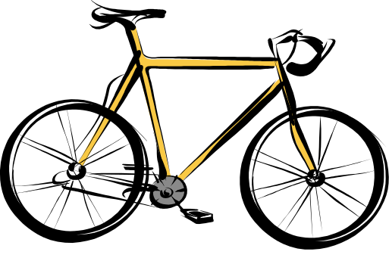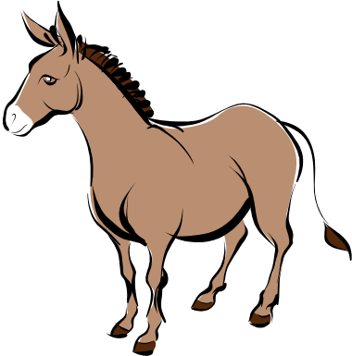

Paragraphs

A paragraph is a section in a piece of writing which deals with one main idea. It always begins on a new line. There is no set length.

Paragraph Checklist

- Is the main idea of each paragraph clear?

- Is everything relevant? Should anything be omitted?

- Is any paragraph overloaded? Should it really be two (or even three) paragraphs making related points?

- Should anything be added to support the main idea of any of the paragraphs? (In a critical essay, for example, you will want to ensure that you have used quotations and references wisely in support of each point you make.)

- Should the order of the paragraphs be rearranged? (You will sometimes find, for example, that your concluding paragraph makes a very good introduction.)

- Does each paragraph lead easily to the next? Should any linking words and phrases be added?

- Are the paragraph boundaries clearly indicated by indenting or spacing?

Task
Write a paragraph about one item of furniture in your bedroom. Everything you say must be strictly relevant to this one piece of furniture.

