Hand-out 3

Polymerase Chain Reaction (PCR) – Amplifying DNA

Introducing PCR

We know that DNA replication occurs naturally in cells before cell division.

Given the correct conditions, DNA fragments can be amplified, through repeated cycles of artificial replication, by the process known as the Polymerase Chain Reaction (PCR).

- During _________________ many copies of a piece of DNA are made, each PCR cycle _______________ the number of DNA fragments.

- PCR is a technique which can be used to produce billions of copies of a specific _______________________ of DNA.

- PCR is used to make copies of a piece of DNA in vitro i.e. outside the body of the organism ______________.

- The process involves cycles of _________________________ thereby exposing DNA to a series of temperature changes.

Research task: PCR ‘Expert’
- Carryout the research task as directed by your teacher. You can use paper or whiteboards to make notes on your research topic.

Requirements for PCR
If you wanted to amplify DNA what would you need?

The PCR Process in Brief (Learn this!)

Pattern of Amplification of a target sequence of DNA

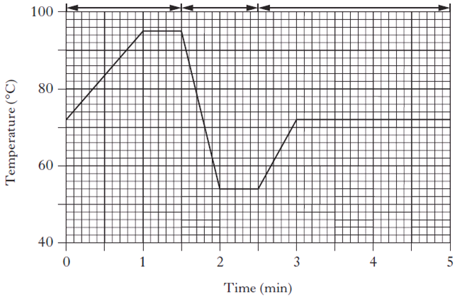

- What is the function of PCR?

- What term describes the production of multiple copies of DNA using PCR?

- Why is cooling important during the second stage of PCR?

- Short sections of DNA called primers are required for PCR. When they are added during the second stage of the thermal cycle what do they do?

- What is the role of DNA polymerase?

- Why is the temperature increased during the final stage of the PCR cycle?

