Hand-out 3

Memory

- Memory is one of our mental faculties. Memory involves _____________,
____________ and ______________ of information.

- Memories include __________________, ______________ and
_______________.

- All information entering the brain passes through _________ memory and
enters ____________________ (STM).

- Information is then either transferred to the _______________________

(LTM) or is ______________.

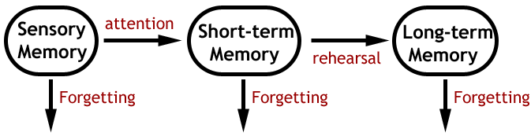

Sensory Memory
Sensory memory lasts ____________________and retains all of the ___________
and ___________ input.

Short-term Memory

Short-term Memory has a ___________________(Memory Span) and holds
information for a ___________________.

Information in the STM must be passed into the LTM or it will be lost by

- ________________, the ‘pushing out of old’ information by new information

- _______, the breakdown of the ‘memory trace’.

More information can be retained in the STM if it is organised.
- _____________ can increase memory span by organising information of smaller units into a chunk e.g. telephone numbers can be chunked to give an area code which reduces 4 numbers to one piece of information—0141 for Glasgow etc.
- _____________ involves repeating information to yourself many times. This extends the length of time the information is held in the STM and increases the chance that it will be transferred to the LTM.

- STM can also _________ data, to a limited extent, as well as ________ information.
This ‘____________________________’ explains why the STM can perform simple cognitive tasks.

Serial Position Effect
This is where the first few and last few items from a string of facts are remembered best.
- The first few items are remembered as there has been ______________________ them and they have become encoded and transferred to the LTM.
- The last few are remembered because they are still in the________________.
- Items in the middle are ____________ by the last items.
Long – term Memory

LTM has an _____________ capacity and holds information for a __________.

Successful transfer of information from the STM to LTM is promoted by rehearsal,
organisation and elaboration of meaning.

- ___________ involves simple repeats or practices of information

- ____________ is where information is placed into logical groups or categories, in a way that is meaningful to the learner.
- _____________ involves building more detail around the information (creating a ‘bigger story’)
For example, the name of a person is much more likely to be transferred to the LTM if it is associated with mental images, personality, experiences and smells, such as their perfume/aftershave.

In order for information to be transferred from the STM to the LTM, information
must be __________ (converted to a form that the brain can process and store).

The quality of the memory depends on the attention given to the encoding it.
Information can be encoded using:
- ________ encoding, such as repetition
- __________ encoding, such as linking with previous memories, which is considered as a deeper form of encoding.

Retrieval
- ___________ _____ aid the retrieval of information from the LTM.
- A contextual cue relates to the time and place when the information was intially encoded into the LTM

