Hand-out 2

The Brain

- The brain is a complex central processing centre of the nervous system.

- It receives incoming information from sense organs and responds by initiating appropriate actions.

- It is made up of billions of neurons.

- Cerebral Cortex

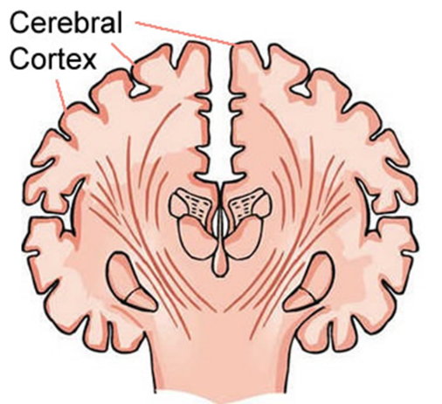
- The ______________ consists of a thick outer surface called the _________________________ (3mm deep) which forms the largest and most complex part of the brain.
- The cerebral cortex is ___________________ to increase its surface area, allowing for more ____________________ to be present on the surface and maximising the number of _________________ between neurons.
- The cerebrum is split by a deep cleft into two halves called _________________________.
- The __________ hemisphere processes information from the ___________ visual field and controls the ________________ of the body (the reverse is true for the right hemisphere).
- The two cerebral hemispheres are connected by a large bundle of nerve fibres called the _______________________. This structure is found deep within the brain. Its function is to __________________________ between the two sides of the brain.

Location of the Corpus callosum
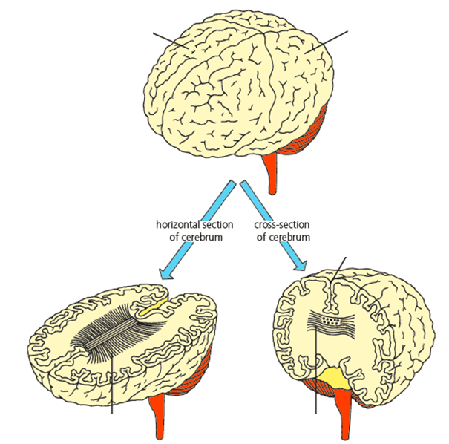

Localisation of Brain Function in the Cerebral Cortex

Area | Function
 | analyses and interprets impulses from the body’s receptors
motor

