Genetic Fingerprinting Investigation

The diagram shows the genetic fingerprints of seven people (P to V):

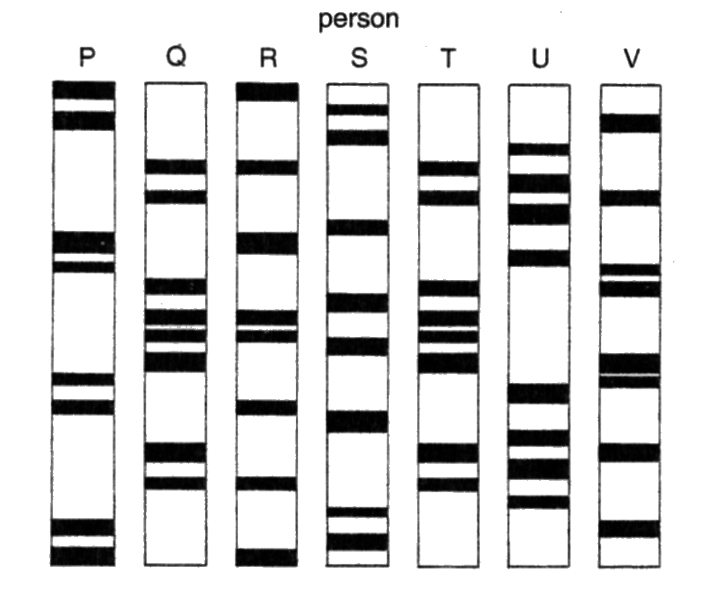

- Identify the parents of person P.

- Identify the monozygotic twins.

- Could person P be the twins’ brother? Explain your answer.

- Could the remaining two people in the diagram have the same parents as P? Explain your answer.

