
l

Driving Equity and Excellence

Improvement Report

Session 2025-26

School: | Woodlands Primary School
Cluster: | Greenfaulds High School
Head Teacher: | Nicola Ferguson

AIR Submission Date | Submission Focus Area | Progress towards improvement priorities
10th October 2025 | QIs 3.1 | Please update your progress towards your priorities (and include nursery progress, if appropriate)
5th December 2025 | QI 1.3 and 3.2 & PEF Update | Please update your progress towards your priorities (and include nursery progress, if appropriate)
20th March 2026 | QI 2.3 | Please update your progress towards your priorities (and include nursery progress, if appropriate)
12th June 2026 | Full submission:  All Qis & PEF Update | Please update your progress towards your priorities (and include nursery progress, if appropriate)
Submissions should be emailed to QISSIP-SIR@northlan.gov.uk and the link EFM.
A Microsoft Form will also be completed with the final submission in June 2026, with a link sent nearer the time.

Section 1: Establishment Details
Establishment Improvement Report
Context of the school:
This section should be used to give brief background information in relation to the type of establishment, location, its management structure and staffing, the school community etc. It should also include some or all of the following: the school’s vision, values and aims; local contextual issues; factors affecting progress (e.g., staffing changes/issues). Please include details of any early years provision, if appropriate.

Please write the report in the third person and remember this is a public-facing document (therefore no pupils, parents or staff should be easily identified).
Woodlands Primary School and Nursery Class is located in Cumbernauld and is part of the Greenfaulds High School cluster.
The school encompasses a mainstream, non-denominational primary and nursery class catering for children with a wide range of needs. The school is made up of 12 classes from nursery to primary 7 with a current school roll of 264 and the nursery class with 48FTE which caters for whole day placements. The school leadership team consists of the Head Teacher, Depute Head Teacher and newly appointed Principal Teacher. There are 16 FTE class teachers and a wide range of support staff.
Pupil Equity Fund (PEF) allocation is £93,100. PEF is used to enhance staffing to allow for a dedicated HWB support teacher who is nurture trained and to provide targeted support for learning. Additional monies are also aimed at helping remove the cost of the school day by ensuring that all school activities, including trips and special events are accessible for all.
Across the school there are currently 9 Care Experienced children, 3 children who are in kinship care and 3 children on the child protection register. There are 38% of pupils who are in receipt of free school meals and 45% in receipt of clothing grant. There is an even gender balance across the school role with 46.6% female pupils and 53.4 % male pupils on the roll. There are 28 children with English as an additional language and 83.9% of pupils who an ethnicity White- Scottish. There are 21% (56 children) living in quintile1 and 12% (32 children) living in quintile 5.
There are 52% in school (138 pupils) and 27% (13 children) in nursery who have a recorded additional support need. This includes a high number of pupils who display dysregulated behaviour. A highly effective nurturing approach, enhanced by use of Emotion Works across the school, is embedded in practice and provides support to all children.
The school has a very positive ethos underpinned by shared vision and values represented by SPIRIT – Safe, Proud, Inspired, Respect, Independent and Tolerant. The school vision was created by pupils and has created a culture where all stakeholders are valued and integral to the work of the school.
Attainment across all areas since 2021 shows a decrease over time, there have been several reasons identified including a higher number of pupils with additional support needs. To address this, the school have reviewed their curriculum and are conducting a test of change to increase motivation and engagement and improve attainment in literacy and numeracy. Current data for academic session 2025-2026 shows impact on targeted areas as detailed below:
SNSA Data – End of Level Data
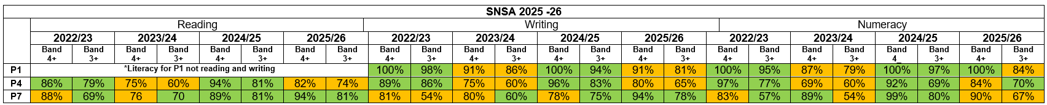
Attainment at Primary 1 remains high, with most children achieving in both literacy and numeracy. There has been a slight dip across literacy and within the top three bands of SNSA numeracy compared to the previous year. An increase of 2 children (6%) in numeracy and 3 children (10%) in literacy would result in almost all children achieving expected levels. Performance within the top four SNSA bands demonstrates strength, with 100% of children achieving in numeracy, indicating strong depth of understanding for most learners. Overall, P1 data remains strong across the stage. The slight decline from the previous year is likely due to cohort variation rather than systemic issues. Early years provision continues to be effective, though slightly less consistently strong than previously. There are currently 3 children (10%) in Band 3 and 3 children (10%) in Band 2, who are working within early level and will require targeted support to achieve expected levels.
At Primary 4, the majority of children are achieving in reading and writing. In reading, an increase of 2 children (6%) would result in most children achieving expected levels. In writing, an increase of 4 children (10%) is required to reach this threshold. There has been a decline in attainment across both reading and writing compared to the previous year, most notably in writing, with reductions of 18pp in the top three bands and 16pp in the top four bands. This suggests that increased challenge and pace are not yet being met consistently across the cohort, and that attainment has not been sustained from earlier stages. In numeracy, attainment is relatively stable, with majority of children achieving within the top three bands. An increase of 2 children (5%) would further strengthen this to ensure most children achieving a level. However, there is a slight dip in the top four bands, indicating a need to further develop application of numeracy skills.

At Primary 7, there has been a significant improvement in literacy, with most children now achieving in both reading and writing. This reflects the positive impact of targeted interventions and teaching approaches, particularly in writing. An increase of 3 children (9%) in reading and 4 children (approximately 10–12%) in writing would result in almost all children achieving expected levels, showing that attainment is close to the next benchmark. In numeracy, the majority of children are achieving expected levels, with an increase of 3 children (9%) required to reach most children in the cohort. There has been a decline of 13pp in the top three bands and 9pp in the top four bands, indicating a reduction in attainment compared to the previous year. This suggests a consistency issue, particularly in the application of numeracy skills and number knowledge, rather than a lack of basic understanding.
Overall SNSA School Profile
Across P1, P4 and P7, attainment data shows a consistently strong pattern of performance, particularly at higher bands. There are very low or zero learners in the lowest bands and strong evidence of equity, with filtered learners performing in line with all learners. There is, however, a recurring pattern of reduced representation in middle bands.

High Level Messages:
The data shows as a school we are:
- Closing the Poverty-Related Attainment Gap - Filtered learners match all learners across all stages, with no attainment gap evident. This demonstrates effective universal and targeted support.
- Supporting high Levels of Attainment - Strong performance at upper bands, particularly in P4 and P7, where learners exceed national averages. This reflects high expectations and effective teaching.
- Providing strong Universal Provision - Consistently low numbers in lowest bands highlight effective early intervention and support (Possibly due to the new classroom layouts to include continuous provision for rehearsal and practice).

Next Steps identified form the SNSAs
- Strengthen differentiation and formative assessment.
- Increase challenge and depth across all stages.
- Improved pace of learning to allow rehearsal and practice throughout the year.
- Enhance moderation and shared understanding of standards.
- Target interventions based on learner need and data analysis.

The SNSA data demonstrates strong attainment across literacy and numeracy, with high performance at upper levels and clear evidence of equity. Future priorities will focus on improving progression through middle bands and increasing high attainment in line with the Scottish Attainment Challenge SAC and stretch aims.

Core Stretch Aims (to narrow the attainment gap)
Literacy
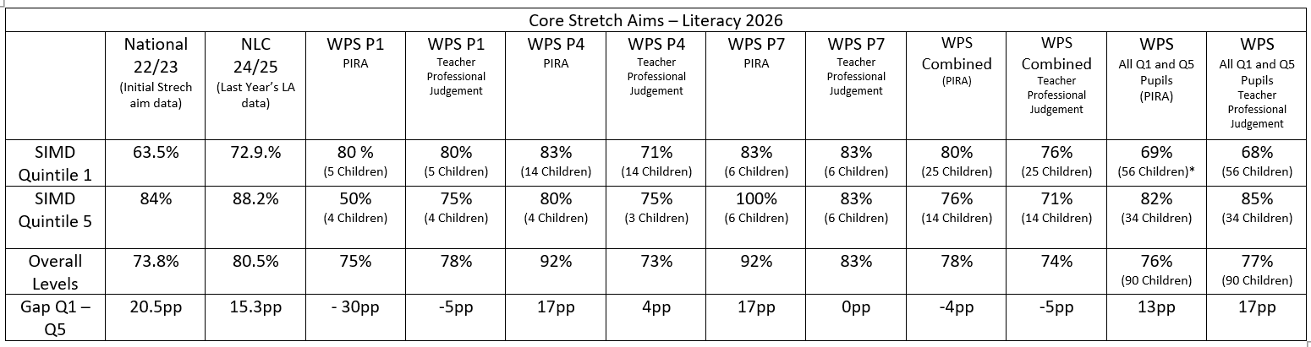
P1 Key Messages - Q1 outperforms Q5 (especially in PIRA). Gap reduces from 30pp → 5pp when using teacher judgement, Q5 attainment relatively low at this stage (50% PIRA). Early literacy for disadvantaged learners is strong and potentially is an identified strength of the school. However, the small cohort sizes (4–5 pupils) make this data variable based on the needs of individual children.

P4 Key Messages - Attainment is broadly similar in PIRA (gap essentially closed). However, teacher judgement shows Q5 slightly ahead. Both groups drop under teacher judgement compared to PIRA Q1: 83% → 71% (-12pp) and Q5: 80% → 75% (-5pp). This data shows there is no longer a clear attainment gap issue, but Q1 learners appear to perform adequately on standardised assessment but may lack secure, demonstrable understanding in class. This suggests literacy demands (e.g. comprehension, writing) begin to challenge Q1 learners more in P4.

P7 Key Messages - Larger gap in PIRA (17pp) and no gap in teacher judgement. Q5 reaches very high attainment (100%) and Q1 remains steady at 83%. By the end of 2nd level Q1 learners achieve well overall. However, Q5 learners are achieving exceptionally high outcomes. Discrepancy could suggest a difference in depth vs breadth of learning or understanding.

Summary Q1 and Q5 - National gap: 20.5pp/NLC gap (last year): 15.3pp
Woodlands Primary School’s current gap (all pupils) shows that PIRA achievement gap is 13pp and TPJ gap is 17pp. Woodlands Primary School’s gap between SIMD Quintile 1 and Quintile 5 is 13pp in PIRA and 17pp in teacher professional judgement. This shows an improvement compared to the initial national position (20.5pp), with the PIRA gap now below the Local Authority figure (15.3pp). However, the teacher professional judgement gap remains slightly higher than the local authority average, suggesting that while progress has been made in narrowing the attainment gap, this is not yet consistent across all measures and requires further focus and attention given to pupil profiling and recording of success and achievement.

Numeracy
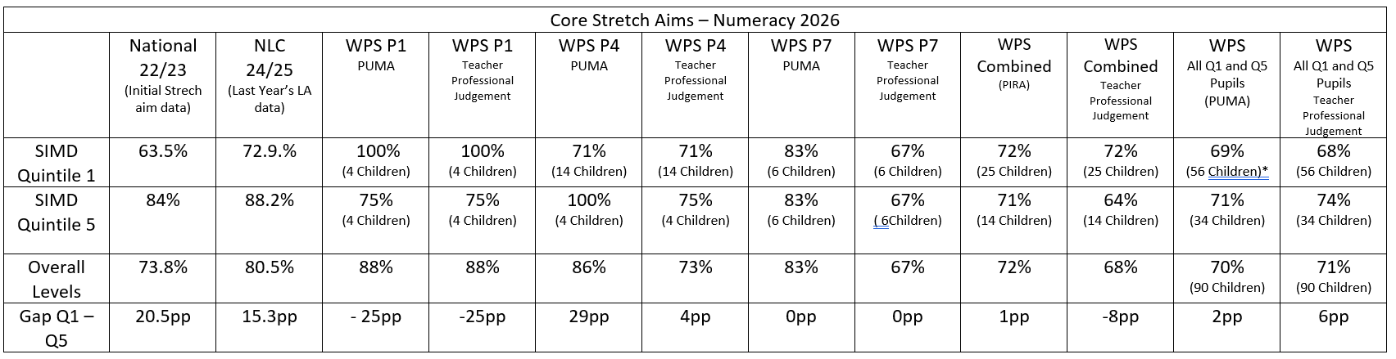
P1 Key Messages - Q1 significantly outperforms Q5 by 25pp with a consistent picture across both PUMA and teacher judgement. Very strong attainment identified for Q1 learners. Early numeracy provision is a clear strength, particularly for disadvantaged learners, However, this is based on a small cohort (4 pupils each). Strong consistency between assessment measures suggests secure early learning.

P4 Key Messages - Large gap emerges in PUMA (29pp). Much smaller gap in teacher judgement (4pp). Q1 attainment drops significantly from P1 (100% → 71%) and Q5 attainment increases to very high levels (100%). Indicates that Q1 learners not sustaining early gains with increased challenge in numeracy concepts at first level.

P7 Key Messages - No gap at all between Q1 and Q5. Both groups perform identically across both measures. Attainment remains strong in PUMA, but lower in teacher judgement. Strong evidence that learning and teaching this year has successfully closes the gap by the end of P7. Even though equity has been achieved the drop from PUMA to teacher judgement (83% → 67%) suggests an assessment alignment issue or that learning application is not being observed or recorded during class lessons.

Summary Q1 and Q5 - National gap: 20.5pp/NLC gap (last year): 15.3pp
Woodlands Primary School’s current gap (all pupils) shows PUMA gap at 2pp and TPJ gap at 6pp.
Woodlands Primary School’s gap between SIMD Quintile 1 and Quintile 5 is 2pp in PUMA and 6pp in teacher professional judgement. This is a significant improvement compared to the initial national position (20.5pp) and is well below the Local Authority figure (15.3pp), indicating that the school has been highly successful in narrowing the attainment gap in numeracy. The very small gap in PUMA suggests strong equity in attainment.
Whole School Year on Year comparison of Q1 and Q5
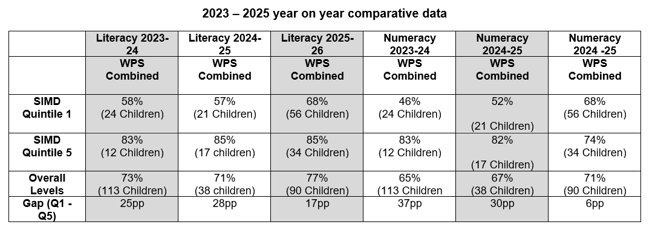
Year on year analysis from 2023 to 2026 shows a clear and significant reduction in the attainment gap between SIMD Quintile 1 and Quintile 5. In literacy, the gap has reduced from 28pp to 17pp, while in numeracy there has been a substantial decrease from 37pp to 6pp.
This improvement is primarily driven by rising attainment among Quintile 1 learners, with literacy increasing by 11 percentage points and numeracy by 22 percentage points over the period. Overall attainment has also improved across the school, indicating that gap closure is being achieved alongside rising standards.
However, there is some evidence that the narrowing of the gap, particularly in numeracy, is partly influenced by a decline in Quintile 5 attainment. While the trend is strongly positive, the literacy gap remains and further work is required around pace and challenge to ensure sustained and consistent progress for all learners.
Teacher Professional Judgement (ACEL)
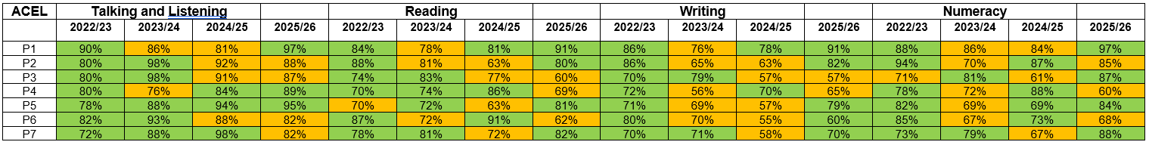
Key Messages – Whole School
This year’s Teacher Judgement (ACEL) data highlights school improvement in three areas. Numeracy across the school shows the biggest gain with an increase of +21%. Writing has increased +12% and Reading shows and improvement of +10%. A declining trend identified is Talking & Listening that has dropped by -16%.
This year’s Woodlands cohort has made very strong progress in core attainment areas (Reading, Writing, Numeracy). The drop in Talking & Listening may suggest reduced focus on oracy or as more likely a cohort-specific issue linked to the increase in children with additional support needs and English and an additional language. Overall the school’s attainment has made a positive shifted towards literacy and numeracy.
Key Messages – Year by Year (cohort tracking)
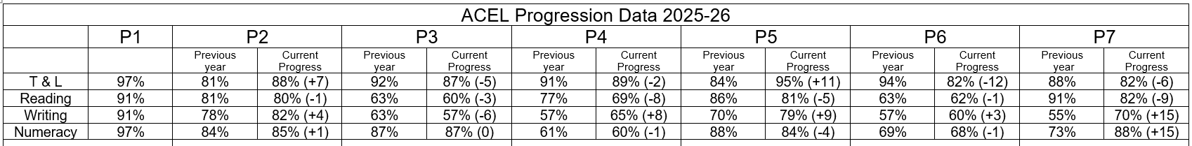
P1 - Used as baseline data – Very strong in Talking and Listening and Numeracy.
P2 - Strong start to progression. Observable gains in 3 areas. Reading broadly stable.
P3 - Numeracy maintained. Decline across all literacy areas. Suggests stall in literacy progression at this stage.
P4 - Slight decline noted in Talking and Listening and Numeracy. Writing improves strongly. Reading shows notable drop
P5 - Overall still positive transition to second level. Very strong gains in Talking and Listening and Writing. Slight drop in Reading and Numeracy.
P6 - Reading and Numeracy remain steady. Writing continues gradual improvement. Significant drop in Talking and Listening.
P7 - Shows a pattern of strong upper-stage attainment gains in core skills with a large gain in Writing and Numeracy with a decline in Reading and Talking and Listening.

Cohort tracking shows that while Writing and Numeracy improve strongly as pupils move through the school, Reading declines across several transitions, particularly from P3 to P4 and P6 to P7. Tracked interventions show that children are able to read but highlights the possibility of issues with finding and translating information into their writing. Talking and Listening also shows a downward trend in upper stages (possible due to an increase in EAL learners). The weakest progression is evident from P2 to P3 where attainment declines across all literacy areas. The most significant gains are seen in Writing and Numeracy in the transition to P7.
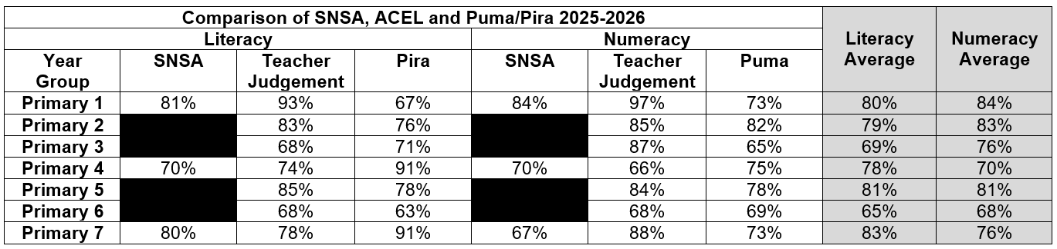
There is strong correlation within P5 Literacy (85, 78, 81), P6 Numeracy (68, 69, 68) and P2 Numeracy (85, 82). There is weak correlation at P1 literacy with a large difference between teacher professional judgement and PIRA scores. This can be attributed to children able to display skills through active learning approaches and not able to apply it in written form. In P4 and P7 literacy children have performed higher in PIRA compared to teacher judgement. This could be attributed to the quiet and focused feature of completing the assessment. When triangulating the attainment data it shows broadly consistent patterns across multiple assessment sources, with strongest performance in P5 and P7. However, there is a noticeable dip in attainment at P3 and a decline at P6 across both literacy and numeracy. Variability between SNSA, teacher judgement and standardised assessments suggests the difference methodology employed in gathering each evidence strand, supporting the need for effective pupil profiling, moderation and assessment to support teacher judgement. Numeracy is strongest in early stages, while literacy improves in upper stages.

PUMA and PIRA DATA
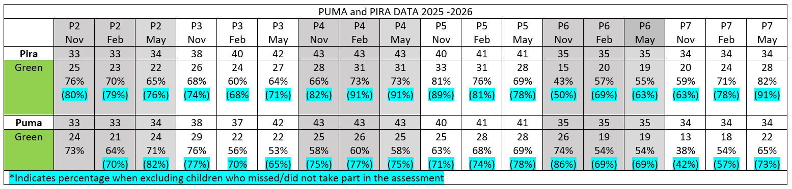
Literacy
Overall, attainment in literacy across P1–P7 is strong, with the majority of pupils achieving expected levels or above. At early stages (P1–P2), pupils demonstrate secure decoding skills and early comprehension. As pupils progress through the school, they become increasingly confident in accessing a wide range of texts, including narrative and non-fiction.
By P4–P7, most pupils demonstrate strong reading attainment, with a significant proportion achieving above-average standardised scores. However, as the cognitive demands of reading increase, greater variability emerges. In particular, pupils experience increasing challenge in higher-order reading skills, including inference, explanation, analysis and evaluation.

A consistent trend across stages shows that while pupils can retrieve information and understand texts at a literal level, some are less confident in justifying their thinking or engaging with deeper interpretation. A gender gap is also evident from P3 onwards, with boys more represented in middle and lower attainment groups.

Numeracy
Attainment in numeracy across P1–P7 is also strong, particularly in core number and calculation skills. At P1 and P2, pupils demonstrate high levels of confidence and accuracy in early numeracy. This strong foundation continues through all stages, with most pupils able to complete procedural tasks successfully.
However, as pupils progress through the school, attainment becomes more variable when they are required to apply their learning. From P3 onwards, a dip in performance is observed as tasks demand increased reasoning and problem solving. This pattern continues through P4–P7.
Across all stages, consistent areas for development include fractions, time and multi-step problem solving. These strands show lower attainment and greater variability, indicating a need to strengthen conceptual understanding and the application of skills in unfamiliar contexts.

Overall Attainment Summary
Across P1–P7, pupils demonstrate strong foundational skills in both literacy and numeracy. The key area for development is the ability to apply learning at depth, particularly in higher-order reading skills and mathematical reasoning. Variability in attainment is most evident when pupils are required to think critically, justify responses and transfer learning to new situations.

PIRA/PUMA Identified Trends based on gender
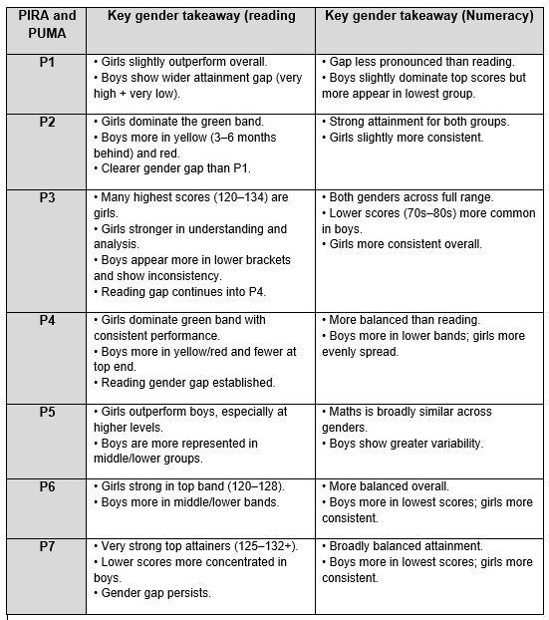
Across the school, gender analysis shows a consistent pattern in reading, where girls outperform boys, particularly at higher levels of attainment and in areas requiring deeper understanding such as comprehension and analysis. Boys are more frequently represented in lower attainment bands and show greater variability in performance.
In numeracy, attainment is more balanced overall, with no significant attainment gap between boys and girls. However, boys demonstrate greater variability, being more represented in both the highest and lowest attainment groups, while girls show greater consistency across the cohort.
Overall, the data suggests that the key area for development is closing the gender gap in reading, while continuing to support consistency and depth of understanding in numeracy for all learners.
PUMA and PIRA Value added
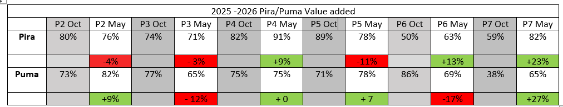

Within our tri-yearly assessments linked to PUMA and PIRA, there is a mixed picture, with progress showing as inconsistent across stages rather than universally declining. Analysis of value-added data from October to May highlights variation between cohorts rather than a whole-school reduction in attainment. While there is strong positive value added in Primary 6 and Primary 7, particularly in reading and numeracy, several middle-stage cohorts show a decline in attainment over the same period.
At Primary 3, there has been notable cohort change, with 4 children joining Woodlands during the year. In reading, the overall number of children achieving success has increased by one pupil; however, the number of pupils identified as 3–6 months behind has more than doubled to 5 pupils, resulting in an overall percentage decrease. In numeracy, a further 4 pupils joined the cohort, and 8 children were unable to participate in the assessment due to absence, illness or family circumstances. This reduced participation contributed to the number of pupils achieving their expected standard decreasing from 27 to 22, and therefore explains the reduction in percentage outcomes.
At Primary 5, the number of pupils who missed the reading assessment due to illness or family reasons more than doubled to 5 pupils. This decrease in participation resulted in attainment dropping from 33 to 28 pupils achieving, accounting for the significant percentage reduction seen within this stage.
At Primary 6, there is a similar pattern in numeracy. The number of pupils unable to participate in the assessment increased from 5 to 7, contributing to the overall drop. In addition, there has been a rise in the proportion of pupils identified as 3–6 months behind, increasing from 7% (2 pupils) in October to 21% (6 pupils) in May. This suggests that, alongside participation issues, there are emerging issues around consistency and pace of progress in numeracy learning.
These variations reflect cohort differences in starting points, levels of participation, and the increasing challenge of curriculum progression, particularly at key transition points such as transition form early to first level (Primary 3) and start of second level (Primary 5). Standardised assessments at these stages place a greater emphasis on application, reasoning and depth of understanding, which may account for lower outcomes in some cohorts despite continued learning.
Importantly, this pattern is not reflected universally across the school. End-of-level attainment data shows stronger outcomes at Primary 4 and Primary 7, indicating that many learners are able to consolidate and achieve expected levels over time. This suggests that current approaches are effective in supporting eventual attainment, but that progress within levels is variable across stages.
Overall, the data suggests that while targeted improvement strategies are having a strong impact in key stages (particularly P4 and P7), there remains a need to ensure greater consistency in progression, pace and challenge across all stages, with a particular focus on the middle stages.
End of Second Level (cohort tracking form 2019 – 2026)
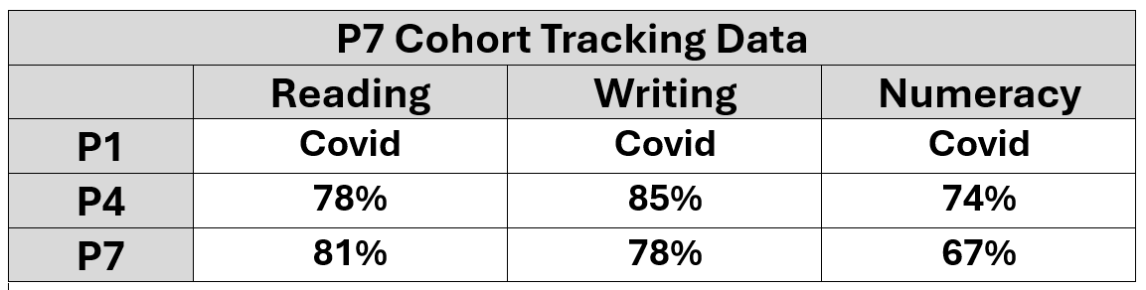
Analysis of this year’s Primary 7 cohort using SNSA data from Primary 4 to Primary 7 shows a mixed pattern of progress across curricular areas. It should be noted that Primary 1 data is unavailable due to the impact of Covid, and that the cohort has experienced some mobility, with a number of pupils joining and leaving the school between Primary 4 and Primary 7.
From Primary 4 to Primary 7, attainment in reading has improved slightly (78% to 81%), indicating steady progress in literacy for this cohort. In contrast, writing attainment has decreased (85% to 78%), suggesting that progress in writing has not been sustained at the same rate. Highlighting a whole school focus to ensure writing levels maintain or improve to promote and maintain sustainable levels of writing for school leavers.
In numeracy, attainment has declined from 74% to 67%, indicating a need to strengthen consistency in progress and depth of understanding as learners apply knowledge through the upper stages.
Overall, this data suggests that while progress in reading has been maintained, there are areas for development in writing and applying numeracy, particularly in ensuring that attainment is sustained as learners move from First to Second Level. The impact of cohort changes and the disruption to early learning should be considered when interpreting this data; however, it highlights the need to continue focusing on consistent progression, pace and challenge across the upper stages.
SDQ Summary - Primary 7 Cohort
SDQ data from this year indicates that the P7 cohort is broadly in line with Local Authority averages for wellbeing, with most pupils demonstrating strengths in prosocial behaviour and positive relationships. A key identified need relates to self-regulation and hyperactivity, rather than conduct, with a small but significant group of learners presenting with elevated levels of difficulty. Emotional concerns are present but generally lower than average and more associated with anxiety than peer relationships. Moving forward, the school will prioritise universal approaches to regulation, alongside targeted interventions for identified pupils, while continuing to build on strong relational and inclusive practice across the cohort.
Attendance and Exclusion Information: (Evidence of strategies employed to improve attendance and reduce exclusions. Please include % of current attendance and exclusion levels.)
Woodlands Primary has an attendance rate of 92.1 % which places it slightly below the North Lanarkshire Council average of 91.2%. Persistent absence at Woodlands is 24.1% (60 children) which is lower than the authority figure of 34.7%. This reflects the school’s ongoing work to promote positive attendance, maintain strong relationships with families and ensure that children feel safe, included and motivated to attend regularly. Staff implement clear procedures for contacting families promptly when unauthorised absences occur and understand the importance of early intervention.
There have been no school exclusions.
Details of consultation: Pupils/Parents/carers/staff/stakeholders.
Pupils – The Pupils are regularly consulted on the work of the school through pupil voice camp fires in their houses at assembly, learner conversations, pupil focus groups, surveys and all children are involved in Think Tank which is a range of committees which lead to whole school improvement driven by pupils. A pupil version of the improvement plan is displayed in the dinner hall and all classes with children’s feedback on progress and impact regularly recorded. What Matters to You is used to gain the views of all learners at the start of every school year and forms the basis for the work of the school.
Parents/Carers – At the start of each session parents are invited to attend an open afternoon and are provided with a parent friendly version of the improvement report and plan. Parent feedback is sought throughout the school year through surveys. What Matters to You is used to gain the views of all learners at the start of every school year and forms the basis for the work of the school. The Parent Council meet bi-monthly to review the ongoing work of the school and to link with the wider parent forum.
Wider Community - Partner agencies are encouraged to offer regular feedback as part of shared approach to support learners and community links have been reinforced with Rotary Club linked to the Peace Garden and Bowling Club to which has led to enhanced experiences for learners through involvement in Holocaust Memorial Day and wider achievement in sports. Strong links with the Educational Psychologist, SALT, Social Work and Forest School Staff ensure support for all learners and partners are regularly consulted on the work of the school through ongoing professional dialogue.
Section 2: What progress have you made in closing any poverty related attainment gap?
(Submission Dates: 5th December and 12th June 2026)
Equity Plan
Please write a brief summary (500 words max.) of your approach to ensuring equity and the progress you have made. The following key questions could be considered:
Focus on short/medium/long term outcomes. What has improved/changed for young people affected by poverty? What difference did your approach make to the wider tackling poverty agenda? In what ways are you reducing the poverty-related attainment gap? To what extent are you considering long-term sustainability as part of your planning and reporting process? What are your next steps?
There is no requirement to submit PEF/Equity Plans during session 2025-26; random sampling will continue throughout the academic session.
At mid-term review – please highlight any significant challenges to PEF plan and any significant underspends and discuss this with your EFM and/or a member of the SAC team.
October Update
(Consider planned intervention, impact and evidence)
Removing the Cost of the School Day/ Support for Children and Families - Woodlands Primary School has effectively reduced the cost of the school day to ensure equity for all learners. School uniform shop is supporting an increasing number of families. This has supported children to attend school and attendance of children in SIMD 1-3 and/or in receipt of free school meals is on par with their peers.
Sustainability - HWB teacher is working alongside class teachers and support staff to build capacity and ensure that all staff are able to support learners to engage in class and to provide appropriate supports to meet their needs. Emotion works has been implemented by all staff supported by nurture/HWB teacher and this has ensured a consistent approach to how we support our learners to manage and regulate their emotions. Learners know what to expect across the school and this has greatly reduced anxiety linked to transitions.
December Update
(Consider planned intervention, impact and evidence)
Removing the Cost of the School Day/ Support for Children and Families - Woodlands Primary School has effectively reduced the cost of the school day to ensure equity for all learners. All families have been given tickets for school show at no cost. Christmas Jumper swap shop has allowed children to wear a Christmas Jumper to school at no cost to families. All learners will be provided with festive activities at no cost to parents. Families in need of support are to be gifted ASDA gift cards to support cost of Christmas and links to charities has helped to provide toys for families in need. This has supported children to attend school and attendance of children in SIMD 1-3 and/or in receipt of free school meals is on par with their peers.
Sustainability - HWB teacher is working alongside class teachers and support staff to build capacity and ensure that all staff are able to support learners to engage in class and to provide appropriate supports to meet their needs. Emotion works has been implemented by all staff supported by nurture/HWB teacher and this has ensured a consistent approach to how we support our learners to manage and regulate their emotions. Learners know what to expect across the school and this has greatly reduced anxiety linked to transitions. HWB teacher is supporting high number of learners who are anxious in school and struggling with attendance. Nurture groups are up and running for identified learners to support them in school. Forest School is run every Thursday to provide outdoor learning for identified learners and provides them with a High 5 Award.
Additional Staffing – Identified learners in P3 and P6 have been supported by CST with data showing increased attainment. Identified learners at P2,3,5 and 7 have been given block of support for identified areas of literacy and due to additional staffing, evidence in class demonstrates positive impact on attainment and on pupil confidence in reading.
March Update
(Consider planned intervention, impact and evidence)
Sustainability - Emotion works has been implemented by all staff supported by nurture/HWB teacher and this has ensured a consistent approach to how we support our learners to manage and regulate their emotions. Learners know what to expect across the school and this has greatly reduced anxiety linked to transitions. HWB teacher is supporting high number of learners who are anxious in school and struggling with attendance. Nurture groups are up and running for identified learners to support them in school. Forest School is run every Thursday to provide outdoor learning for identified learners and provides them with a High 5 Award.
Additional Staffing – Identified learners in P3 and P6 have been supported by CST with data showing increased attainment. Identified learners at P2,3,5 and 7 have been given block of support for identified areas of literacy and due to additional staffing, evidence in class demonstrates positive impact on attainment and on pupil confidence in reading.
End of Session Update (June 2026)
Consider overall impact of PEF plan and evidence.
All learners are supported by a nurturing ethos and approach which is embedded in practice across all areas of the school and was recognised as a strength of the school during VSE.
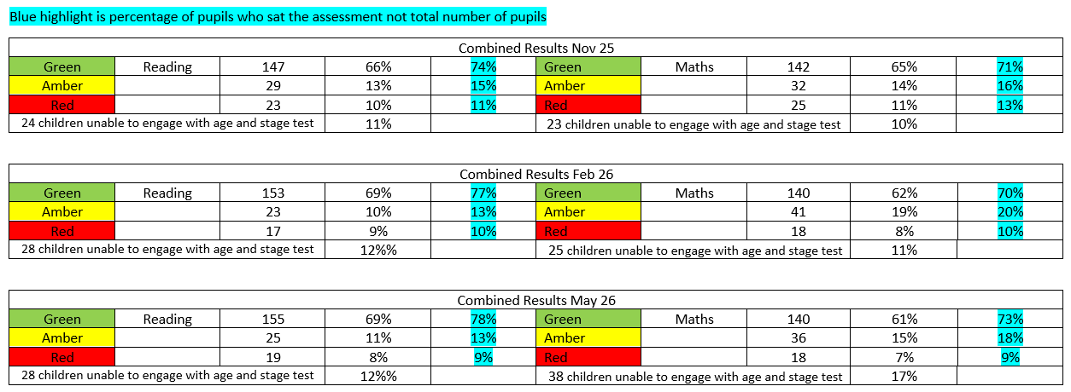

From October to May the school observed an increase from 74% to 78% of pupils achieving a level in literacy/Reading and an increase from 71% to 73% of pupils achieving a level in numeracy. Due to a variety of reasons (illness/ holidays/absence) more children were unable to participate in the Numeracy assessment in May.
Distressed and dysregulated behaviour has decreased across the school as a result of targeted support and interventions and all learners, with exception of 2 children, are engaging and coping well in school.
Attendance across the school has increased and is above NLC average, number of learners with persistent nonattendance continues to decrease and is below NLC average (percentages recorded above) as a result of additional supports in school for children and parents in supporting attendance.
Additional support for Health and Wellbeing, attainment and attendance of identified learners:

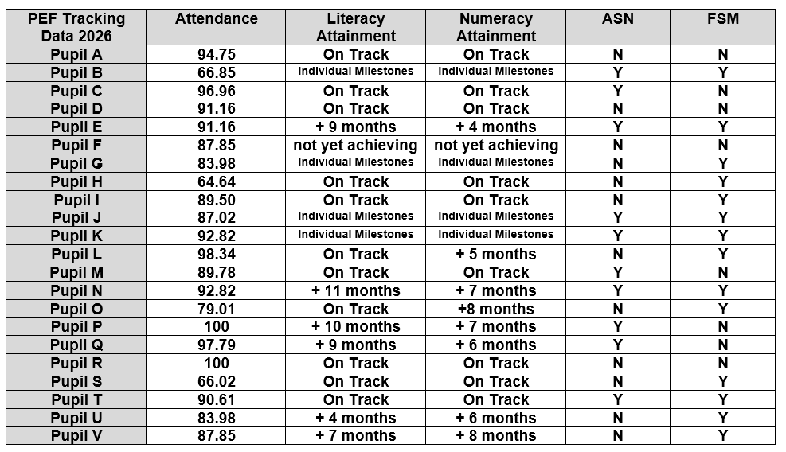

Within Q1, 31% of children are receiving direct support from the Health and Wellbeing and nurture teacher. Attainment within this group is currently low, with 20% achieving expected levels in literacy and 16% in numeracy. Socio-economic factors are significant, with 64% of this group in receipt of free school meals.
Attendance data for this cohort shows considerable variability, ranging from 64.6% to 100%, with an overall average of 87.9%. This is below both the national expectation (approximately 90–95%) and the North Lanarkshire Council average of 92.4%. The data highlights a significant gap between the highest and lowest attenders. Half of the identified group (11 out of 22 pupils) are not yet meeting expected attendance levels of 90% or above. Within this, a significant minority (6 pupils) have attendance below 85% and three pupils (B, H, S) whose attendance is below 70%. In contrast, a small group (5 pupils) demonstrate excellent attendance, providing a strong foundation for learning. This variation suggests that while targeted support is in place, further work is required to address attendance as a key barrier to improving outcomes for specific pupils in this Q1 group.

Section 3: Summary of Impact of Annual Improvement Plan Priorities (Submission June 2026)
Priority 1 (Long Term Outcome): A new whole school approach to curriculum design and delivery will empower all learners to achieve their potential in literacy and numeracy, make connections in and across their learning, apply their skills across curricular areas and make choices in what and how they learn.
(Please insert the relevant information below)
NIF Priority:  1. Placing the human rights and needs of every child and young person at the centre of education  2. Improvement in children and young people’s health and wellbeing;  4. Improvement in skills and sustained, positive school leaver destinations for all young people. | NIF Driver:  1.School and ELC Leadership  2.Teacher and Practitioner Professionalism  3.Parent/Carer Involvement and Engagement  4.Curriculum and Assessment
NLC Priority:  2.Closing the attainment gap between the most and least disadvantaged children  3.Improvement in children and young people’s health and wellbeing with a focus on mental health and wellbeing  4.Improvement in employability skills and sustained, positive school leaver destinations for all young people | QI:  1.2: Leadership for learning  1.3: Leadership of change  2.2: Curriculum  2.3: Learning teaching and assessment  3.1: Ensuring wellbeing, equality and inclusion  3.2: Securing children’s progress  3.3: Developing creativity and skills for life
If you used any aspect of your PEF fund to support this priority; please detail the expenditure here:
Additional staffing (0.5 PEF fund match £40,000) for targeted interventions, staff CLPL/ongoing training (£3000 – partially funded by PEF), forest school (0.1FTE £7,000) funded by PEF.
RATIONALE: Observation of pupil engagement throughout the school highlights specific areas of challenge including motivation, resilience and ability to work co-operatively with others to extend and enhance learning. Pupils require support to make meaningful links across learning and identify where skills can be transferred. Work in assessment jotters shows lacks volume and variety in terms of methods of assessing (write/say/make/do). Learner conversations, pupil focus and staff professional discussions groups all identify need for a curriculum design which embeds and enhances skills-based learning approaches, play and enquiry based learning, STEM and outdoor learning from P1-7 and provides opportunities for learners to make decisions as to how learning is captured. Initial trial of change in approach has shown increased motivation and learner engagement thus leading to whole school change. In order to meet future NLC targets a further increase of 8.3% in numeracy is required and intervention in writing to close the gaps in identified stages (P1 into P2, P5 into P6 and P6 into 7 with focus on next years P3 and P7 cohort.
OUTCOMES:
Targeted support for identified learners to improve attainment in literacy and numeracy.
Whole school approach to curriculum design and delivery which engages and motivates all learners.
Consistent pedagogical practice which ensures pace challenge and differentiation at all stages.
EXPECTED IMPACT:
Attainment in numeracy will increase by 8% (2-4chn) to 10% (4-chn) at all stages.
Attainment in writing increased by 10% (4-6chn) at all stages.
Attainment of learners identified for targeted support will increase by 5%.
Summary of Progress and Impact: (based on outcomes for learners): (How are you doing? How do you know? What action was taken and what was the impact?)
- The Validated Self Evaluation (VSE) undertaken in March 2026 identified that the school’s new approach to curriculum design and delivery was having a positive impact on learners however this was at the early stages of development. Feedback from learners through learner conversations and focus groups highlights this as an aspect of learning they enjoy along with opportunities to select favourite aspects of prior learning as part of the monthly showcase. Learners identified for support through regular analysis of data have shown significant gains in their learning. Targeted support from learning assistants in primaries 1-3 along with support at primaries 4-6 from CST has led to an increase from 74% to 78% of pupils achieving a level in literacy/Reading and a 71% to 73% of pupils achieving a level in numeracy, as demonstrated through range of assessment including ACEL, SNSA, PUMA/PIRA and YARK.
- Attainment in writing at P1, P4 and P7 has increased according to teacher judgement by 8pp in P4 and 15pp in P7. SNSA results show P1 are testing at 81% (2 % However, lower than the national average). P4 are testing at 65% (1% above the national average), and P7 are testing at 78% (15% above the national average). evidence in jotters demonstrates that learners continue to struggle with application during daily writing and lack stamina in taught writing. Development of whole school consistent approaches to writing is at the early stage and is a priority for next session.
- Numeracy attainment is a clear strength. SNSA results indicate P1 at 84% (4% above national average), P4 at 70% (16% above), and P7 at 67% (6% above). Performance has remained steady throughout the year, with P1 achieving 73% in May PUMA assessments and P4 maintaining a consistent 75% attainment rate. Primary 7 has demonstrated significant improvement, increasing by 29 pp from 42% in October to 73% in May. This improvement is attributed to planned daily revision of key concepts. While learners demonstrate strong understanding of number processes, PUMA data highlights problem-solving and specific areas of mathematics as priorities for further development.
Next Steps: (What are we going to do now?)
- Embed consistent whole school approaches to pedagogy to ensure pace, challenge and differentiation for all learners with high quality feedback and questioning at all stages.
- Develop pupil profile which demonstrates learning and supports self and teacher feedback.
Establish a whole school approach to daily and taught writing including handwriting, grammar, punctuation and spelling.
Priority 2 (Long Term Outcome): A robust approach to supporting learners with additional support needs, with a focus on health and well-being, involving all stakeholders will ensure that all learners receive the support needed to build emotion well-being and resilience.
(Please insert the relevant information below)
NIF Priority:  1. Placing the human rights and needs of every child and young person at the centre of education  2. Improvement in children and young people’s health and wellbeing; | NIF Driver:  1.School and ELC Leadership  2.Teacher and Practitioner Professionalism  3.Parent/Carer Involvement and Engagement  4.Curriculum and Assessment
NLC Priority:  3.Improvement in children and young people’s health and wellbeing with a focus on mental health and wellbeing  4.Improvement in employability skills and sustained, positive school leaver destinations for all young people | QI:  1.2: Leadership for learning  1.3: Leadership of change  2.2: Curriculum  3.1: Ensuring wellbeing, equality and inclusion  3.2: Securing children’s progress  3.3: Developing creativity and skills for life
If you used any aspect of your PEF fund to support this priority; please detail the expenditure here:
0.5 PEF fund match teacher at cost of approximately £40,000 provides additional 1FTE staffing and ensures a full time HWB/Nurture teacher to support identified learners. 0.1 FTE to support Forst School at cost of £7000.
RATIONALE: The number of learners with additional support needs equates for 50% of the school population, this includes a wide variety of social and emotional, behavioural, language and communication and learning needs. For some identified learners, parents are struggling to manage their needs at home and are increasingly looking to school for support, this is also impacting on their child both in and out of school. Lack of resources available to parents and carers means in most cases school is sole support with parents and carers seeking support for their child’s emotional health and well-being. Increasing numbers of learners are presenting with emotional dysregulation and at times find learning within the traditional classroom environment challenging. In order to meet the current needs of learners and ensure that all children are engaged and attending school further enhancement of current HWB supports is a priority.
OUTCOMES:
Targeted HWB supports and interventions for identified learners displaying distressed and dysregulated behaviours.
All learners will be supported to build their skills in emotional regulation and resilience.
‘What Matters to You’ survey will gather the views of all stakeholders and underpin school values.
EXPECTED IMPACT:
Attendance and engagement of identified learners will increase.
Number of children displaying distressed and dysregulated behaviour will decrease.
All learners will be able to use skills learned to help them regulate in school.
All stakeholders will share the school vision, values and aims creating strong partnership approaches and a positive school ethos where all are valued.
Summary of Progress and Impact: (based on outcomes for learners): (How are you doing? How do you know? What action was taken and what was the impact?)
- Attendance has increased and is currently 92.1 with persistent nonattendance at 24.1. Support for learners through targeted HWB interventions have improved school attendance and engagement. Learner feedback using GMWB toolkit demonstrates increase in motivation and confidence of identified learners.
- All but 2 leaners have demonstrated a decrease in dysregulated and distressed behaviour and are able to sustain being in class. Observation across the school shows that all learners are coping within their class environment as a result of a strong nurturing approach across all areas of school, nurturing environments and supports which meet their needs. VSE in March 2026 recognised the ethos of the school including its strong roots in nurture as a strength of the school.
- Feedback from learners during class visits and focus groups highlights emotion works as an effective tool in helping them understand and regulate their emotions. Class displays highlight work that has been undertaken to support regulation strategies and learners are able to talk confidently about this aspect of their work.
- Vision and values of the school are shared by all stakeholders and there is a very strong sense of partnership working which improves outcomes for learners. Recent VSE and Care Inspectorate Inspection in nursery recognized this as a strength of the school and feedback from parents and partners was strong and consistent.
Next Steps: (What are we going to do now?)
- Continue to promote and strengthen use of emotion works across all stages to support learners HWB.
- Continue targeted support for identified learners to support their engagement in the wider life of the school.
- Expand work with parents to include handy hints and parent workshops linked to emotion works.
Nursery Priority (Long Term Outcome): All learners will have experience high quality play-based learning with a key focus on developing their skills in literacy and numeracy.
(Please insert the relevant information below)
NIF Priority:  1.Improvement in children and young people’s health and wellbeing;  2.Closing the attainment gap between the most and least disadvantaged children and young people;  3.Improvement in attainment, particularly in literacy and numeracy. | NIF Driver:  1.School and ELC Leadership  2.Teacher and Practitioner Professionalism  3.Parent/Carer Involvement and Engagement  4.Curriculum and Assessment  5.School and ELC Improvement
NLC Priority:  1.Improvement in attainment, particularly literacy and numeracy  2.Closing the attainment gap between the most and least disadvantaged children  3.Improvement in children and young people’s health and wellbeing with a focus on mental health and wellbeing  5.Improved outcomes for vulnerable groups | QI:  1.1: Self-evaluation for self-improvement  1.3: Leadership of change  1.4: Leadership and management of staff  2.3: Learning teaching and assessment  2.4: Personalised support  3.1: Ensuring wellbeing, equality and inclusion  3.2: Raising attainment and achievement
If you used any aspect of your PEF fund to support this priority; please detail the expenditure here:
N/A
RATIONALE: A high percentage of learners entering nursery present with language and communication skills which are significantly below their chronological age which is impacting on their ability to interact meaningfully with peers and adults. Most learners continue to show gaps in basic literacy and numeracy skills and need support to encourage them to use these skills in their play. Ongoing evaluation and observation has shown that some learners need support to manage their day, in particular they have responded well to opportunities to engage in adult led learning experiences, particularly during the afternoon session. As the permanent staff team continue to strengthen working relationships to meet the needs of the learners, continued focus on ongoing evaluation and improvement using revised care standards/HGIOELC will ensure a culture of continuous improvement.
OUTCOMES:
Opportunities for learners to develop their skills in literacy and numeracy will be available in all areas of the nursery supported by high quality resources.
Language and communication will be supported through high quality interactions and provocations including support for identified learners.
All staff will engage in self-evaluation of their collective/individual practice using revised quality framework.
EXPECTED IMPACT:
Attainment in literacy and numeracy of all learners will increase.
Almost all learners will make progress in their language and communication, demonstrating skills in line with age/stage.
All staff will demonstrate knowledge and understanding of self evaluation, revised quality framework and their role in ongoing improvement.
Summary of Progress and Impact: (based on outcomes for learners): (How are you doing? How do you know? What action was taken and what was the impact?)
- Tracking discussion with key workers demonstrates that almost all learners in nursery are attaining appropriate levels of literacy and numeracy as demonstrated through daily interactions and observations. Nursery environment effectively supports learners to develop their literacy and numeracy skills through high quality resources and areas that are literacy and numeracy rich. The high-quality environment was recognised by Care Inspectorate in May 2026.
- Interventions to support learners’ development of language and communication including rhyme time and story time have impacted positively on oral communication. Learners are now leading their own rhyme time demonstrating independence and confidence. All learners in nursery are more able to make their needs known.
- All staff are developing a shared understanding of good practice using revised quality framework. Staff are able to evaluate current approaches in line with best practice and identify next steps for development which lead to improved experiences and outcomes for learners through high quality environment. Staff have successfully evaluated current approaches to personal planning leading to revised care plans.
Next Steps: (What are we going to do now?)
- Continue to develop approaches to planning, observation and assessment which is clearly focussed on significant aspects of learning including next steps.
- Continue to develop systems and approaches to tracking learner progress including new care plans.
- Ongoing self-evaluation and improvement linked to revised quality framework.

Section 4: Key strengths/successes linked to Quality Indicators
(NB: establishments should continue to ensure that their own self-evaluation calendar reflects a cyclical coverage of all quality indicators.)
Using the information gathered through ongoing self-evaluation processes, including discussions in family groups, please briefly outline key strengths/successes in relation to each of the core QIs, and next steps. (QIs should not exceed 500 words.) If your establishment has a nursery, please also include nursery key strengths/successes within each QI.
Please refer to submission information on page 1, which outlines required submission dates for the core Q.I.s, when completing this document.

How good is our leadership and approach to improvement?
QI 1.3 Leadership of change
Developing a shared vision, values and aims relevant to the school and its community | Strategic planning for continuous improvement | Implementing improvement and change
Please identify relevant NIF details and highlight links to SIP/PEF Plans. Please record specific PEF evaluations in blue.
NIF Priority: 1. Improvement in attainment, particularly in literacy and numeracy and 3. Improvement in children’s and young people’s health and wellbeing.
NIF Driver: School Leadership, School Improvement and Teacher Professionalism.
UNCRC: Article 29 – Goals of Education
RECR (if appropriate): N/A
Linked SIP/PEF Priority (if applicable): Priority 1 – Curriculum Design and Delivery, Priority 2 – HWB and Supporting Learners Needs, Nursery Priority – High Quality Play with focus on literacy and numeracy.
How well are you doing? What’s working well for your learners?
- The school upholds a strong, rights-based ethos that nurtures positive relationships and provides a safe, inclusive environment where all learners and families are well supported.
- All staff are committed to meeting the needs of learners to ensure they reach their potential. This commitment is reflected in daily practice and embedded across all aspects of school life.
- Led by the Head Teacher there is a collaborative culture for school improvement. This ensures almost all staff have a shared understanding of the vision for school improvement.
- All staff are committed to continuous improvement and adjust their learning and teaching approaches to ensure best practice that meets the needs of learners and the community. They engage in relevant CLPL to improve pedagogical practice.
- All staff engage well in self-evaluation activities and demonstrate the capacity to reflect on the school’s strengths. They collectively identify evidence-based, data-driven priorities for future improvement. Most staff are becoming increasingly active and confident in this process.
- All teachers undertake leadership roles, linked to the improvement plan. As part of the PRD process. SMT encourage individuals to lead specific areas based on their strengths and skills. This impacts positively on the pace of change and improvement.
- Staff work well collegially to implement, and effect change to ensure continuous improvement for learners.
- Academic and wider achievements are celebrated to ensure that achievements of all learners are embraced and celebrated and that all children experience success.
- Robust quality assurance procedures are in place and implemented consistently. This ensures quality experiences and improved outcomes for most learners.
- All stakeholders are involved in sharing and promoting vision and aims of the school across the school and wider community. As a result, these are now well embedded and provide a focal point for improvement activity.
- Almost all staff have a clear understanding of the social, economic and cultural context in which children and their families live, supporting planning for improvement.
How do you know? What evidence do you have of positive impact on learners?
- The school upholds a strong, rights based ethos that nurtures positive relationships and provides a safe, inclusive environment where all learners and families are well supported.
- All staff are committed to meeting the needs of learners to ensure they reach their potential. This commitment is reflected in daily practice and embedded across all aspects of school life.
- Led by the Head Teacher there is a collaborative culture for school improvement. This ensures almost all staff have a shared understanding of the vision for school improvement.
- All staff are committed to continuous improvement and adjust their learning and teaching approaches to ensure best practice that meets the needs of learners and the community. They engage in relevant CLPL to improve pedagogical practice.
- All staff engage well in self-evaluation activities and demonstrate the capacity to reflect on the school’s strengths. They collectively identify evidence based, data driven priorities for future improvement. Most staff are becoming increasingly active and confident in this process.
- All teachers undertake leadership roles, linked to the improvement plan. As part of the PRD process. SMT encourage individuals to lead specific areas based on their strengths and skills. This impacts positively on the pace of change and improvement.
- Staff work well collegially to implement, and effect change to ensure continuous improvement for learners.
- Academic and wider achievements are celebrated to ensure that achievements of all learners are embraced and celebrated and that all children experience success.
- Robust quality assurance procedures are in place and implemented consistently. This ensures quality experiences and improved outcomes for most learners.
- All stakeholders are involved in sharing and promoting vision and aims of the school across the school and wider community. As a result, these are now well embedded and provide a focal point for improvement activity.
- Almost all staff have a clear understanding of the social, economic and cultural context in which children and their families live, supporting planning for improvement.
What are you going to do now? What are your improvement priorities in this area?
- Continue to work with all stakeholders to strengthen the improvement process including identifying strengths and areas for improvement throughout the school year through regular stakeholder consultation and engagement.
- Embed work of Professional Learning Community to ensure staff leadership of whole school improvement.
- Continue to embed new vision and values with all stakeholders.

How good is the quality of care and education we offer?

QI 2.3 Learning, teaching and assessment
Learning and engagement | Quality of teaching | Effective use of assessment | Planning, tracking and monitoring
Please identify relevant NIF details and highlight links to SIP/PEF Plans. Please record specific PEF evaluations in Blue.
NIF Priority: Improvement in children's and young people’s health and wellbeing.
Improvement in attainment, particularly in literacy and numeracy.
NIF Driver: Assessment of Children’s Progress & School Improvement
UNCRC: Article 28 – Right to Education Article 29 – Goals of Education
RECR (if appropriate):
Linked SIP/PEF Priority (if applicable): Priority 1 and 2
How well are you doing? What’s working well for your learners?
- Across the school, all learning environments are built on positive and nurturing relationships which leads to high quality learning outcomes for learners. Nurture principles are embedded in almost all classes.
- All staff are embracing innovative approaches to learning and teaching to better meet the needs of learners and ensure that all have opportunity to learn in a way that meets their needs.
- All staff are inclusive and use nurturing approaches to support learners and meet their needs.
- All staff use a range of teaching approaches to engage and motivate learners. Learners in P3–7 are increasingly able to choose and use high-quality resources, including digital technologies, to support their learning. This approach is beginning to develop further at early level.
- All staff work collaboratively to meet the needs of learners through shared planning opportunities, moderation and opportunities to share good practice.
- Most teachers plan to ensure the curriculum and learning and teaching approaches emphasise skills development and promotes skills for life, learning and work. As a result, Most/Majority of learners are playing an increasingly active role in leadership within school and are being actively encouraged to encouraged to be independent in their learning through opportunities to select and design their own learning tasks.
- The majority of staff provide meaningful feedback, both orally and written format, As a result, most learners receive feedback on their progress including next steps to help them improve.
- Most learners are encouraged and supported to give feedback to their peers through range of approaches including learning partners, using traffic lights and orally.
- All teacher use a range of learning environments and teaching approaches to motivate and engage learners.
- All learners experience varied and active learning through Play, STEM and continuous provision in classes.
- Most staff plan effectively to meet learners needs. They use progression pathways, to ensure breadth and depth in learning. As a result, most learners’ experiences are appropriately challenging and matched to their needs and interests, with some opportunities for personalisation and choice in some curricular areas.
- Staff are becoming more confident in the use of digital approaches to enhance and support learners, at First and Second level.
- All staff are involved in regular moderation discussions to ensure shared expectations and standards within and at end of a level.
- Most staff use a wide range of assessment information, as outlined in the quality assurance calendar, to inform teacher professional judgements and inform planning that supports continuous improvement.
- Assessment information is used meaningfully during discussions/tracking meetings to plan for continuous improvement and inform decisions around interventions.
- All learners’ progress and achievement is regularly reviewed to ensure all learners, including those who are most deprived and children who are care experienced, make good progress from previous levels of achievement.
- Robust tracking and monitoring procedures are in embedded in practice to support continuous progress for learners. As a result, steady progress from previous levels of attainment is evident for the majority of learners.
- Learners are regularly engaged in discussion around their progress and most are becoming more able to identify how to improve their own learning with progression evident throughout school.
- All Parents are given accurate information regarding pupil progress, and their views are sought in how school is meeting their child’s learning needs and next steps.
How do you know? What evidence do you have of positive impact on learners?
- Most class environments have been adapted to encourage application of learning and allow children to select the skills they want to work on. Continuous provision for active and engaged learning within and out of the class base encourages children to revisit prior learning and enhance and develop their skills further, this is further enhanced by Monthly Masterclass where learners select learning they would like to revisit.
- All planning for learning and teaching focusses on development of skills for life.
- Pupils are involved in leading work of the school through involvement in Think Tank Friday with all learners part of a committee.
- Pupils are regularly encouraged to lead learning through pupil focus groups, learner conversations, camp fires, learning diaries and monthly house assemblies (House Hangout).
- Traffic lighting is used consistently from primaries 1-7 to give instant feedback on learning, this is both teacher and learner driven. In most classes written feedback is given for specific lessons and oral feedback given regularly.
- Feedback in jotters includes some opportunities for self and peer assessment, children work regularly with a learning partner to offer oral feedback on learning.
- Discussion with learners during class visits highlights wide range of approaches in use to engage children in learning.
- Observations of active and play based learning are used to assess learner’s progress alongside review of daily tasks, teacher judgement and more formal assessments.
- Puma/Pira data along with teacher judgement is used to identify targeted support for literacy and numeracy. Data is used to identify whole school areas for improvement/intervention, specific class/year group interventions and targeted support for individuals and groups.
- Assessment jotters are used to demonstrate progress in learning throughout the year and from stage to stage.
- Dashboard in place for each year group which provides details of all data including SNSA, Puma/Pira, teacher judgement and interventions to ensure a wide and clear picture for all children. SMT meet termly with staff to analyse data and identify future priorities and improvements.
What are you going to do now? What are your improvement priorities in this area?
- Enhance and formalise recognition of wider achievements through record keeping including extending learning diaries to include wider achievements and home learning and populate wider achievement tab within data dashboard.
- Continue to enhance and embed continuous provision within classes as part of new approach to curriculum design and delivery.
- Continue to enhance and develop assessment strategies to ensure high quality feedback in all lessons including consistent approaches to self and peer assessment and questioning.

How good are we at improving outcomes for all our learners?

QI 3.1 Ensuring wellbeing, equality and inclusion
Wellbeing | Fulfilment of statutory duties | Inclusion and equality
Please identify relevant NIF details and highlight links to SIP/PEF Plans. Please record specific PEF evaluations in Blue.
NIF Priority: Improvement in children and young people’s health and wellbeing. Closing the attainment gap between the most and least disadvantaged children and young people.
NIF Driver: Teacher and practitioner professionalism. Parent/carer involvement and engagement.
UNCRC: Article 3: Best interest of the child. Article 28: Right to education.
RECR (if appropriate): N/A
Linked SIP/PEF Priority (if applicable): Priority 1 – Curriculum Design and Delivery, Priority 2 – HWB and Supporting Learners Needs, Nursery Priority – High Quality Play with focus on literacy and numeracy.
How well are you doing? What’s working well for your learners?
- All staff have a strong commitment to ensuring the wellbeing of learners. They have good understanding of GIRFEC and UNCRC and this is evident in their practice.
- All staff, pupils and some parents have a good understanding of children’s rights and these are integral to the culture, values and ethos of the school.
- All staff are proactive in meeting the individual needs of children within their class and the wider school and use wide range of supports to ensure that the health and wellbeing of all children is supported.
- All staff are actively involved in creating and reviewing support plans for children to ensure that the needs of all learners are met.
- Across the school, teaching and non- teaching staff consistently model behaviours that actively promote and sustain the wellbeing of all learners. Their strong commitment to children, families and colleagues is evident in proactive, timely responses to emerging needs, which contributes to a positive, nurturing culture across the school.
- All staff comply with statutory duties and procedures relating to Child Protection. Staff use CLPL to keep abreast of current legislation, guidance and advice both locally and nationally and this ensures that everyone is clear about their professional duties and responsibilities.
- HWB (SHANARRI) indicators are understood and used by all teachers formally and informally to regularly assess and review the needs of learners.
- Inclusion is a strong feature within our school both in terms of meeting the needs of learners with additional needs and removing barriers to ensure equity for all.
- SMT are proactive in supporting families and staff demonstrate an exceptional level of commitment to supporting families. This has created an ethos where children and families feel safe and listened to and are secure in the ability to discuss personal/sensitive aspects of family/personal lives.
- Behaviour in the school is positive and most children respond well to the supports and structures in place. Children, staff and parents are highly supportive of each other and relationships are positive.
- All children benefit from a strong universal approach to developing positive HWB, underpinned by nurture principles and trauma informed practice training. This is a fundamental feature of school ethos and practice. Bespoke nurture approaches are used effectively to support identified learners.
- Pupils voice is strong and children are always listened to and are given opportunity to chat with their class teacher, nurture/HWB teacher or SMT through learner conversations, bubble time, camp fires, etc and children regularly approach staff for support.
- School improvement priorities include regular opportunities to review legislation and codes of practice and is a key feature of staff meetings and training.
- School policies ensure and promote best practice in wellbeing, equality and inclusion based on up-to-date legislation and guidance.
- Planning for children with specific barriers is robust to ensure their needs are met and the correct intervention considered. As a result, interventions to support individual children are impacting positively.
- Wellbeing of all children is assessed as part of ongoing assessment procedures and demonstrates improved outcomes for all.
- Interventions to ensure equity for individuals and groups facing barriers to learning are improving outcomes and attainment.
- School assemblies are all rights/SHANARRI based and support inclusivity and diversity and encourage all children to challenge discrimination.
- The school learning environment promotes inclusion and provides variety of safe spaces for all children.
- Outdoor environment has been developed to provide wide range of learning opportunities and spaces that will meet the needs of all learners taking into account different interests.
- All staff have achieved The Promise and are committed to supporting care experienced learners in our school.
How do you know? What evidence do you have of positive impact on learners?
- School has previously received two RRS Gold awards and is UNCRC is embedded in all practice.
- All staff have engaged in Circle training/IOC and used this to evaluate their own practice and shared approaches throughout the school and have ensured that the learning environment they create meets the children’s needs.
- All staff have engaged in training in Emotion Works and are involved in embedding this throughout the school. School have achieved their bronze award and are working towards silver.
- All staff are fully trained in GIRFEC and demonstrate this within their daily practice where learning approaches and environments are adapted to meet individual needs.
- All school events are free of charge and all steps have been taken to reduce and remove as much as possible the cost of a school day including non-branded uniform, clothing and food banks.
- Effective supports are in place to support all learners to experience positive relationships within school including bespoke programmes of intervention for pupils experiencing trauma/dysregulation and with specific additional support needs.
- HWB teacher with nurture qualifications is in place to support identified pupils on a planned basis and to respond to crisis/challenge.
- Forest School is in place for identified children and supports them to achieve their High 5 Award.
- Communication with parents and partners regarding wellbeing and inclusion through parent’s nights, reports and meetings.
- Boxhall Profile/Gasgow Motivation and Wellbeing Profile are used to measure impact of support for identified learners.
- Data demonstrates that attainment for all learners is improving and that individuals facing barriers to learning are making gains in attainment.
- All children have 2 hours of PE per week, outdoor learning including PE makes good use of outdoor space.
- Staff have engaged in training through Outreach Support from We Aspire to support dysregulation and effectively use de-escalation strategies.
- Feedback from stakeholder groups linked to consultation on school values recognise inclusion and good relationships as key factors that underpin our school.
- All staff have increased knowledge of their corporate parenting responsibilities and school have achieved the national Keeping the Promise Award (We Promise level) with a positive impact on GIRFEC Planning.
- All learners are engaged in clubs delivered monthly within the school day to meet learner needs through Fun 31.
What are you going to do now? What are your improvement priorities in this area?
- Continue to enhance involvement of and communication with parents, partners and wider community around wellbeing and inclusion including SHANARRI.
- Extend use of Glasgow Motivation and Wellbeing Profile to measure wellbeing of all learners annually.
- Use of Leuvens Scale to measure learner engagement in identified areas.

How good are we at improving outcomes for all our learners?

QI 3.2 Raising attainment and achievement
Attainment in literacy and numeracy | Attainment over time | Overall quality of learners’ achievement | Equity for all learners
Please identify relevant NIF details and highlight links to SIP/PEF Plans. Please record specific PEF evaluations in Blue.
NIF Priority: Improvement in children and young people’s health and wellbeing. Closing the attainment gap between the most and least disadvantaged children and young people.
NIF Driver: Teacher and practitioner professionalism. Parent/carer involvement and engagement.
UNCRC: Article 3: Best interest of the child ,Article 28: Right to education.
RECR (if appropriate): N/A
Linked SIP/PEF Priority (if applicable): Priority 1 – Curriculum Design and Delivery, Priority 2 – HWB and Supporting Learners Needs, Nursery Priority – High Quality Play with focus on literacy and numeracy.
How well are you doing? What’s working well for your learners?
Based on 2024-25 data;

- Most learners are achieving appropriate levels in literacy and numeracy, based on P1,4,7 combined.
- At P1 and P4 stages, most learners achieve expected levels in all 3 literacy organisers and numeracy.
- At the P4 stage, most learners achieve expected levels in L&T and majority in reading, writing and numeracy.
- Almost all learners are making progress in their learning, from previous levels.
- Raising attainment in literacy and numeracy are key to the school priorities for improvement which is leading to increased attainment.
- Progress is demonstrated through robust tracking and monitoring of attainment over time in literacy and numeracy at all stages.
- Tracking and monitoring of attainment in all curricular areas based on teacher judgement is improving at all stages.
- Data demonstrates most learners are making good progress.
- Confident teacher judgement along with range of assessment are impacting positively on accuracy and rigour in teacher professional judgements about attainment over time.
- Learners are encouraged to have a say in the quality of their learning experiences and how to improve.
- Attendance levels are high, slightly above NLC average, and there are no school exclusions.
- Inclusion is successful for almost all learners.
- Effective tracking systems are implemented to monitor the impact of interventions and school improvements on learner progress.
- Attainment Data for November shows steady improvement in literacy and numeracy.
- Attainment data used effectively to identify appropriate interventions and support throughout the year.
- Outdoor learning is being used at all stages to support learning.
- Cost of the School Day Policy underpins our approach to ensuring that no child misses out due to financial barriers.
How do you know? What evidence do you have of positive impact on learners?
- Parent Information Night involving parents and pupils shared new approaches to curriculum design and delivery to meet learner needs.
- Outdoor learning is a key feature of curriculum design and being developed at all stages.
- Strong links with partner agencies supports learners at key stages including transition.
- Termly updates provide information for all parents on supporting learners at home.
- Weekly class blogs share learning with parents and carers.
- Termly tracking meetings measure/ensure progress of all learners with data based on solid teacher judgement backed by robust assessment.
- Data demonstrates that attainment for all learners is improving and that individuals facing barriers to learning are making gains in attainment.
- Data demonstrates that almost all learners in P3 and P6 receiving targeted literacy interventions have made progress since August.
- Evidence from High 5 Award for identified learners attending forest school.
- Emotion works prominent throughout school and language is used by most learners.
- Current data used to inform future supports and interventions.
- Puma and Pira and SNSA along with teacher judgement used effectively to evaluate progress.
- Anomalies between assessment data (PUMA/PIRA) and teacher judgement are identified through tracking meetings and next steps identified to ensure robust approaches to securing learner progress including use of PHAB, YARK and MALT assessment.
- Wider achievement of learners is recognised and celebrated at school assemblies and displayed in school.
What are you going to do now? What are your improvement priorities in this area?
- Enhance approaches to tracking and monitoring wider achievement of all learners.
- Continue to develop approaches to tracking and monitoring attainment of BGE at all stages.
- Continue to enhance and embed outdoor learning at all stages.

Section 5: NIF Quality Indicators: Summary (Submission June 2026)
Assigning levels using quality indicators
School/centres should evaluate aspects of their work using the following core Quality Indicators (QIs). Levels should be assigned using the national 6-point scale. Where there has been a recent (post- August 2016) HMIE inspection, the levels awarded should also be included. Please note that the level should relate to the entire QI and not a specific theme.
Quality indicator | School self-evaluation | HMIE Inspection evaluation (if appropriate)
1.3 Leadership of change | Good
2.3 Learning, teaching and assessment | Good
3.1 Ensuring wellbeing, equity and inclusion | Very Good
3.2 Raising attainment and achievement | Good

Early Years – HMIe & Care Inspectorate (from September 2025)
Quality indicator | Establishment self-evaluation | HMIe evaluation
1 Leadership | Good
2 Children thrive and develop in quality spaces | Very Good
3 Children play and learn | Good
4 Children are supported to achieve | Good

Key priorities for improvement planning next session
This section should articulate with the school (and nursery, if appropriate) improvement plan for the forthcoming session or plan cycle. It should focus on a small number of key improvement priorities which will be expressed as outcomes for learners (as they will appear on the strategic overview of the new improvement plan).
- Further strengthen our curriculum and pedagogical approaches to empower all learners to achieve their potential in literacy and numeracy, make connections in and across their learning, and apply their skills across curricular areas by making choices in what and how they learn.
- Development of new whole school approach to writing including taught and daily writing will improve attainment in writing at all stages by 5%.
- All learners will thrive and make good progress in their learning and development, supported by high quality play-based learning, robust approaches to assessment, tracking and monitoring and more focussed use of personal care plans.

Appendix 1
UNCRC | HGIOS 4 | National Improvement Framework
Article 1 - definition of the child  Article 2 - non-discrimination  Article 3 - best interests of the child  Article 4 - implementation of the Convention  Article 5 - parental guidance and child's evolving capacities  Article 6 - life, survival and development  Article 7 - birth registration, name, nationality, care  Article 8 - protection and preservation of identity  Article 9 - separation from parents  Article 10 - family reunification  Article 11 - abduction and non-return of children  Article 12 - respect for the views of the child  Article 13 - freedom of expression  Article 14 - freedom of thought, belief and religion  Article 15 - freedom of association  Article 16 - right to privacy  Article 17 - access to information from the media  Article 18 - parental responsibilities and state assistance  Article 19 - protection from violence, abuse and neglect  Article 20 - children unable to live with their family  Article 21 – adoption  Article 22 - refugee children  Article 23 - children with a disability  Article 24 - health and health services  Article 25 - review of treatment in care  Article 26 - social security  Article 27 - adequate standard of living  Article 28 - right to education  Article 29 - goals of education  Article 30 - children from minority or indigenous groups  Article 31 - leisure, play and culture  Article 32 - child labour  Article 33 - drug abuse  Article 34 -sexual exploitation  Article 35 - abduction, sale and trafficking  Article 36 - other forms of exploitation  Article 37 - inhumane treatment and detention  Article 38 - war and armed conflicts  Article 39 - recovery from trauma and reintegration  Article 40 - juvenile justice  Article 41 - respect for higher national standards  Article 42 - knowledge of rights  Article 14 - freedom of thought, belief and religion  Article 15 - freedom of association  Article 16 - right to privacy  Article 17 - access to information from the media  Article 18 - parental responsibilities and state assistance | 1.1: Self-evaluation for self-improvement  1.2: Leadership for learning  1.3: Leadership of change  1.4: Leadership and management of staff  1.5: Management of resources to promote equity  2.1: Safeguarding and child protection  2.2: Curriculum  2.3: Learning teaching and assessment  2.4: Personalised support  2.5: Family learning  2.6: Transitions  2.7: Partnerships  3.1: Ensuring wellbeing, equality and inclusion  3.2: Raising attainment and achievement  3.3: Increasing creativity and employability  PEF INTERVENTIONS  - Early intervention and prevention  - Social and emotional wellbeing  - Promoting healthy lifestyles  - Targeted approaches to literacy and numeracy  - Promoting a high quality learning experience  - Differentiated support  - Using evidence and data  - Employability and skills development  - Engaging beyond the school  - Partnership working  - Professional learning and leadership  - Research and evaluation to monitor impact  EDUCATION AND FAMILIES’ PRIORITIES  - Improvement in attainment, particularly literacy and numeracy  - Closing the attainment gap between the most and least disadvantaged children  - Improvement in children and young people’s health and wellbeing with a focus on mental health and wellbeing  - Improvement in employability skills and sustained, positive school leaver destinations for all young people  - Improved outcomes for vulnerable groups  A QUALITY FRAMEWORK FOR ELC  1 Leadership  1.1 Leadership and management of staff and resources  1.2 Staff skills, knowledge, values and deployment  1.3 Leadership of continuous improvement  2 Children thrive and develop in quality spaces  2.1 Children experience high quality spaces  3 Children play and learn  3.1 Play and learning  3.2 Curriculum  3.2 Learning Teaching and Assessment  4 Children are supported to achieve  4.1 Nurturing care and support  4.2 Wellbeing, inclusion and equality  4.3 Children’s progress  4.4 Safeguarding and child protection | NIF Priorities  - Placing the human rights and needs of every child and young person at the centre of education;  - Improvement in children and young people’s health and wellbeing;  - Closing the attainment gap between the most and least disadvantaged children and young people;  - Improvement in skills and sustained, positive school leaver destinations for all young people ;  - Improvement in attainment, particularly in literacy and numeracy.  NIF Drivers  - School and ELC Leadership  - Teacher and Practitioner Professionalism  - Parent/Carer Involvement and Engagement  - Curriculum and Assessment  - School and ELC Improvement  - Performance Information  NIF Outcomes  - A globally respected, empowered, and responsive education system with clear accountability at every level that supports children, young people, and adult learners to thrive. The system enables the development of their knowledge, skills, values, and attributes that give them the best opportunity to succeed and contribute to Scotland’s society and economy.  - Young people experiencing the benefit of schools and early years settings working in excellent partnerships with wider children’s services and other partners, families, and communities, in line with the GIRFEC approach.  - Inclusive and relevant curriculum and assessment which gives young people the knowledge and skills necessary to contribute to society, and shape a sustainable future, while celebrating and supporting progression for all.  - High levels of achievement across the curriculum for all learners, with action to close the poverty-related attainment gap  - Highly skilled teachers and school-leaders driving excellent learning, teaching and assessment for all, especially those with additional support needs  - Improving relationships and behaviour, and attendance, with increased engagement in learning and a culture of dignity and respect for all.  - An education system engaging in digital technology to enhance all aspects of learning and teaching, supported by a digitally skilled workforce and tackling digital inequality.
Developing In Faith
Roman Catholic Schools are required to provide links within their SIP and SIR to the themes contained within ‘Developing in Faith’, as requested by the Bishops’ Conference of Scotland.
1. Honouring Jesus Christ as the Way, the Truth and the Life
2. Developing as a community of faith and learning
3. Promoting Gospel Values
4. Celebrating and Worshiping
6. Serving the common good.

