

Staff
All staff must sign and date that they have been given a copy of all policies and time to read them.

Nicola Ferguson Head Teacher

John Green Depute Head Teacher

Joanne Sefton Principal teacher

Kirsty Carnan Lead Early Learning Practitioner

Jenna Blades Early Learning Practitioner NLC7

Jane Doherty Early Learning Practitioner NLC7

Morven Henderson Early Learning Practitioner NLC7

Michelle Morrison Early Learning Practitioner NLC7

Jenna McLachlan ELC Support Worker NLC4/Acting ELP NLC7

Nicola Wylie ELC Support Worker NLC4

Emma Kit Man Hung ELC Support Worker NLC4

Marie Docherty ELC Support Worker NLC4

Updated and shared with all staff February 2026 by Nicola Ferguson

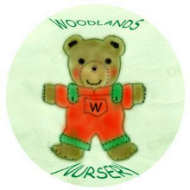 Woodlands Nursery Class – STAFF 

