

Whistleblowing

Guidelines from NLC in Teams/NLC Sharepoint/MyNL

Contact details for Care Inspectorate, NLC and HT are available in nursery cloakroom.

Updated and shared with all staff February 2026 by Nicola Ferguson

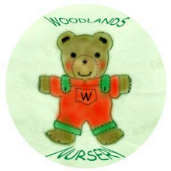 Woodlands Nursery Class – WHISTLEBLOWING 

