

Walks and Local Visits

Within The School Grounds
The school playground can be accessed. This must be a 1:8 ratio.

Out With The School Grounds
Opportunities for the children to access the local community including the shops, parks and garden centres are a valuable part of nursery life. In any case where children will be going out with the nursery grounds, decisions around ratio’s must be discussed and agreed with the HT as these may vary depending on the destination, mode of travel and specific needs of the children. A ratio of 1:5 will be acceptable in most cases.

Further Afield
If you want to go anywhere different to the places listed above please see HT first to discuss and risk assess. Where possible a ratio of 1:3 for larger all day trips is preferable.

Updated and shared with all staff February 2026 by Nicola Ferguson

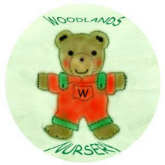 Woodlands Nursery Class – WALKS AND LOCAL VISITS 

