

Valuables in Nursery

It is the policy of North Lanarkshire Council that children do not bring valuables to school and the statement in the school handbook reads:

The council wishes to minimise claims from the loss of Pupil’s clothing and/or personal belongings. Parents are asked to assist in this area by ensuring that valuables, unnecessarily expensive items of clothing, jewellery etc. are not brought to nursery. Parents should note that any claims submitted to cover the loss of such items are likely to be met only where the authority can be shown to have been negligent.

Staff each have a locker to store personal items.

Updated and shared with all staff February 2026 by Nicola Ferguson

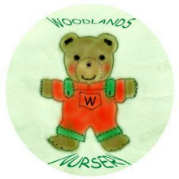 Woodlands Nursery Class – VALUABLES IN NURSERY 

