

Transition Calendar

August - October
Nursery staff will continue to visit the children in primary one and support them to settle into school. Children from primary one will visit the nursery to share their learning.

November
Nursery and primary one pupils work together for the Children in Need activity day where groups are mixed and pupils work between nursery and primary one.

December
Nursery pupils are involved in whole school events including the Nativity and Pantomime.

January - March
Primary one staff visit the nursery to work with the children in a familiar environment.

April - June
Nursery children enjoy play sessions with the primary one children in the learning zone.
All new starts are invited to visit primary one for 4 afternoons to become familiar with the class environment, on the final visit the children attend with their parents and enjoy lunch together.

Enhanced transition for identified children is flexible and adapted to meet individual need.

Updated and shared with all staff February 2026 by Nicola Ferguson

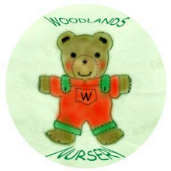 Woodlands Nursery Class – TRANSITION CALENDAR 

