

TOOTHBRUSH CLEANING SCHEDULE  Clean all toothbrushes under running water every Friday  Throw out ‘chewed’ toothbrushes and record  Replace ‘chewed’ toothbrushes on Monday |  | 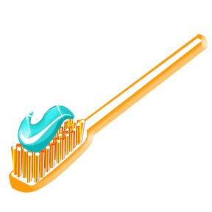
Date | Signature of Responsible Person | Comments

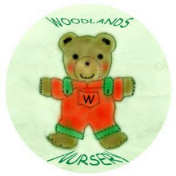 Woodlands Nursery Class – TOOTHBRUSH RECORD 

