

Toothbrushing Programme
Protocol for Staff

- Consent letter supplied by the school dental nurse will be given to parents by office staff when a child is enrolling. Parents/Carers must give their consent before their child/children can take part in the programme.

- The dental nurse will supply toothbrush racks, toothbrushes and toothpaste. The toothbrush racks are on loan from the Community Dental Service.

- The staff should keep the racks clean by rinsing in hot soapy water and will be responsible for maintaining the cleanliness of the brushes as well as the racks.

- The racks must not be covered unless they are the specialist type with combined rack and cover.

- The dental nurse will supply pictorial charts to match children’s names against their individual toothbrush picture to ensure children use only their own toothbrush.

- Staff will supervise the tooth brushing daily after lunch.

- The staff will apply a pea-sized amount of toothpaste on the child’s brush and children should not rinse their mouth out after brushing.

- Brushes must never be left soaking in Milton or any other cleaner.

- Brushes should be rinsed individually with water to remove any surplus saliva and toothpaste.

10.The staff will be responsible for the programme on a daily basis.

11.The dental nurse will change brushes every 10-12 week period or sooner as
necessary.

Updated and shared with all staff February 2026 by Nicola Ferguson

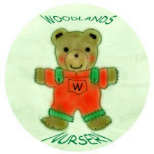 Woodlands Nursery Class – TOOTHBRUSHING PROGRAMME 

