

Staff Recruitment and Selection Procedures

As head of the Nursery Miss Nicola Ferguson would deal with all Staff Recruitment and Selection Procedures.

Senior staff follow very carefully North Lanarkshire’s Guidelines on Recruitment and Selection.

Updated and shared with all staff February 2026 by Nicola Ferguson

Updated August 2018 by N. Ferguson

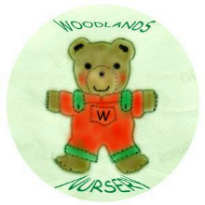 Woodlands Nursery Class – STAFF RECRUITMENT AND SELECTION 

