

Staff Training/Professional Review & Development

Continued professional learning and opportunities for development is integral to effective practice. Each staff member will be given the opportunity to attend courses in order that his/her own personal learning and development interests are addressed. Furthermore, opportunities for staff training linked to priorities in the improvement plan will be provided by the Head Teacher as part of whole school improvement.
A professional review and development will be carried out every April/May for all staff. Staff are actively encouraged to engage in development opportunities provided by NLC through LearnNL and are kept informed of what is on offer by email.
Early Years Workers complete their own folder containing details of any courses, in service training that they have undertaken to ensure they cover the criteria for registration with SSSC. Their PRD is recorded using the proforma paperwork for single status staff as issued by NLC.

Improvement Plan

The improvement plan is the means by which we move the services of our establishment forward.

All staff are involved in creating the whole school improvement plan each year and are active participants in development work.

Updated and shared with all staff February 2026 by Nicola Ferguson

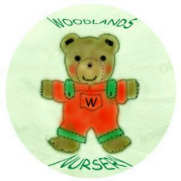 Woodlands Nursery Class – STAFF TRAINING 

