

Staff Remits

The remits for all staff including the:

Head Teacher
Lead Early Learning Practitioner
Early Learning Practitioner
ELC Support Worker
Clerical Assistant

Are in line with NLC policy.

Updated and shared with all staff February 2026 by Nicola Ferguson

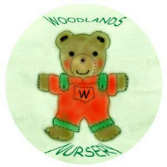 Woodlands Nursery Class – STAFF REMITS 

