

Loving Lunches and Snack

Aim:

- Ensure the children are provided with a variety of food which promote healthy eating and a balanced diet.

Objectives:

- To encourage healthy eating
- To promote personal hygiene
- To promote independence and decision making
- To promote positively as a free choice act.
- To promote equal opportunities and positive behaviour through social skills.

Procedures:

- Children will be encouraged to foster good personal hygiene as part of their normal daily routine
- Children will have the opportunity to sample food which may not be familiar to them
- Children will be encouraged to develop self-help skills in serving their own food
- Children will sit with their peers and staff to eat together, encouraging social interaction as part of mealtimes
- Cereal is available first thing as children arrive and snack is provided in the afternoon.

Children will have the chance to follow a routine –
ie. wash hands
select choice of milk/water
find place at table
select from choices offered in buffet style server in the centre of the table
clear their dishes and wash their hands when they have finished.

Please also see Loving Lunches by Care Inspectorate

Updated and shared with all staff February 2026 by Nicola Ferguson

Updated August 2018 by N. Ferguson

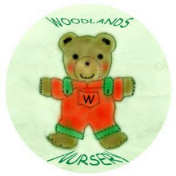 Woodlands Nursery Class – LUNCHES AND SNACK 

