

Smoking

North Lanarkshire Education and Families works a No Smoking Policy in all establishments this includes vapes. This is within the building and on school grounds.

We at Woodlands Nursery adhere to these guidelines. Anyone wishing to smoke must do so outside the school gates and away from the building entrances.

Updated and shared with all staff February 2026 by Nicola Ferguson

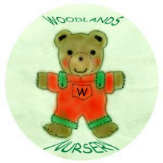 Woodlands Nursery Class – SMOKING 

