

Sickness In Children

- If a child is clearly unfit for nursery either the parent(s) or emergency contact will be advised. The enrolment form provides details of the appropriate contacts.

- Children who have sickness and/or diarrhoea will be excluded until the child has been free of infection for 48hours.

- Headlice-if a child is infected then they may attend nursery on commencement of corrective treatment.

- Should a member of staff identify the headlice infection, then he/she would discreetly advise parents/carers.

- Where necessary children with infections will be excluded in line with NHS Lanarkshire guidance.

- Child attendance is monitored by each Keyworker. Should the Keyworker be concerned about attendance then he/she would advise the Head Teacher or Principal Teacher.

- Advice for all infections in terms of exclusion from nursery are on display in the cloakroom.

Updated and shared with all staff February 2026 by Nicola Ferguson

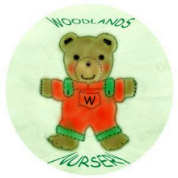 Woodlands Nursery Class – SICKNESS IN CHILDREN 