

SET UP ROUTINE |  | TIDY UP ROUTINE
Garden |  | Garden
Changing area is tidy and floor is clear |  | Children help tidy garden, bringing toys over to container door
Wellies in pairs on shelf |  | Check garden is clear of all toys
Waterproofs hanging up |  | Container tidy and all resources stored in correct place
Jackets hanging up |  | Broken resources removed
Fleece (if required) hanging up |  | Sand pit covered
Check garden for broken glass etc.
Ensure gates closed |  | Wellies in pairs on shelf
Children choose seat, peg shoes, waterproofs on, wellies on, jacket on |  | Clean and replace any waterproofs if required
Select resources for play |  | Clean and replace any jackets if required
Set up mud kitchen with materials of choice |  | Dirty waterproofs/jackets into machine
Open and check outdoor digging area and add selected resources for play |  | Tidy and store resources
Check loose parts play areas. |  | Secure all resources
Fill up water trough. |  | Tidy and clean mud kitchen
Check Teepee is clean inside and safe for use |  | Clear, check and secure outdoor digging area
Set up mud kitchen with materials of choice |  | Clear, check and tidy loose parts play area,
 |  | Drain water trough, rinse and dry water toys.

Updated and shared with all staff February 2026 by Nicola Ferguson
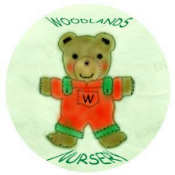 Woodlands Nursery Class – OUTDOORS SET UP & TIDY UP ROUTINE 

