

Room 2

If you are in Area 2 you are responsible for safety and security in the following areas:

- Living Room
- STEM
- Creative Area
- Sand

You should ensure that:
- All areas are set up and ready for use prior to the start of the session.
- All sockets are covered.
- All electrical cables must be stored carefully away from children’s play space
- Floor area is free of hazards.
- Resources are accessed and managed in a purposeful manner.
- Children do not climb on furniture.
- Resources are checked before use and broken or incomplete materials are removed.
- Children are encouraged to help with tidy up.
- Submit in writing any safety concerns immediately to Head Teacher using ‘Play Area Safety Form’.
- Children are discouraged from swinging on seats.
- Resources are accessed and managed in a purposeful manner.

Updated and shared with all staff February 2026 by Nicola Ferguson

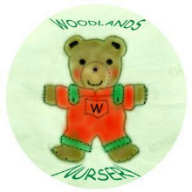 Woodlands Nursery Class – SET UP ROOM 2 

