

SET UP ROUTINE |  | TIDY UP ROUTINE
Snack |  | Snack
Snack boxes are prepared for each group and stored |  | Area has been wiped and tidied
Empty dishwasher |  | Both cloths into dishwasher
Milk arranged in fridge by date |  | Fill and start dishwasher
Cups available for water |  | Staff plates/cups into staffroom
Worktop is clean and clear of clutter
If cooking with children all ingredients and utensils are available and ready for use
Theatre/Dressing Up |  | Theatre/Dressing Up
Check no obstructions on stairs/slide
Display items in baskets/on rails |  | Tidy and replace objects in baskets/rails
House |  | House
Check all resources are displayed attractively |  | Check all resources are intact and tidied
Dressing up clothes in role play area |  | Check that all clothes are hanging up and props in basket
Check that play kitchen is stocked |  | Tidy all play food and wash at the end of the week
Arrange activity for the floor area |  | Tidy away resources and leave floor area clear
Water |  | Water
Fill water tray |  | Empty and wipe out water tray
Check all toys in correct containers/baskets |  | Check all toys and play in baskets
Literacy |  | Literacy
Check writing baskets and ensure materials are ready for use |  | Tidy up writing baskets and replace any items
Resources set up attractively |  | Resources tidied away in correct boxes

Updated and shared with all staff February 2026 by Nicola Ferguson

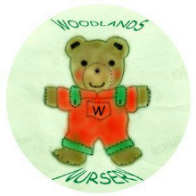 Woodlands Nursery Class – ROOM 1 SET UP & TIDY UP ROUTINE 

