

Room 1

If you are in Room 1 you are responsible for safety and security in the following areas:

- Kitchen/Snack
- Literacy
- Home Corner
- Water
- Challenge Areas

You should ensure that:

- All areas are set up and ready prior to the start of the session
- All sockets are covered.
- Electrical equipment and resources not in use are stored out of children’s reach.
- Allergy list is consulted at beginning of each session.
- Procedures for snack preparation are carried out (policy & procedures manual).
- All spillages are cleared as soon as possible.
- Bin lid is always on bin.
- Chairs are stacked to a max. of 5.
- All cleaning fluids are stored properly.
- Proper use of equipment and utensils by children.
- Sink area is not overcrowded by children.
- Children are encouraged to tidy up after themselves.
- Resources are accessed and managed in a purposeful manner
- Resources are checked before use and broken or incomplete materials are removed
- Submit in writing any safety concerns immediately to Head Teacher.

Updated and shared with all staff February 2026 by Nicola Ferguson

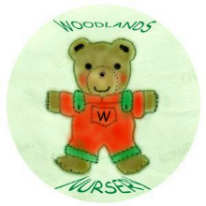 Woodlands Nursery Class – SET UP ROOM 1 

