

Security Policy Statement and Procedures

Our aim is to make our nursery safe, happy and welcoming for everyone.

- We ask staff and pupils to think carefully about their own safety at all times.

- The doors to pupil entrances open only from the inside.

- All nursery doors into the main school and cloakroom are double handled with one handle above the reach of children.

- Gates from the nursery outdoor area into the wider playground are kept closed. Gates surrounding the main playground are kept closed between 9.15am and 2.45pm.

- We have a controlled entry system operating at the main entrance.

- We ask all staff to wear identification badges at all times.

- We ask all visitors to sign in and out at the main entrance and to wear a “visitor’s badge when in the nursery or nursery grounds.

- We ask you to let us know if you see anyone acting suspiciously near or at our nursery or school.

- We ask you to share with us any ideas you may have to make our nursery safer.

AND IN PARTICULAR

- We ask everyone to be patient – good security can be frustrating

Updated and shared with all staff February 2026 by Nicola Ferguson

Updated and shared with all staff December 2022 by Nicola Ferguson

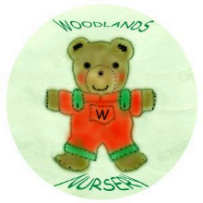 Woodlands Nursery Class – SECURITY STATEMENT 

