
- Check that all areas are free from hazards
- Check side gates are closed and secure
- Ensure main door remains closed and fire door into school is closed
DATE | TIME | PERSON RESPONSIBLE | OUTCOME

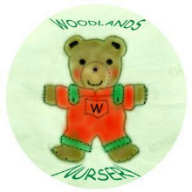 Woodlands Nursery Class – DAILY RISK ASSESSMENT CLOAKROOM 

