
- Check that all areas are free from hazards including floor space
- Check all toys and equipment are in safe condition for use and stored correctly
- Check that room and toilets have been cleaned (if necessary report any issues/concerns immediately to janitor and SMT)
- Ensure that all kitchen surfaces are clear
DATE | TIME | PERSON RESPONSIBLE | OUTCOME

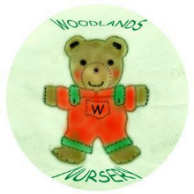 Woodlands Nursery Class – DAILY RISK ASSESSMENT ROOM 1 

