

Risk Assessment
Premises and Play Areas

The nursery is cleaned each day. The cleaning staff use cleaning materials supplied and approved by North Lanarkshire Council. Toilets are checked at lunchtime and any issues with cleanliness reported to the janitor.

Nursery staff are responsible for checking toys/materials each session to ensure there are no broken or damaged toys on the floor.

All materials are stored carefully and at an appropriate height.

Updated and shared with all staff February 2026 by Nicola Ferguson

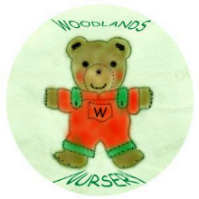 Woodlands Nursery Class – RISK ASSESSMENT – PREMISES & PLAY AREAS 

