
Family Views/Comments…..

Child’s Name: Keyworker: Date:

I am going to progress my learning by:

 | Target | Success Criteria | Evidence and Assessment of Learning
Health and Well-Being |  |  | Write/Say/Make/Do
Language and Literacy |  |  | Write/Say/Make/Do
Mathematics and Numeracy |  |  | Write/Say/Make/Do

Date of Review:
Keyworker comment:

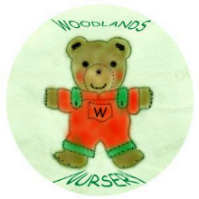 Woodlands Nursery Class – LEARNING TARGETS 

