

What are we assessing? How are we assessing? How are we recording evidence?
AUDIENCE: Who is it for? ( child / parents / carers / management / external) PURPOSE: Why are we doing it?
CONTENT: What’s in it? How often are we assessing? How are we linking our observations to assessment?
ASSESSMENT TOOL | CHILD | PARENT / CARER | MANAGEMENT | EXTERNAL
CHAT BOOK  Talk, informal, current, skills Assessment of chat, use of words and mark making | Individual colour  In groups | x | ü | ü
SKILLS SHEET  Mainly social and emotional development | Observations of children in and through play. Next steps for support / challenge | Discussion | Discussion | ‘Tracking’ progress
LANGUAGE DEVELOPMENT  Using Universally Speaking – stages of speech and communication skills | Informal talk  Group activities  Different areas of the Nursery | Discussion | Discussion | ‘Tracking’ progress
MARK MAKING  (Writing and mathematical marks)  Stages of development | Encouraging marks making everywhere. Photographic evidence  Noting interest, development and independence. | Discussion | Stages of development | Progress and variety of experiences
BIG BOOK IN EACH AREA  P6/7 to support chat | Photographic record of play experiences in each area.  Children can relate to their own learning. | Stay and Play sessions | Wider school skills initiative | Show and talk about. Nursery experiences and provision.
ONLINE FOLDER | Own development, personal to child. | Direct to parent / carer. Share with child
MY LEARNING  Child chooses, talks and prompts: I like playing… My favourite place is… Here’s what I like best in Nursery. My favourite lunch is… I went to…  My favourite toy at home is.. I am looking forward to… | Personal to the child.  Links to skills and attitudes | Transition development. Chat with child. | Tracking development and progress
Quality Observations
- What are we observing/Types of observation/What will we use/What will we do with the observations
- Their interests and preferences
- Their levels of competence and social development
- Their strategies in and through play
- Their skills and accomplishments
- Their attitudes and levels of engagement
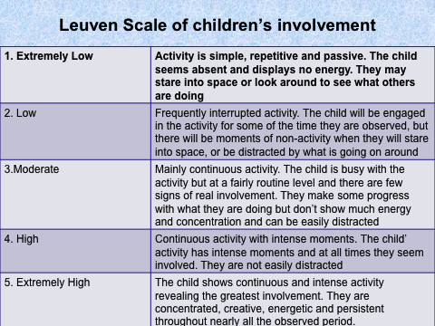
Updated and shared with all staff February 2026 by Nicola Ferguson

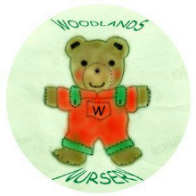 Woodlands Nursery Class – PLANNING AND ASSESSMENT 

