
APPENDIX 5
NORTH LANARKSHIRE COUNCIL: DEPARTMENT OF EDUCATION
ADMINISTRATION OF MEDICINES
MEDICAL PROTOCOL MONTHLY CHECKS

WOODLANDS NURSERY CLASS

Date | Child’s Name | Protocol Still  Applicable  (Please tick) | Staff’s Signature | Parent’s Signature

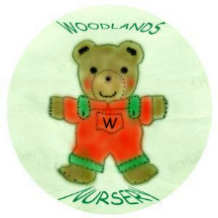 Woodlands Nursery Class – MEDICINE (Appendix 5) 

