
APPENDIX 4
NORTH LANARKSHIRE COUNCIL: DEPARTMENT OF EDUCATION
ADMINISTRATION OF MEDICINES
STORAGE OF MEDICINES

WOODLANDS NURSERY CLASS

Child’s Name | Medicine | Expiry Date | Checked by | Signed

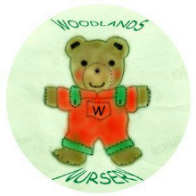 Woodlands Nursery Class – MEDICINE (Appendix 4) 

