
APPENDIX 3
NORTH LANARKSHIRE COUNCIL: DEPARTMENT OF EDUCATION
ADMINISTRATION OF MEDICINES
RECORD OF ISSUE OF MEDICATION

WOODLANDS NURSERY CLASS

For all pupils – Session – (_____________)
Date | Time | Name of Child | Dosage | Reason | Signature

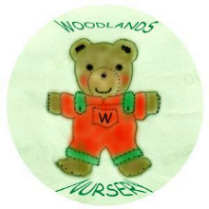 Woodlands Nursery Class – MEDICINE (Appendix 3) 

