
APPENDIX 2
NORTH LANARKSHIRE COUNCIL: DEPARTMENT OF EDUCATION
ADMINISTRATION OF MEDICINES
DAILY RECORD OF DOSAGE

WOODLANDS NURSERY CLASS

Pupils Individual Record: Child’s Name_______________________
Name of Person Administering Medicine | Date | Time | Name of Medication | Dosage | Signature of  Parent/Carer | Signature of  Staff Member

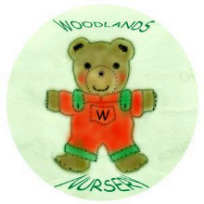 Woodlands Nursery Class – MEDICINE (Appendix 2) 

