

3. Roles for all personnel

Task | Time-scale | Personnel
1. Obtain factual information at start of crisis | Within hours | Senior staff
2. Senior management meet with support personnel | Within hours | HT & PT + support
3. Establish an intervention team | Within hours | HT & PT +  Support
4. Contact families | Within hours and until all informed | Clerical staff
5. Staff meeting to give information | Same day if practicable | HT & PT
6. Inform pupils in small groups | Same day if practicable | Nursery staff
7. Arrange a debriefing meeting for staff involved in disaster | Same day if practicable | External support
8. Debriefing for pupils involved in the disaster | As soon as possible allowing for health & safety | External support
9. Identify high risk pupils and staff | Next few days | Nursery staff
10. Promote discussion in classes | Next few days and weeks | Nursery staff
11. Identify the need for group or individual treatment | Incrementally over days or weeks after disaster | Nursery staff
12. Organise treatment etc. | As required | HT

Updated and shared with all staff February 2026 by Nicola Ferguson

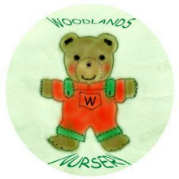 Woodlands Nursery Class – ROLES FOR PERSONNEL 

