

2. Support Agencies & Personnel

Contact | Name | Phone no
Head of Service | James McPartland | 01698 403140
Education and Families Manager | Vicky Sherry | 01698 403140
ELC Quality Officer | Eileen McGeough | 01698 403140
Police: | Local Station | 101
Fire Brigade | Local Station | 999
Educational Psychologist | Sarah Booth | 01236 632407
Monklands Hospital | General  01236 748748 | Ask for Casualty
Social Work Dept. Cumbernauld | Duty Officer | 01236 638700

Updated and shared with all staff February 2026 by Nicola Ferguson

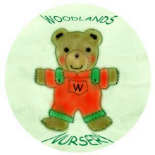 Woodlands Nursery Class – SUPPORT AGENCIES 

