

ICT POLICY

FROM NLC

SEE FOLDER

Updated and shared with all staff February 2026 by Nicola Ferguson

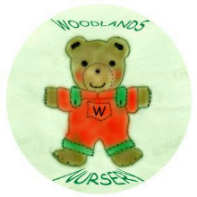 Woodlands Nursery Class – ICT POLICY 

