

Health and Safety

As North Lanarkshire Authority has extensive Health and Safety Policies I feel that these give specific advice for each incident and would say that Woodlands Nursery adheres to these Circulars at all times and would use them as a first course of action.

All relevant circulars are available within the Sharepoint on Teams.

Updated and shared with all staff February 2026 by Nicola Ferguson

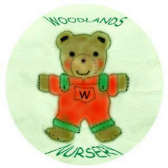 Woodlands Nursery Class – HEALTH & SAFETY 

