

First Aid

First Aider – Angela Tagg (Whole School including nursery)

- The First Aid Box is located in the Playroom. (Cupboard in snack area)

- When first aid is administered, it should be recorded in the Accident Book.

- The First Aid Box will be inspected monthly by the First Aider.

- Emergency Contacts and the children’s own GPs are listed on the child’s enrolment forms. These forms are located in the office. All details are also stored on Seemis.

- Accident procedures should be followed in accordance with our Nursery Accident policy and North Lanarkshire Council’s policy.

Updated and shared with all staff February 2026 by Nicola Ferguson

Updated August 2018 by N. Ferguson

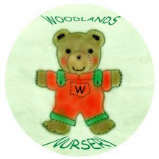 Woodlands Nursery Class – FIRST AID 

