

Educational Excursions and Visits

Excursions and visits are a valuable part of the educational experience for nursery pupils and the responsibility for approving these is with the HT of the nursery.
Any education excursion must have approval from the HT.
Outings Requiring Transport
- All excursions must be discussed with staff including head teacher and depute head teacher as part of monthly nursery meeting. Agreement will be made for any preliminary steps required at this point.

- HT considers proposed arrangements for the organisation and supervision of the activity. HT ensures that the level of supervision by responsible adult is appropriate to the nature of the visit.

- Head Teacher along with clerical staff will make arrangements including booking venue and transport, ensuring all permission forms are up to date.

- Depending on the nature of the trip or visit ensure that all potential risks have been identified and all reasonable precautions taken to ensure the safety of all participants. Ensure the risk assessment from the places to be visited have been read and important points handed out to all adults, (if available). A preliminary visit by an appropriate person may be necessary.

- After the visit HT will ask for a verbal report on the visit. It will cover effectiveness of the arrangements, educational achievements and detail any problems for future use.

Outings not requiring transport including local walks and visits will follow same procedures outlined above without the transport arrangements.

Updated and shared with all staff February 2026 by Nicola Ferguson

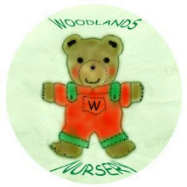 Woodlands Nursery Class – EXCURSIONS 

