
2812

Emergency Closures

Heating
Where there is complete failure of heating and the nursery is or will be below temperature then the HT will Liaise with SLT at North Lanarkshire Council to determine whether the nursery will be open to children.

Water
If there is no water supply and the tank has insufficient water then the HT will Liaise with SLT at North Lanarkshire Council to determine whether the nursery will be open to children.

Adverse Weather Conditions
In all circumstances surrounding adverse weather, HT will liaise with SLT at North Lanarkshire Council and the decision over closure will be made. Parents will be informed through email, school blog, council website and local radio.

In all circumstances the school and nursery adhere to North Lanarkshire Policies contained in
Adverse Weather Policy available on mynl.co.uk

As winter approaches all parents are kept informed as to the procedures for severe weather and guidance as to where information will be available is shared with all parents and carers.

Updated and shared with all staff February 2026 by Nicola Ferguson

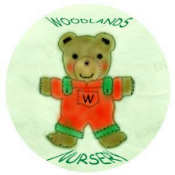 Woodlands Nursery Class – EMERGENCY CLOSURES 

