

Drug Abuse

Procedures for Prevention, Identification and
Investigation of Drug Abuse

In Woodlands Nursery we follow the directive from North Lanarkshire Education and Families contained in the Alcohol and Drug Policy which is available at mynl.co.uk

The staff in the nursery would note their concerns and report them to the Head Teacher.

The Head Teacher would then look at Standard Circular No. C8 for advice and take action from there.

Updated and shared with all staff February 2026 by Nicola Ferguson

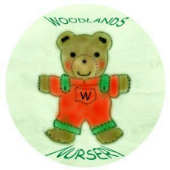 Woodlands Nursery Class – DRUG ABUSE 

