

TEMPERATURE RECORD OF FRIDGE
DATE | SIGN | 1ST TIME | TEMP | 2ND TIME | TEMP | COMMENT

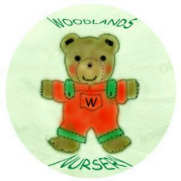 Woodlands Nursery Class – FRIDGE RECORD 

